MCA — MAJOR PROJECT
MAJOR PROJECT REPORT
Submitted in partial fulfilment of the requirements
for the award of the degree of

MASTER'S DEGREE PROGRAMME
in
MASTER OF COMPUTER APPLICATIONS (MCA)

Submitted by
PATEL MAN VISHNUBHAI
Enrollment No.: 25IC03CA053

Project Title: OPENCV-BASED SYSTEM FOR CRACK IDENTIFICATION AND WIDTH ESTIMATION

Under the guidance of
Dr. Srikant Singh
Academic Coordinator (B.Sc. IT/B.Sc. CS-AI), School of Engineering



P P SAVANI UNIVERSITY
SCHOOL OF ENGINEERING
P P SAVANI UNIVERSITY, SURAT, GUJARAT
OCTOBER 2026

Student Declaration and Certificate of Originality
I hereby declare that the project entitled "OpenCV-Based System for Crack Identification and Width Estimation" is my original work, carried out under the guidance of Dr. Srikant Singh for the major project component of MCA, Semester III, at P P Savani University, Surat. The work has not been submitted, in whole or in part, for any other degree, diploma or qualification. All sources, datasets, libraries, frameworks, and external contributions used in this project (OpenCV, NumPy, scikit-image, pandas, Flask, PyMongo, ReportLab and Bootstrap) have been appropriately acknowledged. I understand that plagiarism, fabricated results, or misrepresentation of project work may lead to disciplinary action.
Student Name: PATEL MAN VISHNUBHAI Enrollment/Roll No.: 25IC03CA053
Signature: ______________________ Date: ______________

Guide Certificate
This is to certify that the project entitled "OpenCV-Based System for Crack Identification and Width Estimation" has been carried out by PATEL MAN VISHNUBHAI, Enrollment/Roll No. 25IC03CA053, under my guidance. To the best of my knowledge, the report presents the work completed by the student and is submitted for academic evaluation in accordance with the applicable institutional requirements.
Guide Name and Designation: Dr. Srikant Singh, Academic Coordinator (B.Sc. IT/B.Sc. CS-AI), School of Engineering
Signature: ______________________ Date: ______________
Department / School: Academic Coordinator (B.Sc. IT/B.Sc. CS-AI), School of Engineering, P P Savani University, Surat, Gujarat

Acknowledgement
I express my sincere gratitude to my project guide, Dr. Srikant Singh, for the guidance, review and encouragement received throughout this project. I thank the faculty and staff of the School of Engineering, P P Savani University, for providing the academic environment and facilities needed to complete this work.
I also acknowledge the open-source communities behind OpenCV, NumPy, scikit-image, pandas, Flask, PyMongo and ReportLab, whose libraries form the technical foundation of this system, and the researchers whose published work on crack detection informed the design. Finally, I thank my family and friends for their continuous support.
PATEL MAN VISHNUBHAI

Abstract
Cracks in concrete walls, pavements and road surfaces are an early indicator of structural deterioration, but manual inspection is slow, subjective and difficult to document consistently. This project develops a web-based system that identifies candidate cracks in photographs and estimates their length and width using classical computer vision, without requiring a labelled training dataset. The objective is to give an inspector a repeatable, explainable measurement with every intermediate image visible.
The tool is written in Python and served by a Flask web application; OpenCV, scikit-image, NumPy and pandas do the image work and reporting, and MongoDB keeps the history (with a session-only fallback when no database is running). An uploaded photograph is scaled down, turned to grayscale, blurred, locally contrast-equalised (CLAHE) and converted to a binary mask by adaptive Gaussian thresholding, with a BlackHat image kept as an additional view. Morphological opening and closing, connected-component analysis and shape and distance rules then keep long, connected crack networks and discard text, round blobs and plain surface texture. Every crack is thinned to a one-pixel skeleton with scikit-image: its length is traced along that skeleton and its width is taken as twice the Euclidean distance-transform value on the centreline, reported as the median (mean width) and the 95th percentile (maximum width). A pixels-per-millimetre factor (default 10) gives millimetre values, and configurable width and area limits label each crack Good, Medium or Heavy. CSV, PDF and ZIP exports are produced for each analysis.
The implementation was verified with the repository's 16 automated tests (all passed in the test environment described in Chapter 7), an end-to-end browser run, and controlled experiments on synthetic textured images with known crack widths. In the width sweep, the mean-width estimate was within 0.6 px of the true rasterised width for bars 3 to 13 px wide, skeleton length exceeded the geometric length by about 6 to 7 percent on oblique cracks, faint cracks with contrast below about 35 grey levels were missed, and a 1600 x 1200 image was processed in about 0.16 s. No quantitative evaluation on annotated real photographs has been carried out, and severity labels are software categories, not structural safety judgements.
Keywords: crack detection; OpenCV; image segmentation; skeletonisation; distance transform; crack width estimation; Flask

Table of Contents
Chapter 1 — Introduction 1
1.1 Background and context of the problem 1
1.2 Problem statement 1
1.3 Need and motivation 1
1.4 Aim and measurable objectives 2
1.5 Scope 2
1.6 Proposed solution and expected contribution 3
1.7 Brief overview of the methodology 3
1.8 Organisation of the report 3
Chapter 2 — Literature Review and Existing-System Study 4
2.1 Search strategy and sources consulted 4
2.2 Review of relevant research and systems 4
2.3 Comparison of existing approaches 5
2.4 Identified gap 5
2.5 How the proposed project addresses the gap 5
2.6 Summary 6
Chapter 3 — System Analysis and Requirements 7
3.1 Preliminary investigation and user needs 7
3.2 Existing system and its limitations 7
3.3 Proposed system and benefits 7
3.4 Functional requirements 7
3.5 Non-functional requirements 9
3.6 Hardware and software requirements 9
3.7 Feasibility study 10
3.8 Constraints, assumptions, dependencies and risks 10
3.9 Software Requirements Specification (SRS) summary 10
Chapter 4 — Project Planning and Methodology 11
4.1 Development methodology and reason for selection 11
4.2 Project phases and deliverables 11
4.3 Work breakdown structure (WBS) 11
4.4 Gantt chart with planned and actual dates 11
4.5 PERT chart / dependency diagram 13
4.6 Roles and responsibilities 13
4.7 Risk register and mitigation plan 13
4.8 Dataset preparation and ethical considerations 13
Chapter 5 — System Design 15
5.1 Overall system architecture 15
5.2 Module decomposition and responsibilities 15
5.3 Data flow diagrams 16
5.4 Use-case diagram and descriptions 17
5.5 Activity (process) diagram 18
5.6 Entity–relationship diagram 20
5.7 Database schema 20
5.8 Input and output design 21
5.9 Algorithms and process logic 21
5.10 Security, privacy, validation and access-control design 22
5.11 Design decisions and trade-offs 22
5.12 Worked numerical example of the width measurement 23
5.13 Pseudo-code of the main algorithms 23
5.14 Complexity and performance considerations 25
5.15 Function reference 25
5.16 Analysis life-cycle and status values 26
5.17 User-interface design notes 26
Chapter 6 — Implementation 28
6.1 Development environment and tool versions 28
6.2 Project folder structure and configuration 28
6.3 Module-wise implementation 29
6.4 Important algorithms and code excerpts 29
6.5 Database implementation 30
6.6 API and external-service integration 30
6.7 Validation and error handling 30
6.8 Screenshots of working features 31
6.9 Build, run and deployment instructions 33
6.10 Project file structure 33
6.11 Source code screenshots with explanation 35
6.12 Additional user-interface screenshots 55
6.13 Generated output files 56
6.14 JSON API response 60
6.15 Step-by-step walkthrough of one analysis 61
6.16 Implementation challenges and how they were handled 68
Chapter 7 — Testing and Validation 69
7.1 Testing strategy and test environment 69
7.2 Unit testing 69
7.3 Integration testing 69
7.4 System testing 70
7.5 Performance and validation tests 70
7.6 Test results, defects found and fixes 70
7.7 Traceability matrix 71
7.8 Test code and results for each automated test 72
7.9 Test coverage assessment 79
Chapter 8 — Results, Discussion and Limitations 80
8.1 Implemented features and evidence of completion 80
8.2 Results against each project objective 80
8.3 Quantitative metrics and how they were measured 81
8.4 Comparison with baseline / existing method 82
8.5 Interpretation of results and unexpected outcomes 82
8.6 Known limitations and unresolved issues 83
8.7 User feedback or evaluation 84
8.8 Additional experiments: robustness and sensitivity 84
8.9 Discussion 88
8.10 Threats to validity 89
Chapter 9 — Conclusion and Future Scope 90
9.1 Summary of the problem and solution 90
9.2 Objective-wise completion status 90
9.3 Main contributions and conclusions 90
9.4 Limitations 90
9.5 Future enhancements 90
9.6 Learning outcomes and skills demonstrated 91
References 92
Appendices / Annexures 94
Appendix A — Approved synopsis / proposal and approval record 94
Appendix B — Detailed Software Requirements Specification 94
Appendix C — Database dictionary and sample report 94
Appendix D — Detailed test cases and test evidence 95
Appendix E — User manual / installation and execution guide 95
Appendix F — Repository details and selected source 96
Appendix G — Progress reports / mentor review records 113
Appendix H — Questionnaire, consent form or data-collection instrument 114
Appendix I — Team-member contribution statement 114

List of Figures
Figure 4.1: Gantt chart: progress-report schedule and actual implementation activity 12
Figure 5.1: Layered architecture of the system 15
Figure 5.2: Context-level (Level 0) data flow diagram 16
Figure 5.3: Level 1 data flow diagram 17
Figure 5.4: Use-case diagram 17
Figure 5.5: Processing workflow for an uploaded batch 19
Figure 5.6: Logical data model (MongoDB collections and relationships) 20
Figure 6.1: Processing stages for a synthetic crack (drawn width 6 px) 31
Figure 6.2: Upload page with two selected images 31
Figure 6.3: Results page: summary, remark and downloads 32
Figure 6.4: Per-image results: original, annotated, mask and every processing stage 32
Figure 6.5: First page of the generated PDF report 33
Figure 6.6: File and folder structure of the project 34
Figure 6.7: app.py, lines 1 to 34 35
Figure 6.8: app.py, lines 35 to 54 36
Figure 6.9: config.py, lines 1 to 34 36
Figure 6.10: config.py, lines 35 to 48 36
Figure 6.11: services/image_service.py, lines 1 to 20 37
Figure 6.12: services/preprocessing_service.py, lines 1 to 33 37
Figure 6.13: services/detection_service.py, lines 1 to 34 38
Figure 6.14: services/detection_service.py, lines 35 to 68 38
Figure 6.15: services/detection_service.py, lines 69 to 102 39
Figure 6.16: services/detection_service.py, lines 103 to 130 39
Figure 6.17: services/measurement_service.py, lines 1 to 34 40
Figure 6.18: services/measurement_service.py, lines 35 to 68 40
Figure 6.19: services/measurement_service.py, lines 69 to 102 41
Figure 6.20: services/measurement_service.py, lines 103 to 136 41
Figure 6.21: services/measurement_service.py, lines 137 to 164 41
Figure 6.22: services/classification_service.py, lines 1 to 16 42
Figure 6.23: services/calibration_service.py, lines 1 to 10 42
Figure 6.24: services/storage_service.py, lines 1 to 15 42
Figure 6.25: services/csv_service.py, lines 1 to 34 43
Figure 6.26: services/csv_service.py, lines 35 to 57 43
Figure 6.27: services/zip_service.py, lines 1 to 34 44
Figure 6.28: services/zip_service.py, lines 35 to 50 44
Figure 6.29: models/database.py, lines 1 to 31 45
Figure 6.30: models/analysis_model.py, lines 1 to 34 45
Figure 6.31: models/analysis_model.py, lines 35 to 56 46
Figure 6.32: models/image_model.py, lines 1 to 28 46
Figure 6.33: models/measurement_model.py, lines 1 to 34 47
Figure 6.34: models/measurement_model.py, lines 35 to 43 47
Figure 6.35: routes/upload_routes.py, lines 1 to 34 48
Figure 6.36: routes/upload_routes.py, lines 35 to 68 48
Figure 6.37: routes/upload_routes.py, lines 69 to 102 48
Figure 6.38: routes/upload_routes.py, lines 103 to 136 49
Figure 6.39: routes/upload_routes.py, lines 137 to 169 49
Figure 6.40: routes/analysis_routes.py, lines 1 to 34 50
Figure 6.41: routes/analysis_routes.py, lines 35 to 68 50
Figure 6.42: routes/analysis_routes.py, lines 69 to 98 50
Figure 6.43: routes/history_routes.py, lines 1 to 29 51
Figure 6.44: routes/report_routes.py, lines 1 to 34 51
Figure 6.45: routes/report_routes.py, lines 35 to 48 51
Figure 6.46: utils/validators.py, lines 1 to 22 52
Figure 6.47: utils/file_utils.py, lines 1 to 15 52
Figure 6.48: static/app.js, lines 1 to 34 53
Figure 6.49: static/app.js, lines 35 to 68 53
Figure 6.50: static/app.js, lines 69 to 102 54
Figure 6.51: static/app.js, lines 103 to 113 54
Figure 6.52: requirements.txt, lines 1 to 10 54
Figure 6.53: .env.example, lines 1 to 5 54
Figure 6.54: Upload page before selecting files 55
Figure 6.55: History page 55
Figure 6.56: Download-report card 56
Figure 6.57: Severity thresholds card, shown in pixels and millimetres 56
Figure 6.58: Per-image result card for the first synthetic image 56
Figure 6.59: Crack measurement table in pixels and millimetres 56
Figure 6.60: CSV report opened as a table (selected columns) 57
Figure 6.61: PDF report, page 2 57
Figure 6.62: PDF report, page 3 58
Figure 6.63: PDF report, page 4 59
Figure 6.64: Input image 61
Figure 6.65: Grayscale 62
Figure 6.66: Gaussian blur (5 x 5) 62
Figure 6.67: CLAHE 63
Figure 6.68: BlackHat transform 63
Figure 6.69: Adaptive threshold 64
Figure 6.70: Morphological opening and closing 64
Figure 6.71: Component mask 65
Figure 6.72: Skeleton 65
Figure 6.73: Distance transform 66
Figure 6.74: Width estimation 66
Figure 6.75: Annotated result 67
Figure 6.76: Second test image: three separate synthetic cracks 67
Figure 6.77: Annotated result: cracks C1, C2 and C3 measured independently 68
Figure 7.1: tests/test_app.py, lines 1 to 34 75
Figure 7.2: tests/test_app.py, lines 35 to 67 75
Figure 7.3: tests/test_processing.py, lines 1 to 34 76
Figure 7.4: tests/test_processing.py, lines 35 to 68 76
Figure 7.5: tests/test_processing.py, lines 69 to 102 77
Figure 7.6: tests/test_processing.py, lines 103 to 136 77
Figure 7.7: tests/test_processing.py, lines 137 to 170 78
Figure 7.8: tests/test_processing.py, lines 171 to 193 78
Figure 8.1: Input, annotated result, skeleton and width-estimation image 80
Figure 8.2: Measured versus true raster crack width 81
Figure 8.3: Detection rate versus noise level 85
Figure 8.4: Measured length versus contrast (dashed line: geometric length 578.9 px) 85
Figure 8.5: Length error versus line angle 86
Figure 8.6: Measured width versus image scale 88
Figure 9.1: Progress report schedule 114

List of Tables
Table 1.1: Objectives, planned outputs and verification evidence 2
Table 2.1: Comparison of related approaches 5
Table 3.1: Functional requirements 7
Table 3.2: Non-functional requirements 9
Table 3.3: Hardware and software requirements 9
Table 4.1: Project phases and deliverables 11
Table 4.2: Planned schedule of progress reports 12
Table 4.3: Activities and actual evidence 12
Table 4.4: Risk register 13
Table 5.1: Modules and responsibilities 15
Table 5.2: Use-case descriptions 18
Table 5.3: Design decisions and trade-offs 22
Table 5.4: Distance-transform values for a 5 px wide, 20 px long bar (every second column shown) 23
Table 5.5: Measurement output for the worked example 23
Table 5.6: Function reference 25
Table 6.1: Main configuration parameters (config.py) 28
Table 6.2: Module-wise inputs, processing and outputs 29
Table 6.3: HTTP interface 30
Table 6.4: Size of each part of the repository (lines, from `wc -l`) 34
Table 6.5: Implementation challenges 68
Table 7.1: Test cases and results 70
Table 7.2: Requirements-to-tests traceability 71
Table 7.3: Test coverage assessment 79
Table 8.1: Objective-wise results 80
Table 8.2: Measured width against true raster width on synthetic images (geometric polyline length 578.9 px) 81
Table 8.3: Effect of background noise on detection and width 84
Table 8.4: Effect of crack contrast on detection 85
Table 8.5: Length and width of a straight crack at different angles 86
Table 8.6: Sensitivity to the threshold offset (texture SD 10) 87
Table 8.7: Sensitivity to the threshold neighbourhood size 87
Table 8.8: Same scene at five image scales 87
Table 8.9: Mean stage time over 20 images of 1024 x 768 px with one crack 88
Table 9.1: External interface specification 94
Table 9.2: Logical database dictionary 94
Table 9.3: Sample CSV measurement rows 95
Table 9.4: Commit history summary 96
Table 9.5: Larger source files (line counts); the repository has about 1,990 lines in total 96

List of Abbreviations
Abbreviation | Meaning
API | Application Programming Interface
BGR | Blue-Green-Red colour channel order used by OpenCV
CLAHE | Contrast Limited Adaptive Histogram Equalisation
CSV | Comma-Separated Values
CV | Computer Vision
DFD | Data Flow Diagram
DT | Distance Transform
ER | Entity-Relationship
FR / NFR | Functional / Non-Functional Requirement
HTTP | Hypertext Transfer Protocol
JSON | JavaScript Object Notation
MCA | Master of Computer Applications
NDT | Non-Destructive Testing
PCA | Principal Component Analysis
PDF | Portable Document Format
PERT | Program Evaluation and Review Technique
PNG / JPEG | Portable Network Graphics / Joint Photographic Experts Group
ppm | Pixels per millimetre (calibration factor)
P95 | 95th percentile
SRS | Software Requirements Specification
SVD | Singular Value Decomposition
UI | User Interface
UUID | Universally Unique Identifier
WBS | Work Breakdown Structure

Chapter 1 — Introduction

1.1 Background and context of the problem
Surfaces of concrete, masonry and asphalt develop cracks for many reasons: drying shrinkage, temperature swings, heavy loads, foundation movement and plain ageing. Some cracks are only a cosmetic nuisance. Others let moisture and chlorides reach the steel reinforcement, shorten the life of the structure or point to a deeper structural fault. For this reason inspectors note the position, length and width of each crack and come back later to see whether it has grown.
On site, width is normally read with a crack gauge or comparator card and length with a tape, and the findings are written down by hand. The method is time-consuming over large areas, varies from one inspector to another, cannot be repeated exactly, and leaves almost no visual record. Since photographs are inexpensive to take and their geometry can be extracted by software, an automated and documented measurement workflow is a natural improvement.

1.2 Problem statement
Given one or more photographs of a concrete, wall or pavement surface, the system must (i) decide whether the image contains crack-like structures, (ii) segment those structures, (iii) measure the length and width of each crack, in pixels and, when a scale is known, in millimetres, (iv) assign an easily understood severity category, and (v) present and export the results together with the intermediate images so that a human can check them. The affected users are inspectors, civil-engineering students and maintenance staff who currently perform these steps by hand.

1.3 Need and motivation
- Manual gauge-based measurement is slow and subjective; an automated pipeline gives the same output for the same image every time.
- Many published crack detectors are deep-learning models that need large labelled datasets and offer limited insight into why a result was produced. A classical pipeline can be inspected stage by stage, runs on an ordinary CPU and needs no training data.
- Detection alone is not enough for condition assessment; width and length are the quantities inspectors actually record, so the project concentrates on measurement as well as detection.
- A web interface with exportable CSV and PDF reports makes the tool usable by people who do not write code.

1.4 Aim and measurable objectives
The aim of the project is to design, implement and test an OpenCV-based web application that identifies cracks in images and estimates their length and width. The measurable objectives and the evidence used to verify each are summarized in Table 1.1.
No. | Objective | Planned feature / output | Evidence used to verify completion
O1 | Accept and validate crack photographs | Multi-file upload (JPG, JPEG, JFIF, PNG; at most 20 files; 16 MB request limit) | Upload tests TC-02, TC-03; end-to-end run TC-17
O2 | Segment crack-like regions | Resize, grayscale, Gaussian blur, CLAHE, adaptive threshold, morphology, component filtering | Processing tests TC-04, TC-09 to TC-14; stage images (Fig. 6.1)
O3 | Reject non-crack images | Shape, coherence, coverage and alignment validation | TC-07, TC-08, TC-16, TC-21
O4 | Measure crack length and width | Skeleton length; distance-transform width; median and P95 statistics | TC-05, TC-15, TC-22; Table 8.2
O5 | Convert to physical units and classify | px/mm calibration; Good / Medium / Heavy labels | TC-06
O6 | Present and export results | Results page, annotated images, CSV, PDF and ZIP packages | TC-17 to TC-20; Figs. 6.2 to 6.5
O7 | Keep a history of analyses | MongoDB-backed history with in-memory fallback; delete and search | Code review (Chapter 6); TC-17
Table 1.1: Objectives, planned outputs and verification evidence

1.5 Scope
Included: single or batch image upload; automatic pre-processing, segmentation, validation and measurement; calibration with a configurable default of 10 pixels per millimetre; severity labelling by configurable width and area thresholds; annotated images and all processing stages; CSV, PDF and ZIP exports; stored analysis history; automated tests.
Boundaries: the system analyses still images only (no video or drone streams); it targets visible surface cracks on concrete, wall and pavement images; it does not estimate depth, does not correct perspective or lens distortion, and does not read a scale automatically from the image. Severity categories are software labels defined by the configured thresholds and are not a professional structural safety assessment. There is no user authentication, because the application is intended for local, single-user use.

1.6 Proposed solution and expected contribution
The proposed solution is a Flask web application whose back end applies a deterministic OpenCV pipeline to each uploaded image. The contribution of the project is an end-to-end, explainable crack-measurement tool: it combines contrast enhancement, adaptive thresholding, shape-based filtering that suppresses texture, per-crack skeletonisation, a robust width statistic that is not dominated by junctions or blobs, and a complete reporting workflow, all in one open-source repository that can be run on a standard computer.

1.7 Brief overview of the methodology
An iterative, incremental approach was used. A first working pipeline and web application were committed on 5 October 2026; subsequent iterations on 12 October 2026 reduced pavement-texture false positives, restricted annotations to coherent crack paths, supported several crack networks per image and stabilised width measurement; the repository was finalised on 18 October 2026. Each iteration was checked with synthetic test images added to the automated test suite. Chapter 4 describes the method in more detail.

1.8 Organisation of the report
Chapter 2 reviews related work and existing approaches. Chapter 3 analyses the requirements. Chapter 4 describes planning and methodology. Chapter 5 presents the system design. Chapter 6 describes the implementation. Chapter 7 covers testing and validation. Chapter 8 reports results, discussion and limitations. Chapter 9 concludes and lists future scope. References and appendices follow.

Chapter 2 — Literature Review and Existing-System Study

2.1 Search strategy and sources consulted
Sources were identified by searching Google Scholar and the publisher sites of journals in civil-infrastructure informatics and computer vision using the terms "crack detection", "image processing", "concrete", "pavement", "crack width", "skeleton" and "convolutional neural network". Surveys were used to find primary papers. Official documentation for OpenCV, scikit-image, Flask and MongoDB was consulted for implementation details.

2.2 Review of relevant research and systems
Surveys. Koch et al. (2015) surveyed vision-based defect detection and condition assessment for concrete and asphalt structures, describing the chain from image capture to detection and then assessment. Mohan and Poobal (2018) examined image-processing crack detectors critically and pointed out how strongly they depend on lighting, surface texture and noise.
Classical image processing. Yamaguchi and Hashimoto (2010) described a percolation-based approach aimed at quickly finding cracks in large concrete images. Typical classical pipelines filter the image, threshold it or detect edges, clean the result morphologically and analyse connected components. Otsu (1979) chooses one global threshold from the grey-level histogram, while adaptive thresholding computes it locally and tolerates uneven illumination. CLAHE (Zuiderveld, 1994) raises local contrast while limiting noise amplification.
Deep learning. Zhang et al. (2016) classified road-image patches with a deep convolutional network, and Cha et al. (2017) detected concrete cracks with a convolutional network that needs no hand-designed features. Özgenel and Gönenç Sorguç (2018) compared pretrained networks on building crack images and published a commonly used concrete crack dataset (Özgenel, 2019). Dorafshan et al. (2018) set deep networks against classical edge detectors on concrete images; the networks did better on their data, whereas edge detectors need no training set.
Skeletons and distance transforms. Thinning methods such as Zhang and Suen (1984) shrink a binary shape to a one-pixel centreline, and a distance transform (Borgefors, 1986) assigns each foreground pixel its distance to the nearest background pixel. Combined, they measure the local width of a long thin shape: the distance value on the centreline equals half the width there.

2.3 Comparison of existing approaches
Author / year | Problem | Method / technology | Findings (as reported) | Limitations | Relevance to this project
Koch et al., 2015 | Survey of CV defect detection for concrete and asphalt | Literature review | Organises detection and assessment methods and open problems | Review only; no implementation | Frames the detection-to-assessment pipeline
Mohan & Poobal, 2018 | Critical review of image-processing crack detection | Literature review | Summarises classical methods and their issues with noise and lighting | Review only | Motivates CLAHE, adaptive thresholding and filtering
Yamaguchi & Hashimoto, 2010 | Fast crack detection in large concrete images | Percolation-based image processing | Designed for efficient processing of large images | Detection focus; width not the main output | Classical, training-free precedent
Zhang et al., 2016 | Road crack detection | Deep CNN on image patches | CNN learns crack features from data | Needs labelled training data; output is detection | Contrast with training-free approach
Cha et al., 2017 | Concrete crack detection | CNN without hand-crafted features | Detects cracks under varied conditions | Training data and GPU resources; limited geometry output | Shows the deep-learning alternative
Dorafshan et al., 2018 | CNN vs edge detectors for concrete cracks | DCNN and classical edge detection | CNNs better on their data; edge detectors need no training | Dataset-specific | Supports a hybrid role for classical methods
This project | Detection plus length and width measurement | OpenCV adaptive pipeline, skeleton, distance transform, Flask | See Chapter 8 | No real-photo benchmark yet | Delivers measurement and reporting
Table 2.1: Comparison of related approaches

2.4 Identified gap
Most published work concentrates on classifying or segmenting cracks. Fewer open implementations give an inspector a complete workflow that (a) runs without training data or a GPU, (b) shows every intermediate image, (c) reports width and length in physical units with a robust width statistic, and (d) exports an audit-ready report. Deep-learning approaches also depend on the similarity between the training set and the surface being inspected.

2.5 How the proposed project addresses the gap
The project implements a transparent classical pipeline and couples it to measurement (skeleton length, median and P95 width), calibration, severity classification, history and export. Because no learning is involved, behaviour is controlled by documented parameters in config.py, and each stage image can be inspected in the results page.

2.6 Summary
Classical pipelines are fast, interpretable and training-free but sensitive to texture and lighting; deep-learning models are more robust on matching data but need labelled datasets and give less direct geometric output. This project adopts the classical route, adds texture-suppression filters and a validation step, and focuses on reproducible measurement and reporting.

Chapter 3 — System Analysis and Requirements

3.1 Preliminary investigation and user needs
The intended users are site inspectors, maintenance engineers and civil-engineering students who photograph a surface and want to know whether and how badly it is cracked. Their needs, as identified from the problem context in Chapter 1, are: upload several photographs at once; obtain results without tuning parameters; see where the software found cracks; obtain numbers in millimetres; keep a record; and export results for a report or a spreadsheet. The needs were captured from the project guide's brief and from the literature, not from a formal user survey.

3.2 Existing system and its limitations
- Manual inspection with gauges and tape: accurate at a point, but slow, subjective and poorly documented.
- General image-editing or measurement tools: require the user to trace cracks by hand and calibrate manually.
- Research detectors (often deep-learning): need training data and expertise to run, and typically output masks or boxes rather than width and length reports.

3.3 Proposed system and benefits
The proposed system automates detection and measurement behind a browser interface. Benefits are repeatability (same image, same result), speed (about 0.16 s for a 1600 x 1200 image in the test environment), transparency (all stages saved), physical units, and ready-to-share CSV, PDF and ZIP reports.

3.4 Functional requirements

ID | Requirement | Priority | Verification / acceptance criteria
FR-01 | Upload one or more images (JPG, JPEG, JFIF, PNG), up to 20 per analysis | High | Valid upload accepted; empty batch rejected with HTTP 400 (TC-02)
FR-02 | Validate each file: extension, non-empty, decodable, dimensions between 2 px and 8000 px | High | Invalid extension rejected (TC-03)
FR-03 | Resize to at most 1600 px on the longest side, grayscale, Gaussian blur, CLAHE, BlackHat and adaptive threshold | High | Stage images saved and shown (TC-04, TC-17)
FR-04 | Clean the binary mask with morphology; extract connected components; drop regions below 30 px area | High | TC-04, TC-09
FR-05 | Keep elongated crack-like regions and coherent groups; reject round blobs, text and dispersed regions | High | TC-07, TC-08, TC-11, TC-16, TC-21
FR-06 | Reject an upload batch in which an image contains no detectable crack | Medium | Rejection message with HTTP 422 (code review; TC-21 for logic)
FR-07 | Skeletonise each crack; compute length, area, mean and maximum width | High | TC-05, TC-15, TC-22
FR-08 | Convert measurements to millimetres using a positive pixels-per-millimetre value (default 10) | High | TC-06
FR-09 | Classify each crack as Good, Medium or Heavy using configurable thresholds | Medium | TC-06
FR-10 | Produce annotated image, skeleton, distance-transform and width-estimation images | Medium | TC-17; Figs. 6.1, 6.4
FR-11 | Show a results page with summary, remark, thresholds, stage images and measurement table | High | TC-17; Figs. 6.3, 6.4
FR-12 | Export CSV, PDF and ZIP reports | High | TC-18 to TC-20
FR-13 | Store analyses, images and measurements; list, search and delete history | Medium | Code review; TC-17
FR-14 | Continue to work, with session-only storage, if MongoDB is unavailable | Medium | All tests and runs in this report used the fallback
Table 3.1: Functional requirements

3.5 Non-functional requirements

ID | Requirement | Priority | Measurable threshold / review method
NFR-01 | Performance: process a 1600 x 1200 image in under 1 s on a standard CPU | High | Measured about 0.16 s (Section 8.3)
NFR-02 | Security: sanitise file names, restrict served files to the analysis folder, enforce upload size limit | High | safe_filename, is_within, MAX_CONTENT_LENGTH (Section 5.10)
NFR-03 | Usability: no parameter entry needed for a normal run; image previews and zoomable result images | Medium | Manual walkthrough (Figs. 6.2 to 6.4)
NFR-04 | Reliability: invalid or undecodable images never crash the request | High | TC-02, TC-03; error handling in _process_analysis
NFR-05 | Portability: run on Windows, Linux or macOS with Python 3.10+ | Medium | Pure-Python dependencies; README
NFR-06 | Maintainability: modular layers; thresholds in one configuration file | Medium | Folder structure (Section 6.2)
NFR-07 | Transparency: every pipeline stage is visible to the user | Medium | Stage grid (Fig. 6.4)
Table 3.2: Non-functional requirements

3.6 Hardware and software requirements

Item | Minimum / used
Processor / memory | Any modern 64-bit CPU; 4 GB RAM recommended (no GPU required)
Storage | Space for uploaded images and generated stage images (a two-image analysis produced a 4.3 MB ZIP)
Operating system | Windows 10/11, Linux or macOS
Language / runtime | Python 3.10 or later
Libraries (requirements.txt) | Flask 3, python-dotenv, pymongo 4.6+, opencv-python-headless 4.9+, numpy 1.26+, scikit-image 0.22+, pandas 2.1+, reportlab 4+, pytest 8+, mongomock 4.1+
Database | MongoDB Community Server or Atlas (optional; in-memory fallback otherwise)
Browser | Any current browser; Bootstrap 5.3.3 is loaded from a CDN
Table 3.3: Hardware and software requirements

3.7 Feasibility study
Technical: all required algorithms (CLAHE, adaptive thresholding, morphology, connected components, distance transform, skeletonisation) exist in OpenCV and scikit-image; the project ran on a CPU-only machine.
Operational: the browser interface needs no training; defaults work without configuration.
Economic: every component is open-source; no licence cost. MongoDB is optional.
Schedule: a first working version was committed on 5 October 2026 and refined on 12 and 18 October 2026 (Chapter 4).

3.8 Constraints, assumptions, dependencies and risks
Constraints: image-only input; no depth or perspective correction; fixed default scale of 10 px/mm.
Assumptions: cracks appear darker than the surrounding surface; the image is reasonably in focus; the supplied scale is correct for the resized image.
Dependencies: OpenCV, scikit-image, Flask, pandas, ReportLab; Bootstrap from a CDN for styling.
Risks: false positives on textured or stained surfaces, shadows, joints and markings; false negatives on faint or very thin cracks; scale error if the real pixel size differs from the default. Mitigation is described in Section 4.7.

3.9 Software Requirements Specification (SRS) summary
The system shall provide the functions FR-01 to FR-14 and satisfy NFR-01 to NFR-07. Inputs are image files and, internally, a pixels-per-millimetre value; outputs are annotated images, a measurement table (area, length, mean and maximum width in px and mm, severity), and CSV, PDF and ZIP files. External interfaces are an HTTP interface served by Flask on 127.0.0.1:5000 and an optional MongoDB connection (MONGO_URI). A fuller SRS is given in Appendix B.

Chapter 4 — Project Planning and Methodology

4.1 Development methodology and reason for selection
An iterative, incremental model was chosen because image-processing parameters cannot be fixed in advance: each change to a threshold or filter affects several outputs, so each increment was tested on synthetic images before the next was added. The repository history reflects this: an initial full application, followed by several focused refinements (texture suppression, coherent-path filtering, multi-crack support, normal-direction width sampling and stable width statistics).

4.2 Project phases and deliverables

Phase | Deliverable
Requirement analysis and literature study | Objectives (Table 1.1), requirements (Chapter 3), reference list
Design | Architecture, data-flow, ER and process diagrams (Chapter 5)
Implementation | Flask application, processing services, MongoDB models, report generators
Refinement | Texture suppression, validation rules, multi-crack and width-stability improvements
Testing and validation | Automated tests, end-to-end run, synthetic accuracy experiment (Chapter 7)
Documentation | README and this report
Table 4.1: Project phases and deliverables

4.3 Work breakdown structure (WBS)
1 Analysis: 1.1 problem definition; 1.2 literature study; 1.3 requirements.
2 Design: 2.1 architecture; 2.2 pipeline design; 2.3 data model; 2.4 user interface.
3 Implementation: 3.1 upload and validation; 3.2 pre-processing; 3.3 detection and filtering; 3.4 measurement and classification; 3.5 persistence; 3.6 reports; 3.7 web pages.
4 Verification: 4.1 unit tests; 4.2 end-to-end test; 4.3 accuracy experiment.
5 Documentation: 5.1 README; 5.2 project report.

4.4 Gantt chart with planned and actual dates
Progress was reviewed with the guide through ten weekly progress reports between 16 July and 24 September 2026 (Table 4.2). The repository holds the actual implementation dates from its Git history (5, 12 and 18 October 2026). Figure 4.1 shows both: the diamonds are the progress-report dates and the bars are the commit-based implementation activity, followed by testing and report preparation on 18 October 2026.

Reporting | Date
Progress Report 1 | 16 July 2026
Progress Report 2 | 23 July 2026
Progress Report 3 | 06 August 2026
Progress Report 4 | 13 August 2026
Progress Report 5 | 20 August 2026
Progress Report 6 | 27 August 2026
Progress Report 7 | 03 September 2026
Progress Report 8 | 10 September 2026
Progress Report 9 | 17 September 2026
Progress Report 10 | 24 September 2026
Table 4.2: Planned schedule of progress reports

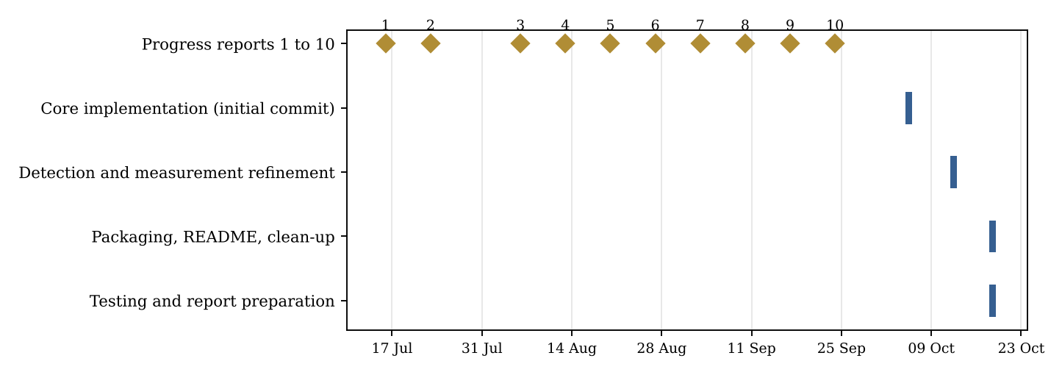
Figure 4.1: Gantt chart: progress-report schedule and actual implementation activity

Task / phase | Actual dates / deliverable evidence | Status
Requirement analysis and literature study | Weekly progress reports 1 to 10 (16 Jul to 24 Sep 2026); Chapters 2 and 3 | Complete
Design | Progress-report period; Chapter 5 | Complete
Core implementation | 05 Oct 2026 initial commit | Complete
Detection / measurement refinement | 12 Oct 2026 (nine commits) | Complete
Packaging and clean-up | 18 Oct 2026 (README, launcher removal) | Complete
Testing and report | 18 Oct 2026; Chapter 7 | Complete
Table 4.3: Activities and actual evidence

4.5 PERT chart / dependency diagram
The critical path follows the data flow of the system: Requirements, then Design, then the processing services (pre-processing, detection, measurement), then web routes and reports, then Testing, then Documentation. Persistence (MongoDB models) and report generation could proceed in parallel once the measurement output format was fixed; the user interface depended on the routes. Figure 5.5 shows the processing dependency at run time.

4.6 Roles and responsibilities
This is an individual project. PATEL MAN VISHNUBHAI carried out analysis, design, implementation, testing and documentation under the guidance of Dr. Srikant Singh.

4.7 Risk register and mitigation plan

Risk | Impact | Mitigation in this project
Textured pavement or stains produce false cracks | High | Adaptive threshold with offset 16; minimum area; aspect/PCA ratio filter; coherent-group filter; coverage limit (commits of 12 Oct 2026)
Non-crack images (text, faces, objects) accepted | High | validate_crack_image with component count, coverage and alignment tests; rejection of the whole batch with a message
Width distorted by junctions and blobs | Medium | Median of junction-excluded centreline samples for mean width; 95th percentile for maximum width
Wrong scale gives wrong millimetres | High | Positive-value validation; scale shown on the results page; limitation documented
MongoDB unavailable | Medium | Start-up ping with 1.5 s timeout; in-memory fallback store
Large or malicious uploads | Medium | 16 MB limit, 20 files, 8000 px limit, extension and decode checks, filename sanitising
Table 4.4: Risk register

4.8 Dataset preparation and ethical considerations
The system itself needs no training dataset. For testing, synthetic images were generated in code (Gaussian-noise background with polylines of known width, and negative images such as plain surface, round blob, text and texture only). No personal data, faces or private property images were collected for this report. Real photographs used in future evaluation should be taken with the owner's permission and stored without personal metadata.

Chapter 5 — System Design

5.1 Overall system architecture
The application follows a layered architecture (Figure 5.1). The presentation layer is a set of Jinja2 templates styled with Bootstrap 5 and a small JavaScript file (static/app.js) that handles file previews, upload submission and the image lightbox. Flask blueprints in routes/ form the application layer and contain only request handling. The image-processing logic lives in services/ and has no dependency on Flask, which allows it to be unit-tested directly. The data layer consists of model modules that talk to MongoDB (or an in-memory dictionary) and a storage/ folder that holds image files and reports; images are deliberately not stored in the database.
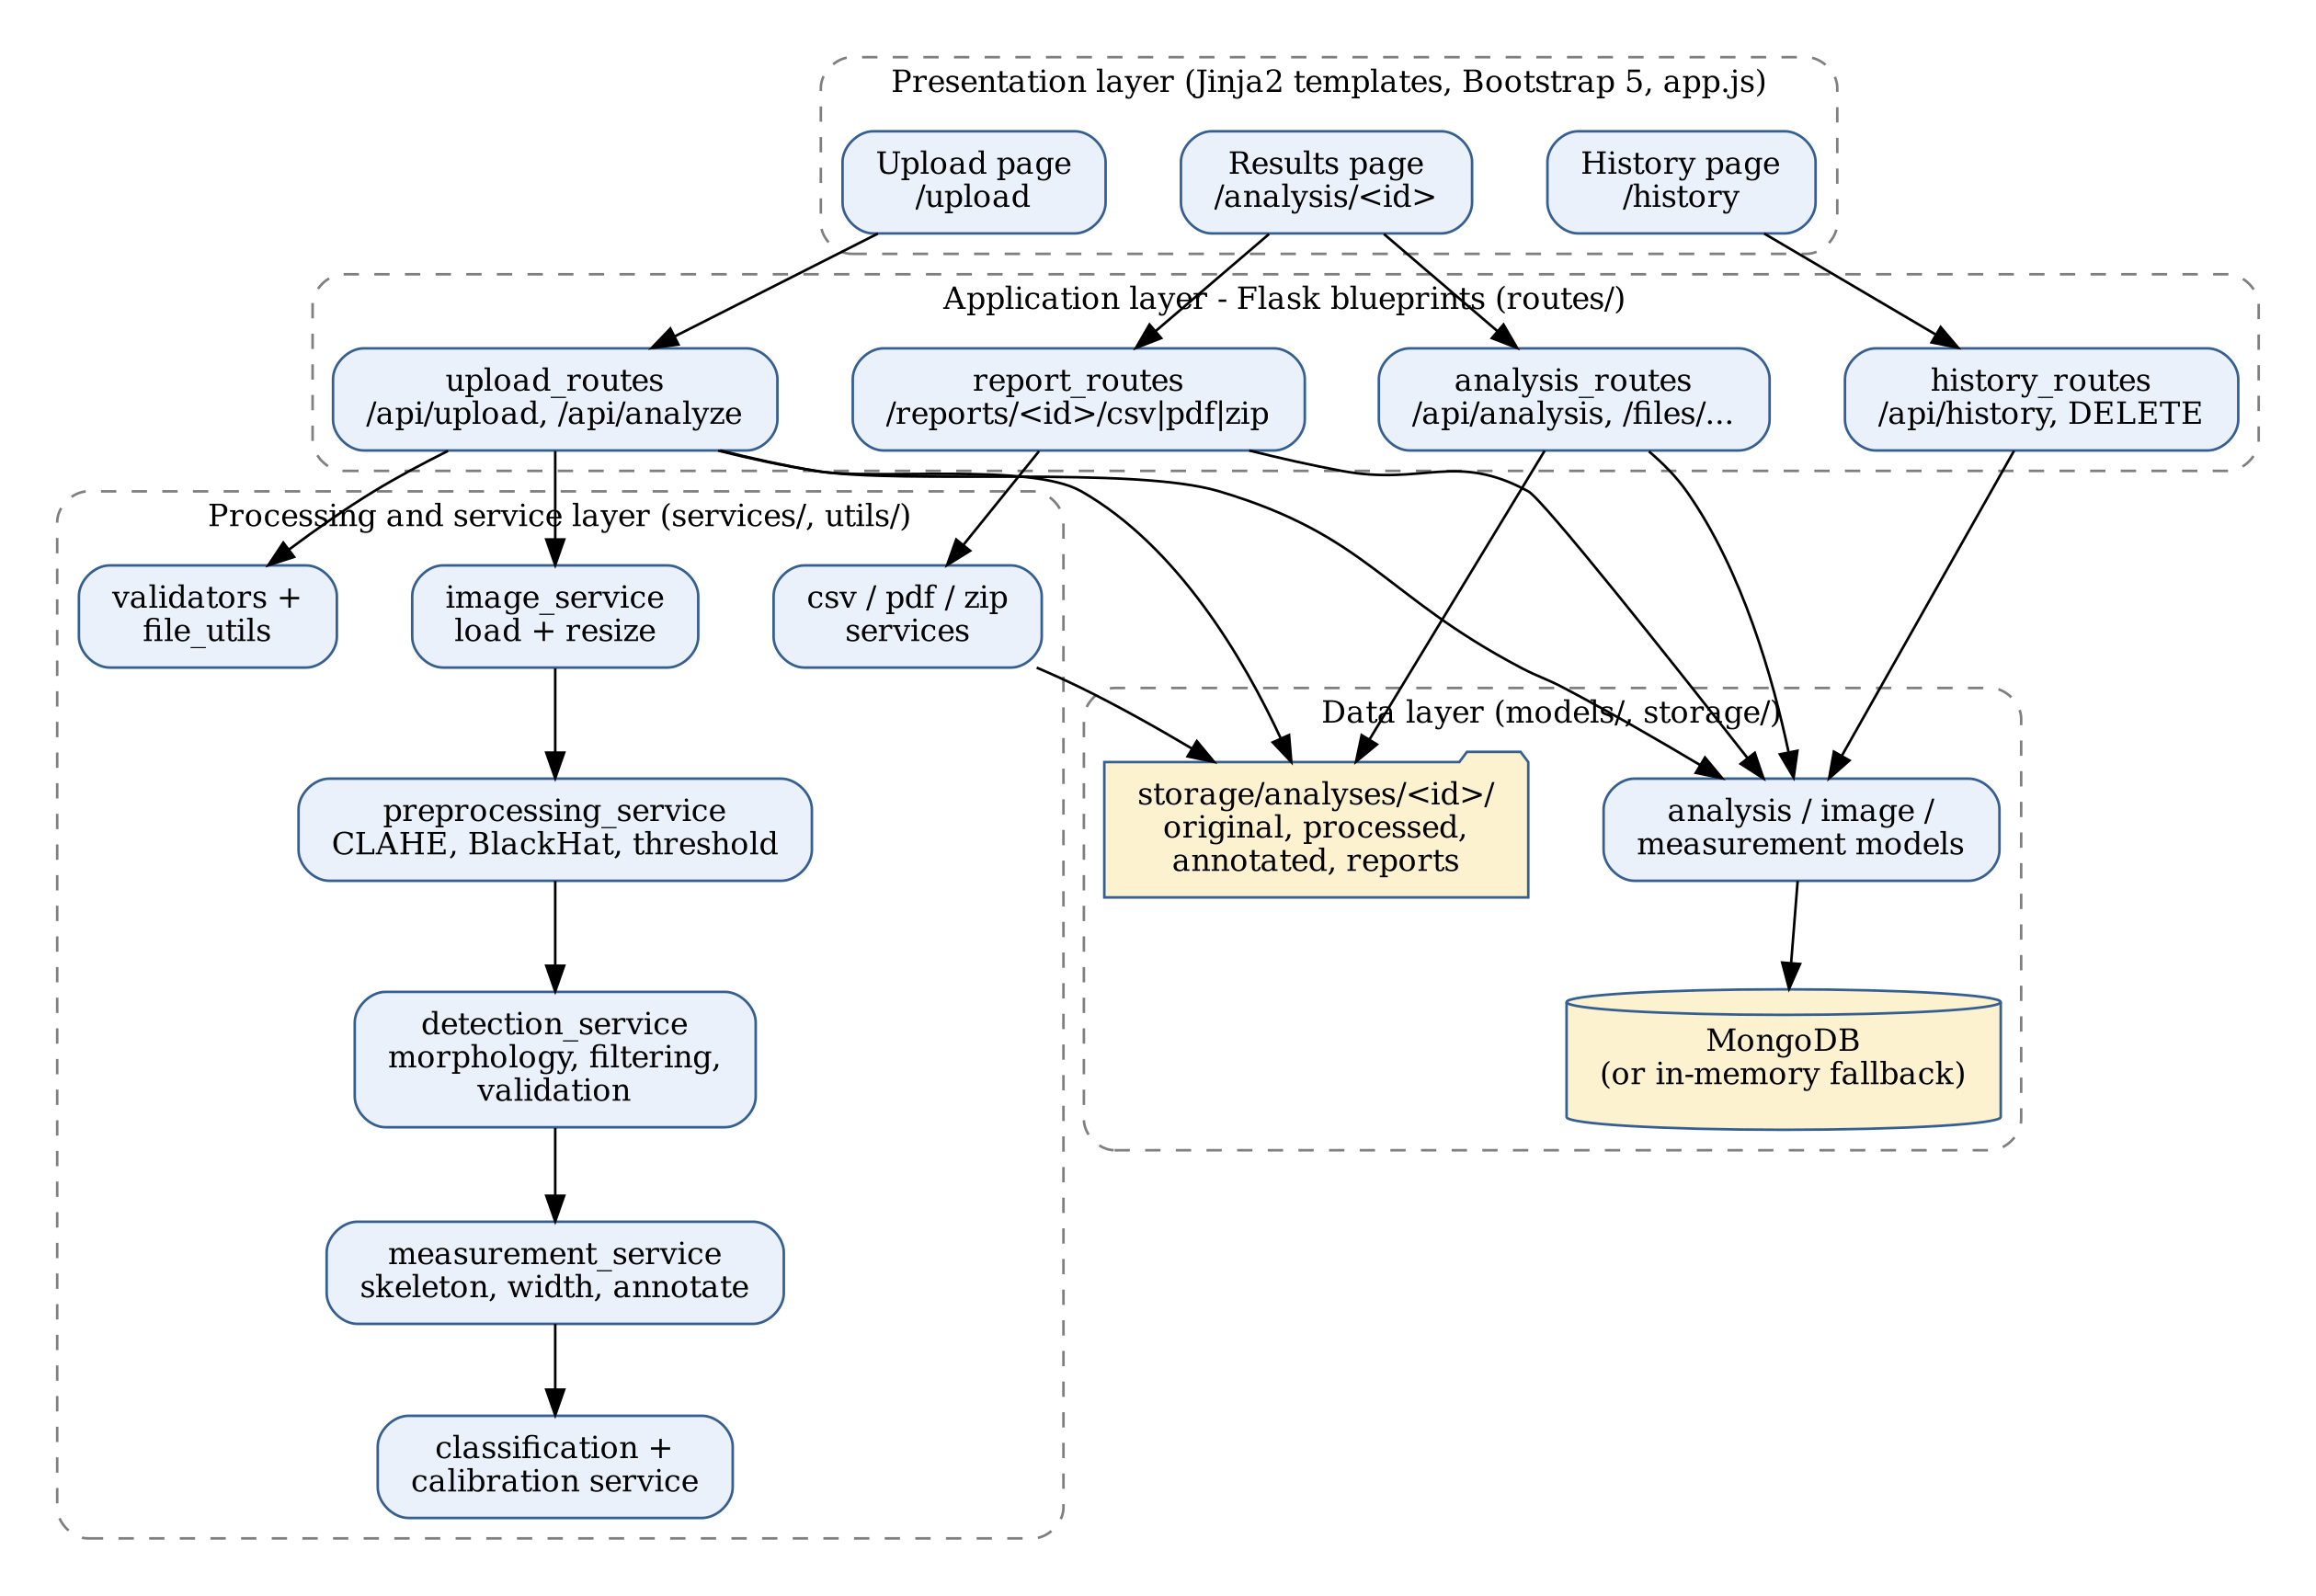
Figure 5.1: Layered architecture of the system

5.2 Module decomposition and responsibilities

Module | Responsibility
app.py, config.py | Application factory, blueprint registration, error handlers; configuration, limits and all processing parameters
routes/upload_routes.py | Upload page, /api/upload and /api/analyze; orchestrates validation, storage and processing per image
routes/analysis_routes.py | Results page, JSON API and protected file serving
routes/history_routes.py | History page, search API, delete API
routes/report_routes.py | On-demand CSV, PDF and ZIP generation and download
services/image_service.py | Image decoding, aspect-preserving resize, image writing
services/preprocessing_service.py | Grayscale, Gaussian blur, CLAHE, BlackHat, thresholding
services/detection_service.py | Morphology, connected components, crack filtering, image validation
services/measurement_service.py | Skeletonisation, length, width, diagnostic images, annotation
services/classification_service.py, calibration_service.py | Good / Medium / Heavy rule; pixel-to-millimetre conversion
services/csv_service.py, pdf_service.py, zip_service.py | Report generation (pandas, ReportLab, zipfile)
models/*.py | MongoDB access and in-memory fallback for analyses, images and measurements
utils/validators.py, file_utils.py | Upload validation, safe file names, path-containment check
Table 5.1: Modules and responsibilities

5.3 Data flow diagrams
Figure 5.2 is the context (level 0) diagram: the user supplies images and receives annotated results and reports, while the system reads and writes a persistent store. Figure 5.3 decomposes the system into six processes.
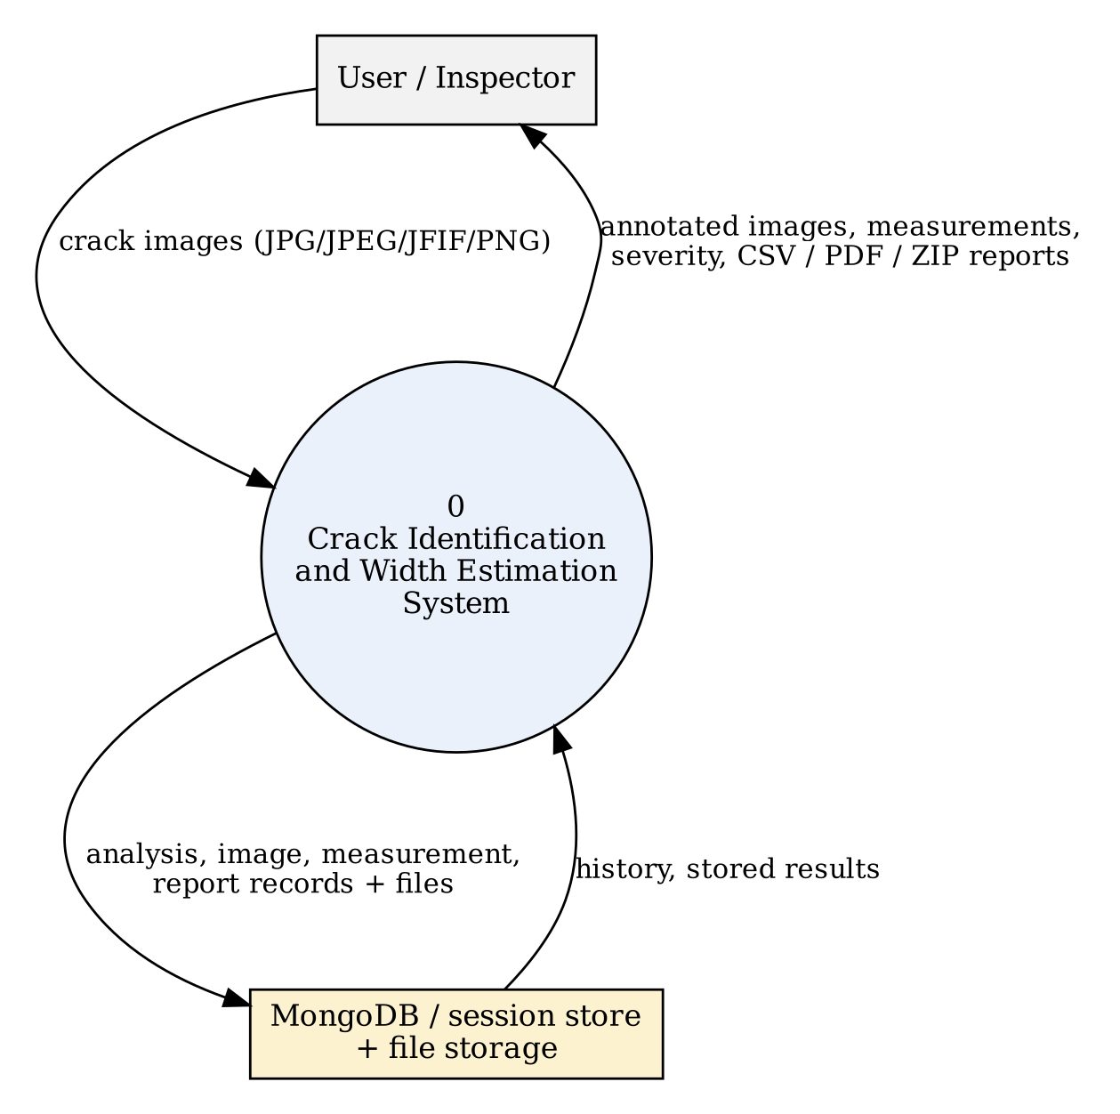
Figure 5.2: Context-level (Level 0) data flow diagram
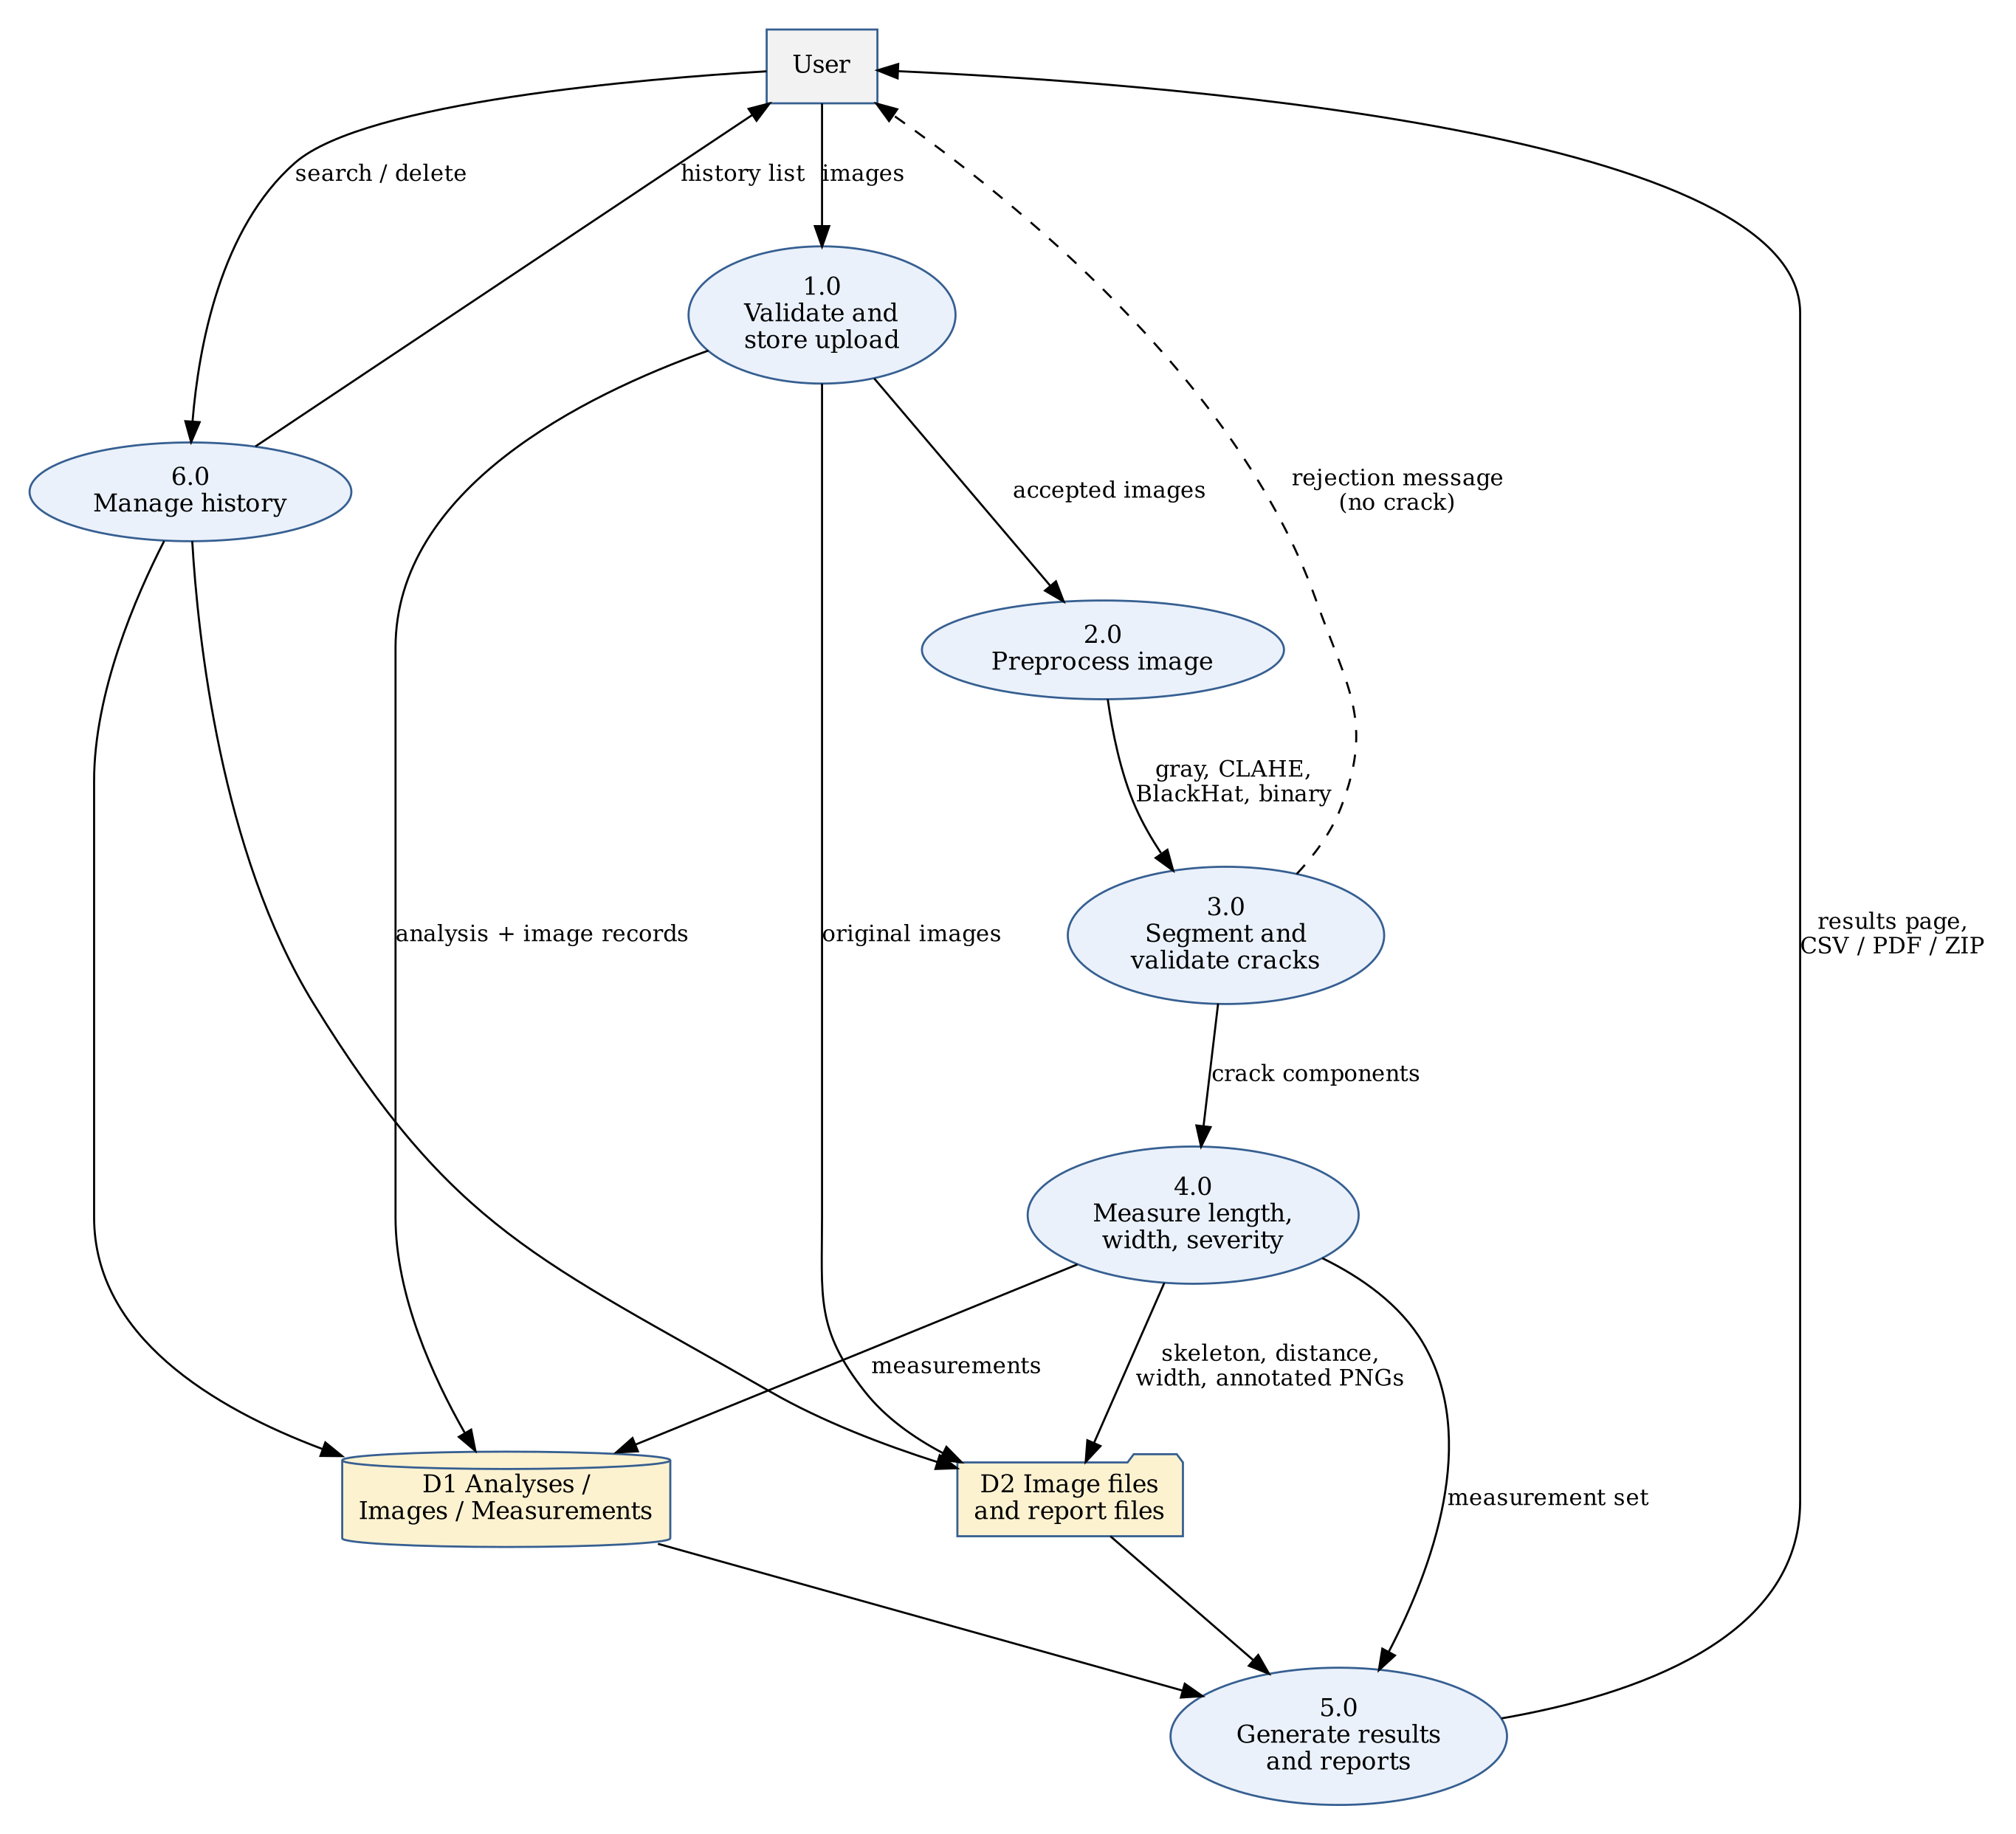
Figure 5.3: Level 1 data flow diagram

5.4 Use-case diagram and descriptions
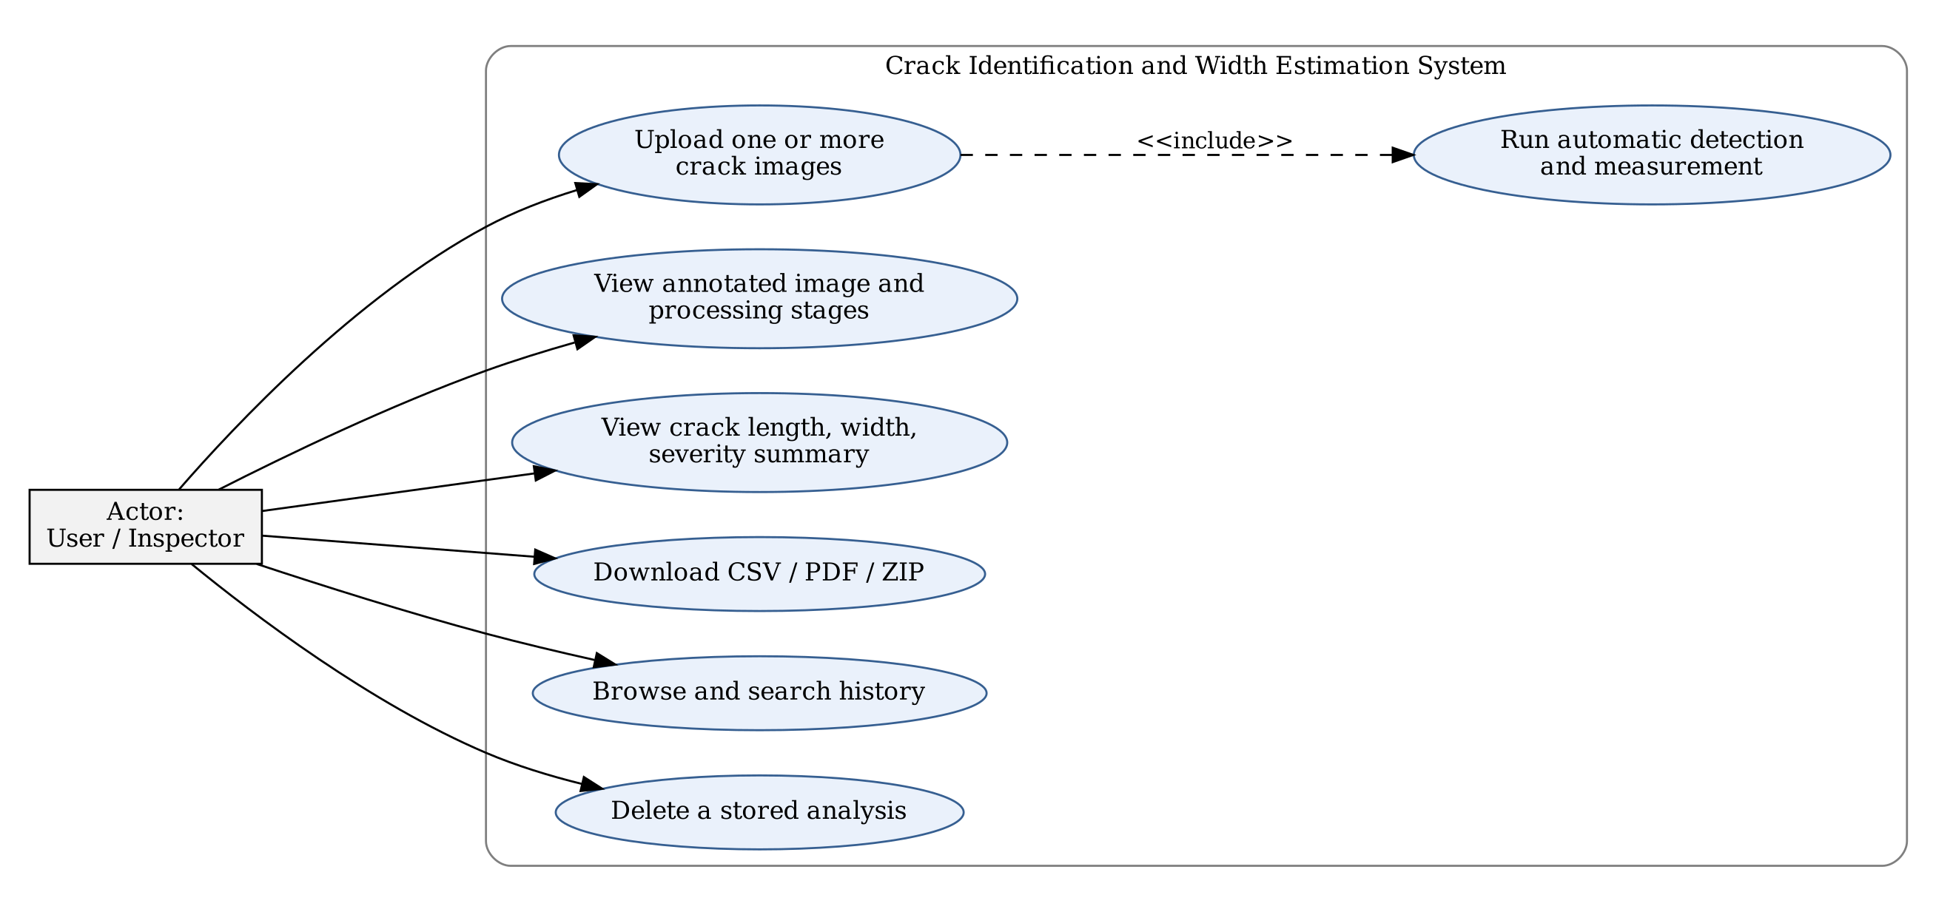
Figure 5.4: Use-case diagram
Table 5.2: Use-case descriptions
Use case | Description
Upload images | Precondition: browser open at /upload. The user selects 1 to 20 images; previews appear; submitting starts the analysis. Postcondition: the user is taken to the results page, or sees an error message.
View results | The user sees the summary (count, total length, average and maximum width, severity counts), remark, severity thresholds, per-image annotated results, stage images and the measurement table.
Download reports | The user chooses CSV, PDF or ZIP; the file is generated on demand.
Browse and delete history | The user lists earlier analyses, searches by name and may delete one, which removes database records and files.

5.5 Activity (process) diagram
Figure 5.5 shows the processing flow executed for each upload. If any image in a batch is rejected as containing no crack, or cannot be processed, the whole analysis (records and files) is removed and an error is returned; otherwise measurements are stored and the analysis is marked Completed.
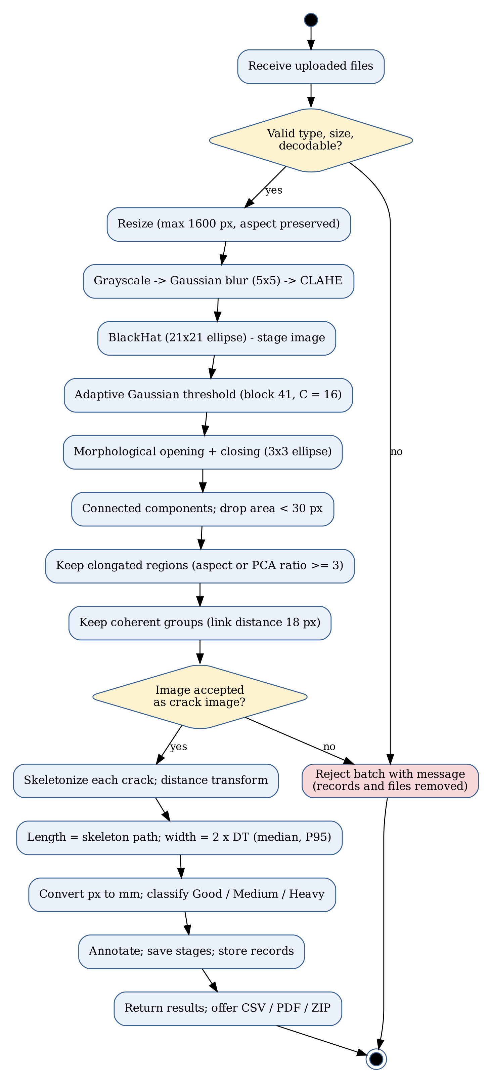
Figure 5.5: Processing workflow for an uploaded batch

5.6 Entity–relationship diagram
Three collections are used: analyses, images and crack_measurements. One analysis has many images and many measurements; each image has many measurements. A fourth index, report_history, is created at start-up but no code in the repository currently writes to it.
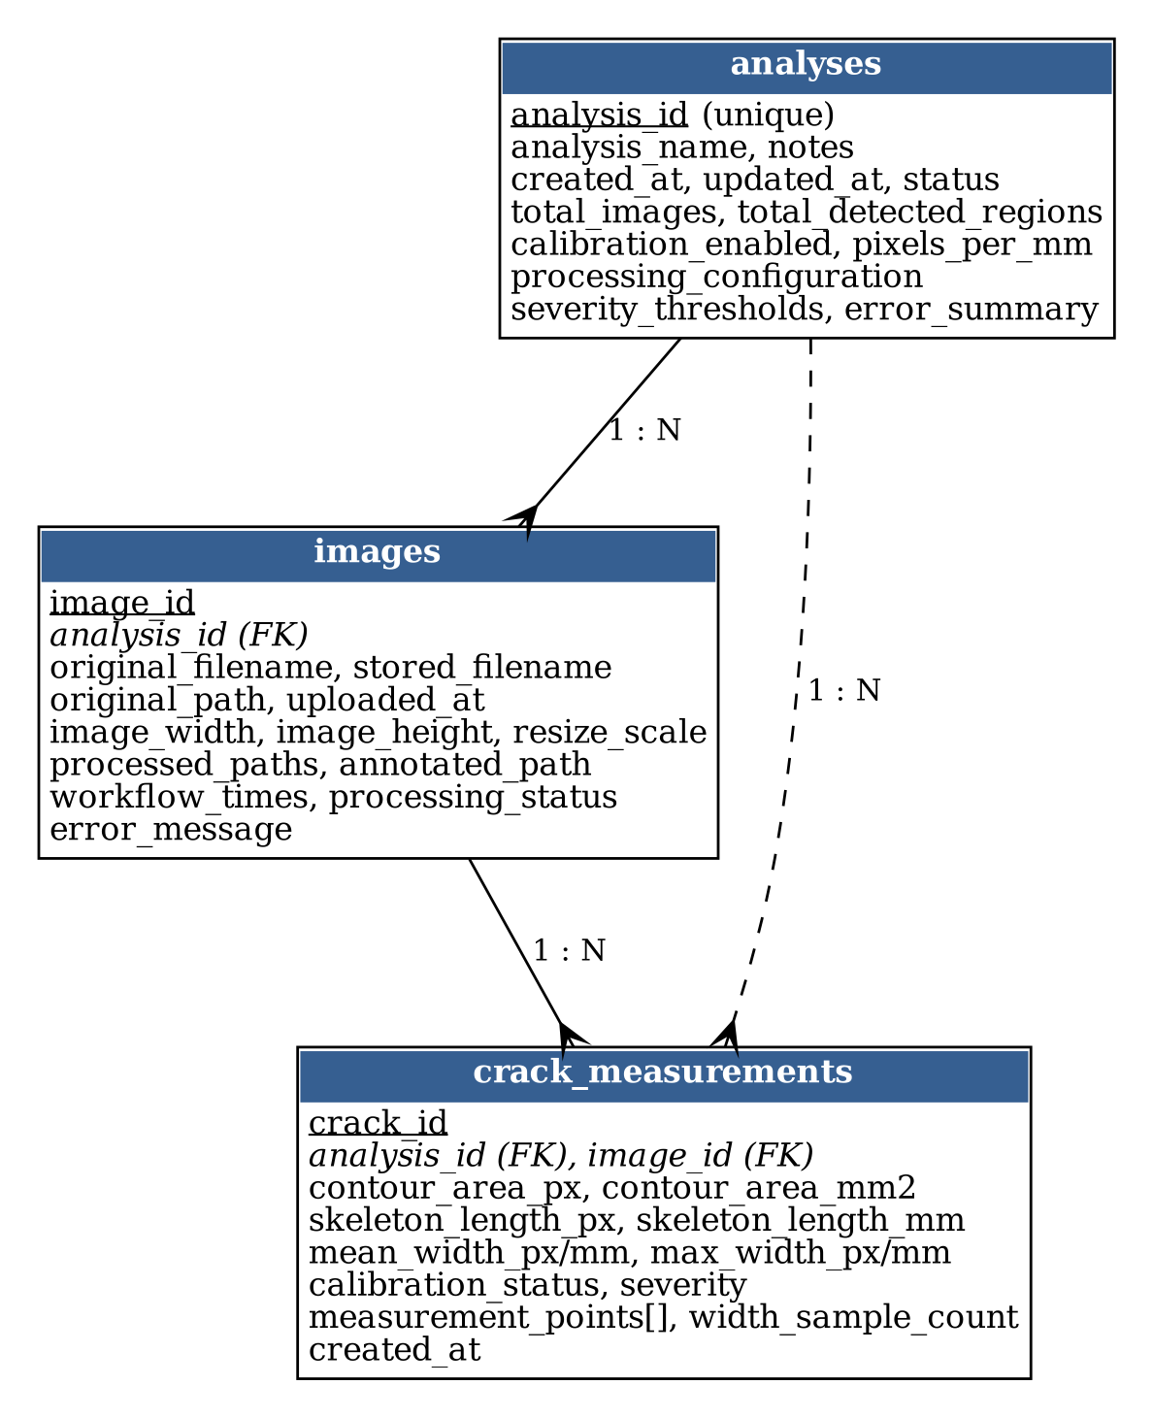
Figure 5.6: Logical data model (MongoDB collections and relationships)

5.7 Database schema
MongoDB is schema-less; the logical schema in Appendix C lists the fields written by the models. Indexes created at start-up are: unique index on analyses.analysis_id; compound index on images (analysis_id, uploaded_at desc); compound index on crack_measurements (analysis_id, image_id); and on report_history (analysis_id, generated_at desc). Identifiers are UUID hexadecimal strings; relationships are by analysis_id and image_id, not by database references.

5.8 Input and output design
Input is a drag-and-drop or file-picker area that accepts .jpg, .jpeg, .jfif and .png files, shows thumbnails with a Remove button and submits all files in one request. Output is the results page (Section 6.8) plus downloadable CSV (one row per crack with analysis-level summary columns), PDF and a ZIP package containing all original, processed and annotated images, the reports and a text manifest.

5.9 Algorithms and process logic
Pre-processing. The picture is first turned into grayscale and blurred with a 5 x 5 Gaussian filter. CLAHE (clip limit 2.0, 8 x 8 tiles) evens out local contrast. A BlackHat operation using a 21 x 21 elliptical element brings out thin dark lines and is stored as a viewing stage only. The binary mask itself comes from an inverted adaptive Gaussian threshold (neighbourhood 41 px, constant 16) on the grayscale image; if no adaptive block size is configured, the code instead thresholds the BlackHat image by percentile or Otsu.
Detection. The mask is opened and then closed with a 3 x 3 ellipse to remove specks and close single-pixel gaps, and components smaller than 30 px are discarded. A component passes as crack-like when its bounding rotated rectangle has an aspect ratio of at least 3, or when the ratio of the two largest singular values of its pixel coordinates (a PCA-style elongation measure) reaches 3. Passing components lying within 18 px of one another are merged into groups, and a group survives if its area is large enough compared with the largest group. Finally, the image is judged to contain a crack if the component count, the covered fraction (up to 8 percent) and the alignment of component centres stay within the configured limits, or if one dominant elongated component exists (a second rule that tolerates up to 15 percent coverage).
Measurement. Each component is thinned to a skeleton with scikit-image. Its length is obtained by adding 1 for every horizontal or vertical link between neighbouring skeleton pixels and the square root of 2 for every diagonal link. An OpenCV Euclidean distance transform (5 x 5 mask) gives the inscribed-circle radius at every pixel, so the local width on the centreline is twice that radius. Skeleton pixels with three or more skeleton neighbours (junctions) are left out; the median of the remaining samples is the mean width and their 95th percentile is the maximum width. About twenty evenly spaced samples per crack are also drawn on the annotated image, aligned with the local normal obtained from an SVD of neighbouring skeleton points.
Classification. A crack is labelled Heavy when its area reaches 5000 px² or its mean width is above 8 px, Medium when its mean width is above 3 px, and Good otherwise. The limits are in pixels and are saved with each analysis.

5.10 Security, privacy, validation and access-control design
Upload validation: allowed extensions, non-empty content, successful decode with OpenCV, and dimension limits (2 to 8000 px).
MAX_CONTENT_LENGTH (16 MB by default) and a 413 JSON error handler; at most 20 files per analysis.
File names are sanitised with safe_filename and prefixed with a UUID; served files must resolve inside the analysis folder (is_within).
Secrets (FLASK_SECRET_KEY, MONGO_URI) come from environment variables or .env, which is excluded from the repository by .gitignore.
The application binds to 127.0.0.1 and has no login; it is not designed for public deployment (see limitations).

5.11 Design decisions and trade-offs
Decision | Alternative | Reason / trade-off
Classical OpenCV pipeline | Deep-learning segmentation | No labelled data or GPU needed; every stage inspectable. Less robust on unseen textures.
Adaptive Gaussian threshold | Global Otsu on BlackHat | Handles uneven lighting and keeps thin lines; the offset must be tuned, although it had no visible effect on a high-contrast crack in the sensitivity tests (Section 8.8).
Median and P95 of centreline widths | Mean and maximum | Robust against junctions and end blobs; hides the single widest point.
Files on disk, metadata in MongoDB | GridFS or Base64 | Simpler and faster to serve images; backup must cover both.
In-memory fallback store | Fail if MongoDB missing | Easier to try and test; data are lost when the process ends.
Reject the whole batch if one image has no crack | Skip that image | Keeps results consistent with the "crack images only" rule; one bad file discards a batch.
Table 5.3: Design decisions and trade-offs

5.12 Worked numerical example of the width measurement
To make the measurement stage concrete, a perfect rectangular bar 20 pixels long and 5 pixels wide was passed through the same OpenCV distance transform and scikit-image skeletonisation that the application uses. Table 5.4 shows the distance-transform values across the bar (rows 4 to 8 of a 13 x 24 mask; every other row is zero). The values rise from 1 at the border to 3 at the centre line, and the centre row is the skeleton.

Row | c2 | c4 | c6 | c8 | c10 | c12 | c14 | c16 | c18 | c20
row 4 | 1 | 1 | 1 | 1 | 1 | 1 | 1 | 1 | 1 | 1
row 5 | 1 | 2 | 2 | 2 | 2 | 2 | 2 | 2 | 2 | 2
row 6 | 1 | 3 | 3 | 3 | 3 | 3 | 3 | 3 | 3 | 2
row 7 | 1 | 2 | 2 | 2 | 2 | 2 | 2 | 2 | 2 | 2
row 8 | 1 | 1 | 1 | 1 | 1 | 1 | 1 | 1 | 1 | 1
Table 5.4: Distance-transform values for a 5 px wide, 20 px long bar (every second column shown)

At the centre row the distance value is 3.0, so the radius of the largest inscribed circle is 3 and the width reported is 2 x 3.0 = 6.0 px, one pixel more than the true width of 5 px. This one-pixel offset is a property of the distance-transform convention (the distance is measured to the nearest background pixel, not to the pixel edge). The skeleton of this bar has length 16.414 px (the bar is 20 px long, and thinning shortens each end by a few pixels); with the default scale of 10 px/mm the mean width is 0.6 mm, and the crack is classified Medium. The same bar gives a contour area of 100 px² and 15 centre-line width samples.

Quantity | Value for the 5 x 20 px bar
Area (px²) | 100
Skeleton length (px) | 16.414
Mean width, median of samples (px) | 6.0
Maximum width, 95th percentile (px) | 6.0
Mean width (mm at 10 px/mm) | 0.6
Severity | Medium
Width samples | 15
Table 5.5: Measurement output for the worked example

5.13 Pseudo-code of the main algorithms
The algorithms are given in language-neutral pseudo-code. They correspond to the functions described in Section 5.15 and to the source code shown in Chapter 6.
Algorithm 1 — Pre-processing
ALGORITHM 1 Pre-processing (image, config)
gray <- convert image to grayscale
blurred <- GaussianBlur(gray, k x k)
enhanced <- CLAHE(blurred, clipLimit, tileGrid)
blackhat <- Morphology(enhanced, BLACKHAT, ellipse(21)) # visual stage
IF adaptive block size is configured THEN
binary <- AdaptiveThreshold(gray, GAUSSIAN, INVERTED, block, C)
ELSE IF percentile configured THEN binary <- blackhat >= percentile
ELSE binary <- Otsu(blackhat)
RETURN gray, blurred, enhanced, blackhat, binary

Algorithm 2 — Component extraction
ALGORITHM 2 Component extraction (binary, config)
cleaned <- CLOSE(OPEN(binary, ellipse(3)), ellipse(3))
labels, stats <- ConnectedComponents(cleaned, 8-connectivity)
FOR each label with area >= minimum_region_area
mask <- pixels of that label
contour <- largest external contour of mask
store {label, area, mask, contour}
RETURN cleaned, union of kept masks, component list

Algorithm 3 — Crack-likeness filter and grouping
ALGORITHM 3 Crack-likeness filter (components, config)
FOR each component
aspect <- longer / shorter side of minimum-area rectangle
ratio <- first / second singular value of the pixel coordinates
IF aspect >= 3 OR ratio >= 3 THEN keep component
groups <- cluster kept components whose bounding boxes are
within 18 px of each other (transitive closure)
keep groups whose area >= 80 px AND
(area >= 8% of the largest group OR (>= 2 components AND area >= 160))
IF none kept THEN keep the largest group
RETURN components of kept groups

Algorithm 4 — Crack-image validation
ALGORITHM 4 Image validation (components, image_shape, config)
IF components is empty THEN RETURN false
coverage <- total component area / image area
alignment <- first / second singular value of component centres
IF count <= 60 AND coverage <= 0.08 AND
(count <= 8 OR alignment >= 3) THEN RETURN true
dominant <- component with the largest area
RETURN dominant.area/image_area >= 0.003 AND dominant.aspect >= 2.4
AND coverage <= 0.15

Algorithm 5 — Crack measurement
ALGORITHM 5 Measurement (component, pixels_per_mm, thresholds)
skeleton <- Skeletonize(component.mask)
dist <- DistanceTransform(component.mask, L2, 5x5)
samples <- skeleton pixels with fewer than 3 skeleton neighbours
widths <- 2 * dist[p] for p in samples
mean_w <- median(widths); max_w <- percentile(widths, 95)
length <- sum over neighbour links: 1 (axis) or sqrt(2) (diagonal)
convert to mm if pixels_per_mm is available
severity <- Classify(area, mean_w, thresholds)
pick about 20 evenly spaced samples; angle <- normal to local tangent (SVD)
RETURN measurements and diagnostic images

Algorithm 6 — Severity classification
ALGORITHM 6 Classification (area, mean_width, thresholds)
IF area >= heavy_min_area OR mean_width > medium_max_width THEN "Heavy"
ELSE IF mean_width > good_max_width THEN "Medium"
ELSE "Good"

5.14 Complexity and performance considerations
Pre-processing is linear in the number of pixels (a few image-wide passes). Connected-component labelling is linear in pixels. Filtering is linear in the number of components, except the grouping step, which compares components pairwise and is quadratic in the number of retained components (limited in practice by the area filter). Measurement is the most expensive step: for every skeleton pixel the code searches the skeleton-point array for neighbours, so the cost grows roughly with the square of the skeleton length. This agrees with the timing results in Section 8.8, where measurement took about 0.057 s of a 0.095 s total on a 1024 x 768 image. If very long skeletons ever become a problem, replacing the array search with a neighbour lookup in a set would reduce the cost to linear.

5.15 Function reference
Function | File | Purpose
create_app(config_class) | app.py | Builds the Flask app, storage folders, database and blueprints
init_db(app) | models/database.py | Connects to MongoDB (1.5 s timeout), creates indexes, or enables fallback
get_db(), get_fallback_store() | models/database.py | Return the live handle or the in-memory dictionaries
create_analysis, get_analysis, update_analysis, list_analyses, delete_analysis_records | models/analysis_model.py | CRUD for analyses; delete cascades to images, measurements and reports
create_image, list_images, update_image | models/image_model.py | Per-image records and status updates
create_measurements, list_measurements, update_measurement_calibration | models/measurement_model.py | Per-crack records; recalibration helper (not called by any route)
load_and_resize(path, max_dimension) | services/image_service.py | Decode and downscale preserving aspect ratio; returns image and scale
write_image(path, image) | services/image_service.py | Create folder and write PNG; raise on failure
preprocess(image, config) | services/preprocessing_service.py | Algorithm 1
detect_components(binary, config) | services/detection_service.py | Algorithm 2
filter_crack_components(components, config) | services/detection_service.py | Algorithm 3 (with _select_coherent_path, _component_gap)
validate_crack_image(components, shape, config) | services/detection_service.py | Algorithm 4 (with _component_alignment_ratio)
measure_component(component, ppm, thresholds) | services/measurement_service.py | Algorithm 5 (with _skeleton_length, _robust_widths)
annotate(image, components, measurements) | services/measurement_service.py | Draw contours, labels C1.. and width sample lines
classify, threshold_description | services/classification_service.py | Algorithm 6 and a text description of the limits
validate_pixels_per_mm, convert_pixels | services/calibration_service.py | Positive-number check and px to mm conversion
analysis_dir, remove_analysis | services/storage_service.py | Create or delete storage/analyses/<id>
create_csv | services/csv_service.py | One row per crack plus analysis summary columns (pandas)
create_pdf | services/pdf_service.py | ReportLab A4 report with tables, images and footer
create_manifest, create_zip | services/zip_service.py | Text manifest and ZIP of all analysis files and reports
validate_upload(file, config) | utils/validators.py | Extension, empty, decodable and size checks
safe_filename, is_within | utils/file_utils.py | Sanitise names; ensure a path stays inside a base folder
upload, analyze | routes/upload_routes.py | HTTP entry points for upload and processing
analysis_page, analysis_api, file_route, processed_file_route | routes/analysis_routes.py | Results page, JSON API and image serving
history, history_api, delete | routes/history_routes.py | History page, search and delete
reports, build_report, download_report | routes/report_routes.py | Report page and on-demand report generation
Table 5.6: Function reference

5.16 Analysis life-cycle and status values
An analysis moves through the states Uploaded (records created and originals saved), Processing (set at the start of _process_analysis) and Completed (set after measurements are stored). Each image has its own status: Uploaded, Completed or Failed. When any image is rejected or fails, the analysis is not marked Failed; instead all of its records and files are deleted and an error is returned to the user, so no partial analysis ever appears in the history. This keeps the history clean but means that a failed batch cannot be inspected afterwards, which is noted as a limitation.

5.17 User-interface design notes
- A fixed top navigation bar carries the application name; the upload page is the landing page.
- The upload form previews every selected image with a Remove button; the submit button triggers an asynchronous request, and the status area reports success or the server's error message.
- The results page orders information from summary to detail: summary card, remark, download buttons, severity thresholds, then one card per image with original, annotated and mask images, a grid of every processing stage, and finally the measurement table.
- Every image can be opened in a lightbox with zoom in, zoom out and reset controls and keyboard and wheel support (static/app.js).
- Colour is used for severity badges (green, amber, red) together with text labels, so the meaning does not depend on colour alone.

Chapter 6 — Implementation

6.1 Development environment and tool versions
The code targets Python 3.10 or later and the libraries in requirements.txt. The tests, experiments and screenshots in this report were produced in a Linux container with Python 3.13.16, OpenCV 5.0.0.93, NumPy 2.5.3, scikit-image 0.26.0, pandas 3.0.5, ReportLab 5.0.1 and Flask 3.1.3. The repository is hosted at https://github.com/ManPatel448/OpenCV-Based-System-for-Crack-Identification-and-Width-Estimation.git

6.2 Project folder structure and configuration
app.py Flask application factory and entry point
config.py Limits and PROCESSING parameters
requirements.txt Python dependencies
.env.example MONGO_URI, MONGO_DB_NAME, FLASK_SECRET_KEY, ...
models/ database.py, analysis_model.py, image_model.py, measurement_model.py
routes/ upload_routes.py, analysis_routes.py, history_routes.py, report_routes.py
services/ image, preprocessing, detection, measurement, classification,
calibration, storage, csv, pdf, zip services
utils/ validators.py, file_utils.py
templates/ base, upload, results, history, reports, analysis_not_found
static/ app.css, app.js
storage/ runtime output (analyses/<id>/original_images, processed_images,
annotated_images, reports)
tests/ test_app.py, test_processing.py
Repository layout
All tunable values are in config.py. The main processing parameters are listed in Table 6.1.
Parameter | Value | Purpose
resize_max_dimension | 1600 | Longest image side after resize
gaussian_kernel | 5 | Blur kernel size
clahe_clip_limit / clahe_tile_grid | 2.0 / 8 | Local contrast enhancement
blackhat_kernel | 21 | Elliptical structuring element for BlackHat
adaptive_threshold_block_size / offset | 41 / 16 | Adaptive Gaussian threshold
morphology_kernel / iterations | 3 / 1 | Opening and closing
minimum_region_area | 30 px | Smallest kept component
minimum_crack_aspect_ratio | 3.0 | Elongation test
crack_link_distance_px | 18 | Grouping distance for components
maximum_crack_components / coverage | 60 / 8 % | Validation limits
maximum_dispersed_components | 8 | Components allowed without alignment
minimum_crack_path_alignment | 3.0 | Alignment ratio of component centres
dominant crack: area ratio / aspect / coverage | 0.003 / 2.4 / 15 % | Dominant-crack acceptance rule
severity thresholds | Good ≤ 3 px; Medium ≤ 8 px; Heavy > 8 px or ≥ 5000 px² | Classification
DEFAULT_PIXELS_PER_MM | 10.0 | Calibration

6.3 Module-wise implementation

Module | Inputs | Processing | Outputs
Upload route | Multipart files | Validate; save originals; create analysis and image records; loop over images | JSON with analysis id, or error 400 / 422
Image service | Image path | Decode as colour; scale down if larger than 1600 px | BGR array, scale factor
Pre-processing | BGR image | Grayscale, blur, CLAHE, BlackHat, adaptive threshold | Dictionary of five stage images
Detection | Binary mask | Morphology, components, shape and group filters, validation | Cleaned mask, component list, accept flag
Measurement | Component | Skeleton, distance transform, robust width, severity | Measurement dict and three diagnostic images
Reports | Analysis, images, measurements | pandas to CSV; ReportLab PDF; zipfile | CSV, PDF, ZIP files
Table 6.2: Module-wise inputs, processing and outputs

6.4 Important algorithms and code excerpts
Two short excerpts from the repository illustrate the core of the method; the remaining logic is described in Section 5.9.
Excerpt 1 shows the elongation test that rejects round blobs and generic texture.
Excerpt 1 — services/detection_service.py, filter_crack_components (abridged)
_, (width, height), _ = cv2.minAreaRect(component["contour"])
aspect_ratio = max(width, height) / max(min(width, height), 1.0)
points = np.argwhere(component["mask"] > 0)
_, sv, _ = np.linalg.svd(points - points.mean(axis=0), full_matrices=False)
principal_ratio = float(sv[0] / max(sv[1], 1e-6))
if aspect_ratio >= minimum_aspect or principal_ratio >= minimum_aspect:
crack_components.append(component)

Excerpt 2 shows how width is derived from the skeleton and the distance transform, and how the robust statistics are taken.
Excerpt 2 — services/measurement_service.py, measure_component (abridged)
skeleton = skeletonize(mask)
distance = cv2.distanceTransform(component["mask"], cv2.DIST_L2, 5)
widths = _robust_widths(distance, np.argwhere(skeleton)) # 2 * distance, junctions skipped
mean_width = float(np.median(widths))
max_width = float(np.percentile(widths, 95))
length = _skeleton_length(skeleton) # 1 or sqrt(2) per neighbour link

6.5 Database implementation
models/database.py creates a PyMongo client with a 1.5 s server-selection timeout and pings the server. On success it stores the database handle and creates the indexes listed in Section 5.7; on any exception it sets mongo_available to false and leaves the handle empty. Every model function checks the handle and, if it is empty, reads or writes a dictionary kept in the Flask application extensions. Appendix C lists the fields of each collection and a sample CSV row.

6.6 API and external-service integration

Method and path | Purpose
GET /upload | Upload page
POST /api/upload, POST /api/analyze | Upload and analyse; JSON result (ok, analysis_id, ...) or error
GET /analysis/<id> | Results page (404 page if unknown)
GET /api/analysis/<id> | Analysis, images and measurements as JSON
GET /files/<id>/<image>/original | annotated | Original or annotated image
GET /files/<id>/<image>/processed/<stage> | A processing-stage image
GET /history, GET /api/history?q= | History page; JSON search by analysis name
DELETE /api/analysis/<id> | Delete records and files
GET /reports/<id>/csv | pdf | zip | Generate and download a report
Table 6.3: HTTP interface
The only external services are the optional MongoDB server and the Bootstrap stylesheet, which is loaded from a CDN.

6.7 Validation and error handling
validate_upload checks the extension, reads the file to confirm it is non-empty and decodable, and checks dimensions. _validate_files rejects an empty selection or more than 20 files. Errors are returned as JSON with status 400 (invalid input), 413 (too large) or 422 (no crack found or processing error). During processing, an exception for one image marks it Failed, and the batch is then removed and reported; an unknown analysis id gives a 404 page.

6.8 Screenshots of working features
Figure 6.1 shows the main processing stages for the synthetic image used in the accuracy experiment; the other screenshots below were captured from the running application in the test environment, using synthetic crack images. Because the sandbox could not reach the Bootstrap CDN, the page was rendered with a small local stand-in stylesheet for Bootstrap's grid, card and button classes; page content, data and layout logic are the application's own.
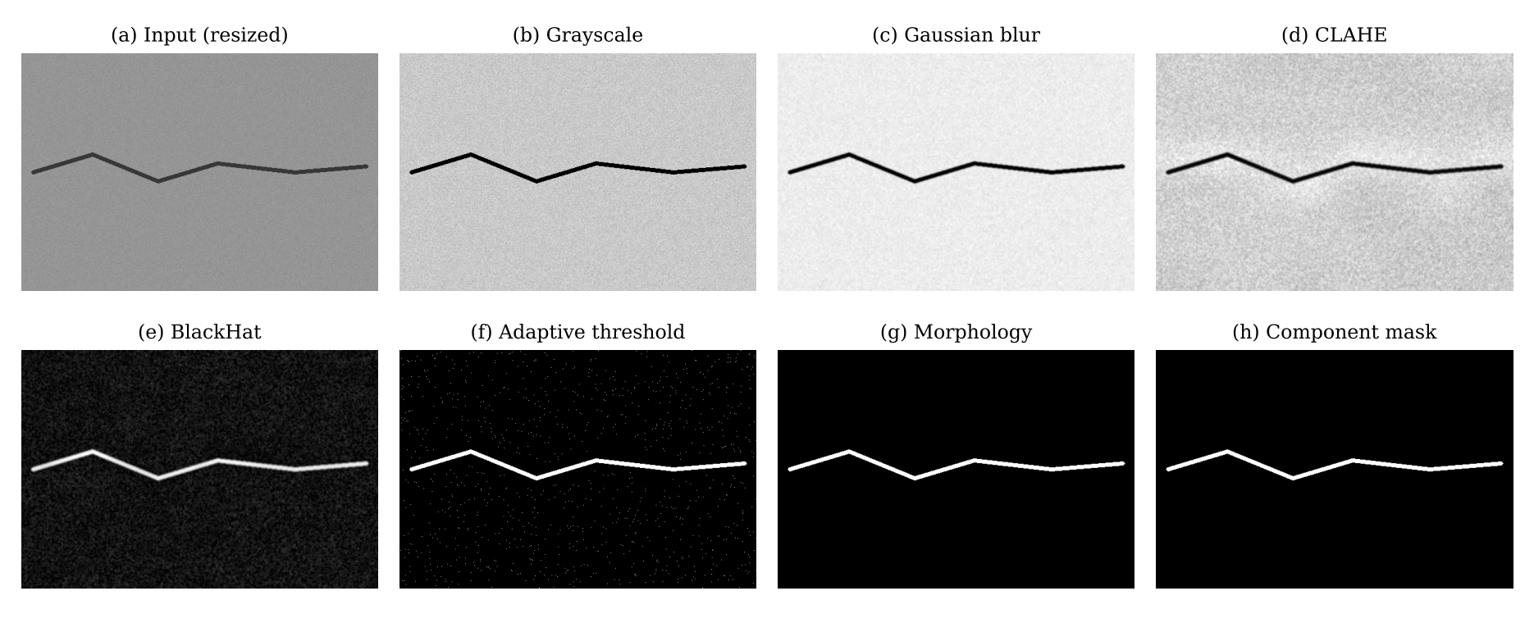
Figure 6.1: Processing stages for a synthetic crack (drawn width 6 px)
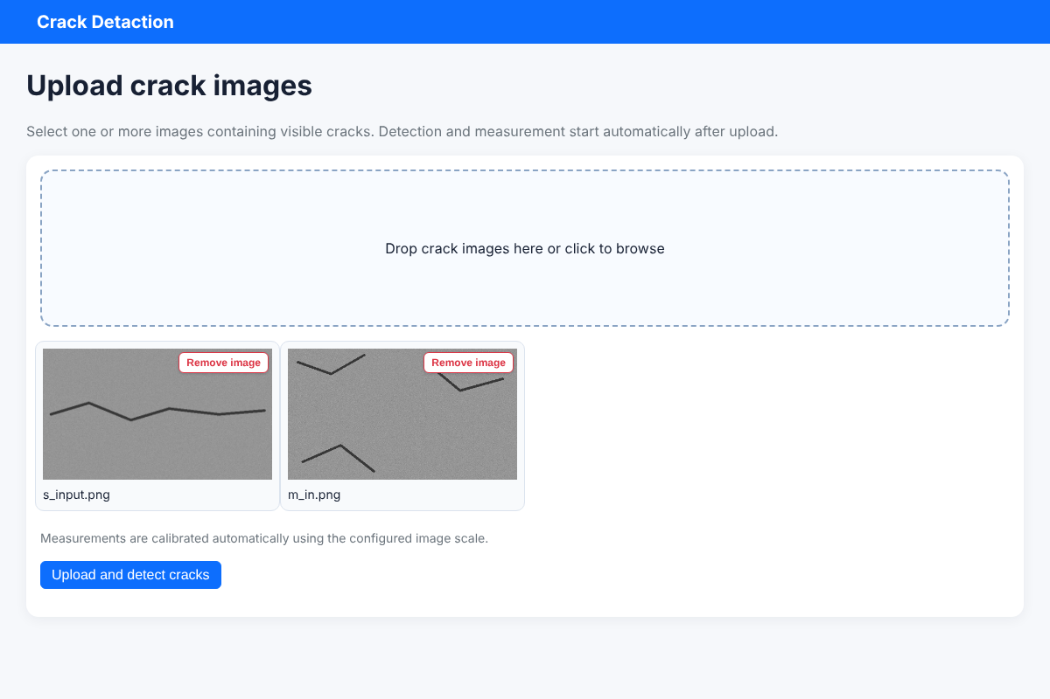
Figure 6.2: Upload page with two selected images
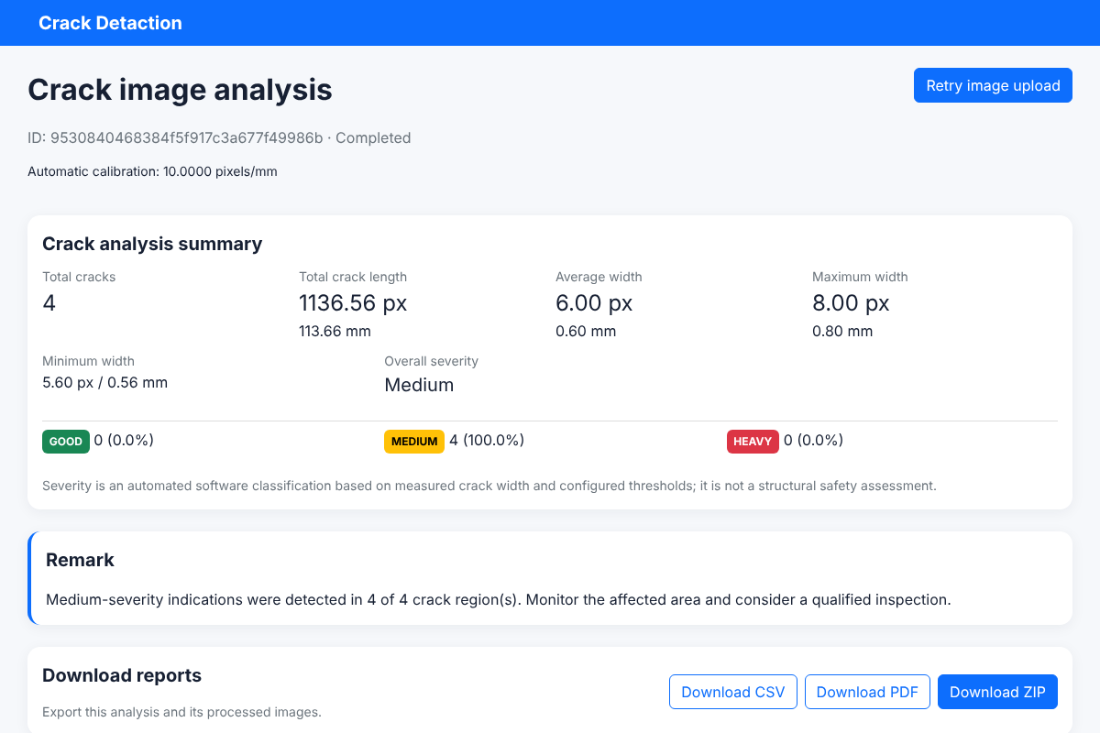
Figure 6.3: Results page: summary, remark and downloads
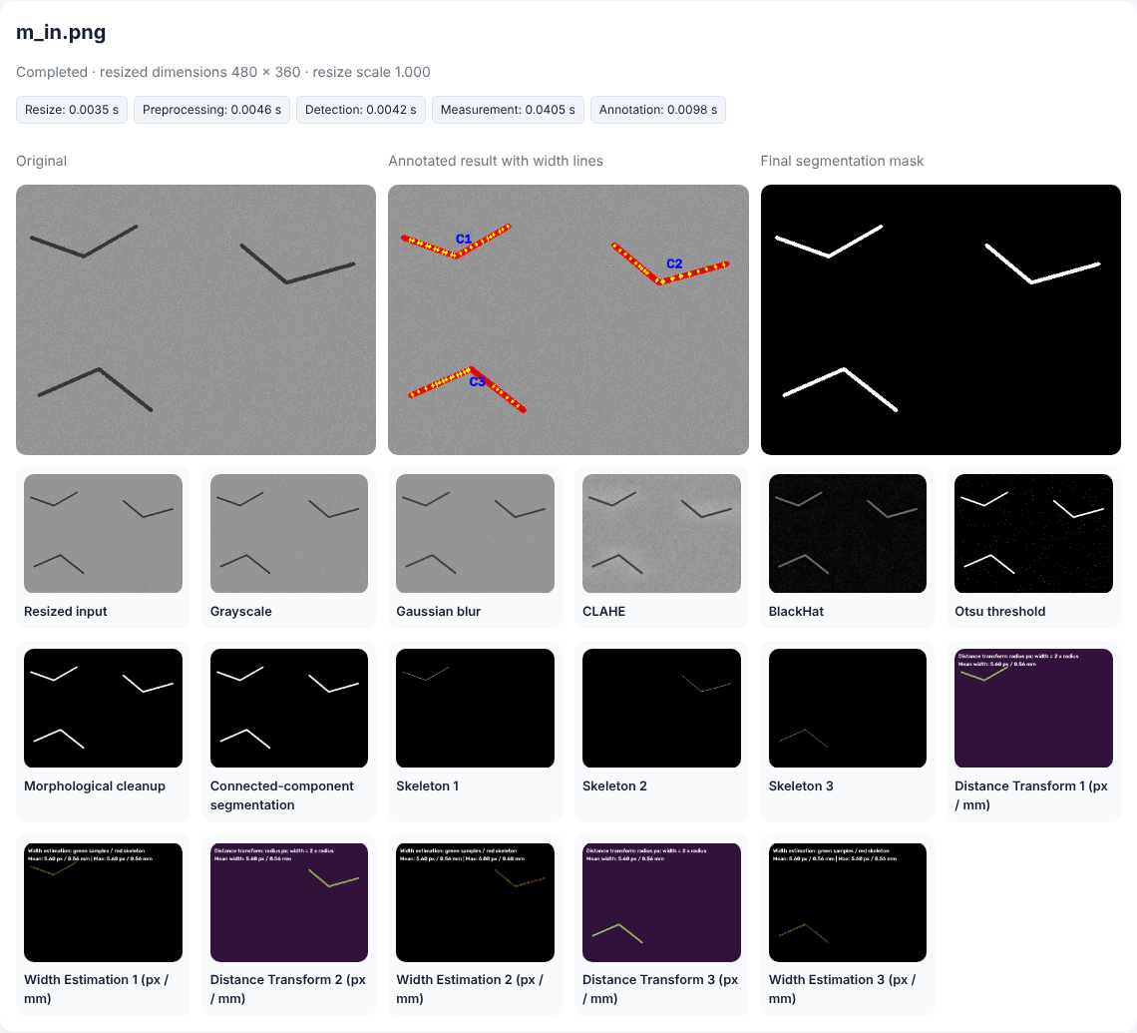
Figure 6.4: Per-image results: original, annotated, mask and every processing stage
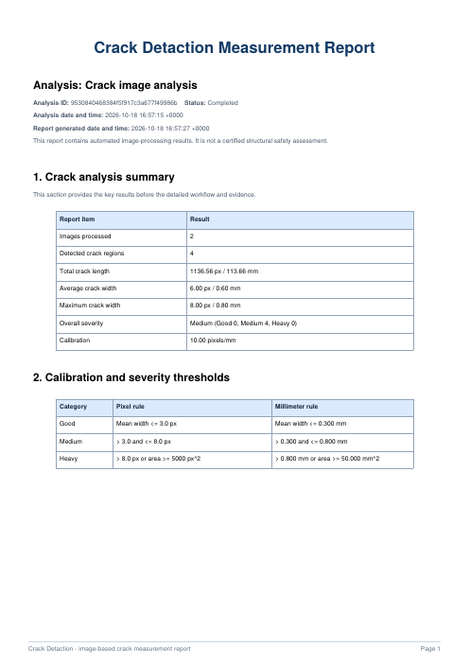
Figure 6.5: First page of the generated PDF report

6.9 Build, run and deployment instructions
- Install Python 3.10 or later; optionally install MongoDB Community Server or create an Atlas cluster.
- Clone the repository and create a virtual environment: python -m venv .venv and activate it.
- Install dependencies: pip install -r requirements.txt.
- Copy .env.example to .env and set MONGO_URI, MONGO_DB_NAME and FLASK_SECRET_KEY.
- Start the server: python app.py; open http://127.0.0.1:5000. Set FLASK_AUTO_RELOAD=0 to disable auto-restart.
- Run the tests with pytest -q.

6.10 Project file structure
Figure 6.6 is a rendering of the repository's folder tree, as listed from the cloned repository (generated folders such as __pycache__ and the runtime contents of storage/ are omitted). The layout separates routes, services, models, utilities, templates and tests, matching the layered architecture in Chapter 5.
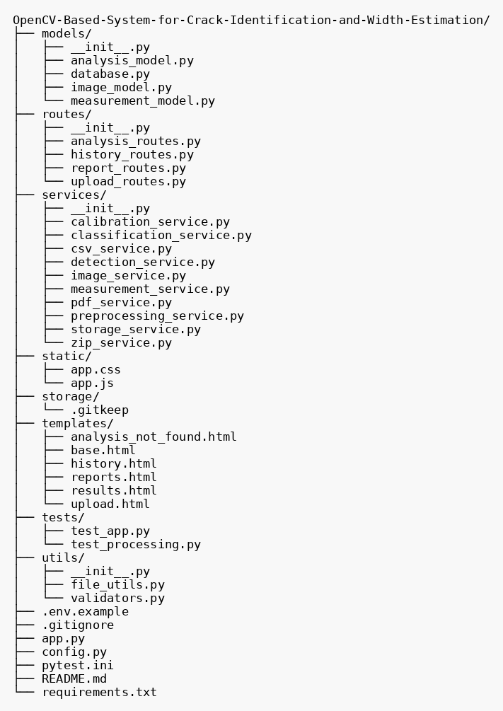
Figure 6.6: File and folder structure of the project

Folder / file | Contents | Lines of code
models/ | database.py (31), analysis_model.py (56), image_model.py (28), measurement_model.py (43) | 158
routes/ | upload_routes.py (169), analysis_routes.py (98), history_routes.py (29), report_routes.py (48) | 344
services/ | preprocessing (33), detection (130), measurement (164), classification (16), calibration (10), image (20), storage (15), csv (57), pdf (291), zip (50) | 786
utils/ | validators.py (22), file_utils.py (15) | 37
templates/ | base, upload, results, history, reports, analysis_not_found (HTML) | 59
static/ | app.js (113), app.css (32) | 145
tests/ | test_app.py (67), test_processing.py (193) | 260
top level | app.py (54), config.py (48), requirements.txt (10), pytest.ini (3), .env.example (5), README.md (60) | 180
Table 6.4: Size of each part of the repository (lines, from `wc -l`)

6.11 Source code screenshots with explanation
This section presents the important source files as screenshots, in dependency order, each followed by a short explanation. Screenshots were produced from the repository files with syntax highlighting and line numbers; the numbers shown are the original line numbers. Files not shown here (the PDF service, templates, style sheet and the two test files) are reproduced in Appendix F or discussed in Chapter 7.

app.py — Application factory and entry point
create_app loads the configuration, creates the storage folders, initialises the database and registers the four blueprints. It also defines the home redirect to /upload, a JSON handler for HTTP 413 (upload too large), an empty favicon response and a 404 handler that returns JSON when the client asks for it. The module creates a global app object, and python app.py runs the development server on 127.0.0.1:5000 with the reloader controlled by FLASK_AUTO_RELOAD.
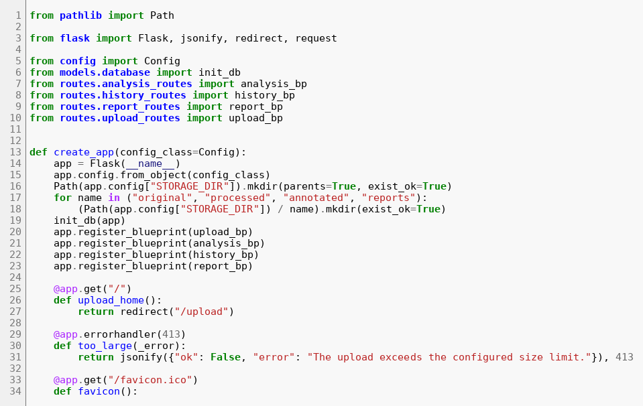
Figure 6.7: app.py, lines 1 to 34
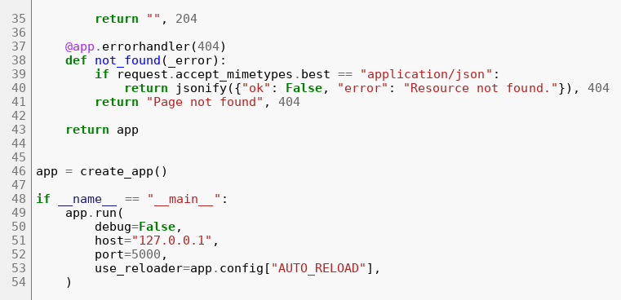
Figure 6.8: app.py, lines 35 to 54

config.py — Configuration and processing parameters
All limits (file size, number of files, image dimension, allowed extensions) and every image-processing parameter are collected in the Config class and can be overridden through environment variables where it matters (MONGO_URI, MONGO_DB_NAME, MAX_CONTENT_LENGTH, STORAGE_DIR, FLASK_AUTO_RELOAD). Keeping the thresholds in one dictionary means they can be tuned without touching the algorithms, and the dictionary is stored with each analysis for traceability.
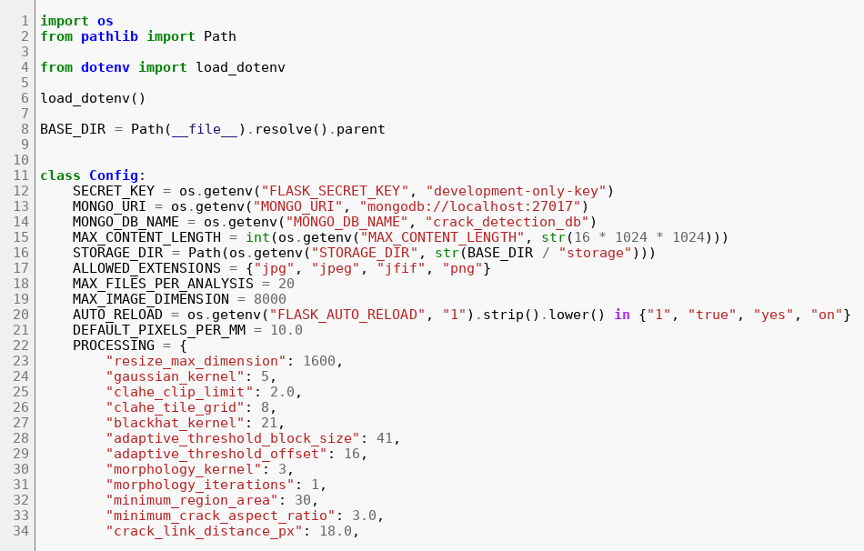
Figure 6.9: config.py, lines 1 to 34
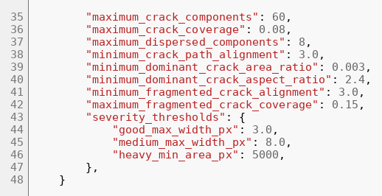
Figure 6.10: config.py, lines 35 to 48

services/image_service.py — Image loading and writing
load_and_resize reads the image as colour, raises a clear error if it cannot be decoded, and shrinks it with area interpolation when its longest side exceeds 1600 px. write_image creates the target folder if needed and raises an error if OpenCV cannot write the file.
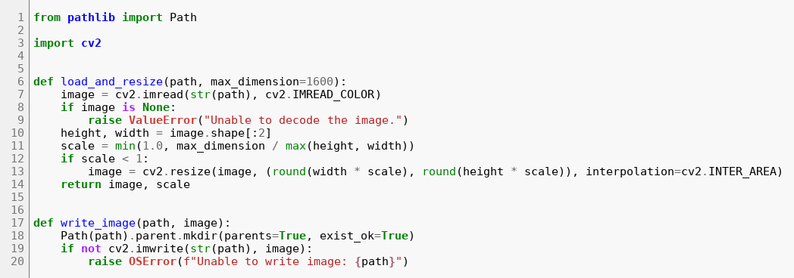
Figure 6.11: services/image_service.py, lines 1 to 20

services/preprocessing_service.py — Pre-processing stage (Algorithm 1)
The function converts to grayscale, blurs, applies CLAHE, computes a BlackHat image and produces the binary mask by adaptive Gaussian thresholding on the grayscale image. Two alternative thresholding branches (percentile and Otsu on the BlackHat image) remain available through configuration. All five images are returned in a dictionary so that the caller can save each one.
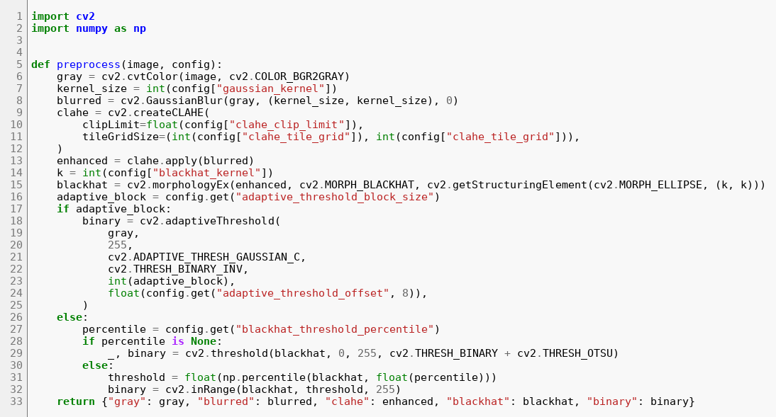
Figure 6.12: services/preprocessing_service.py, lines 1 to 33

services/detection_service.py — Detection, filtering and validation (Algorithms 2 to 4)
detect_components cleans the mask and extracts connected components. filter_crack_components keeps elongated components and then _select_coherent_path groups nearby components and discards isolated texture blobs while preserving several separate crack networks. validate_crack_image decides whether the remaining components look like a crack image at all, using component count, coverage, alignment and a second rule for a single dominant elongated component.
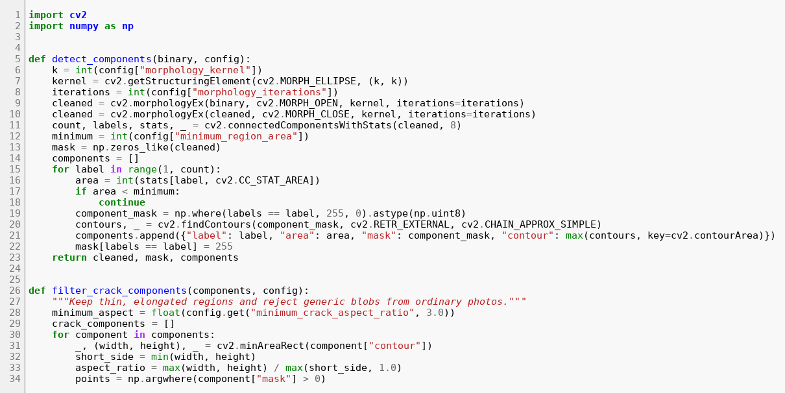
Figure 6.13: services/detection_service.py, lines 1 to 34
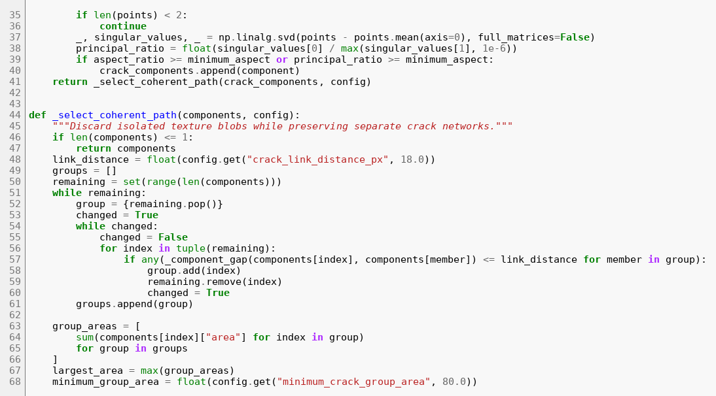
Figure 6.14: services/detection_service.py, lines 35 to 68
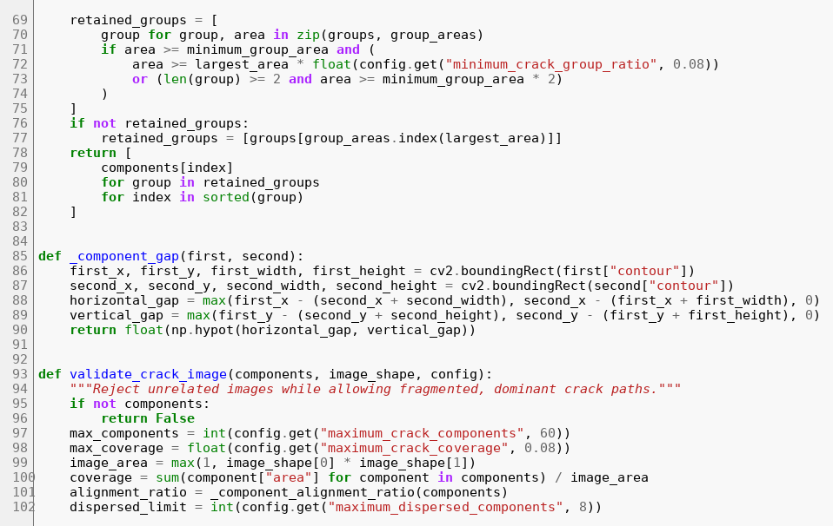
Figure 6.15: services/detection_service.py, lines 69 to 102
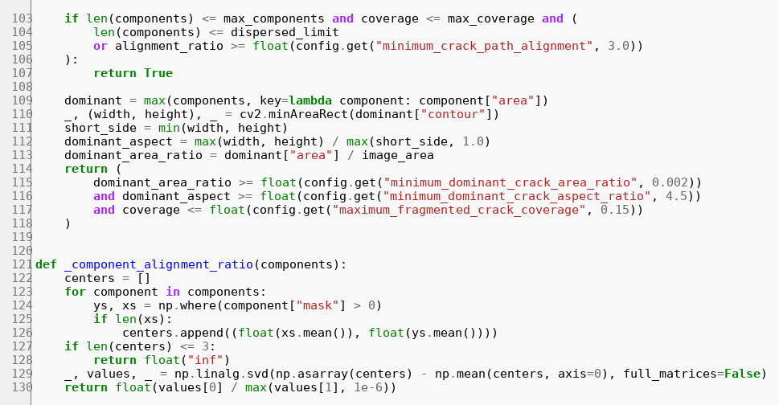
Figure 6.16: services/detection_service.py, lines 103 to 130

services/measurement_service.py — Measurement and annotation (Algorithm 5)
measure_component skeletonises the component, computes the distance transform, derives robust width statistics and the skeleton length, builds the diagnostic images (distance transform with colour map, and width samples over the skeleton) and returns a measurement dictionary. annotate draws the contours, the labels C1, C2, ... and the width sample lines on a copy of the input image.
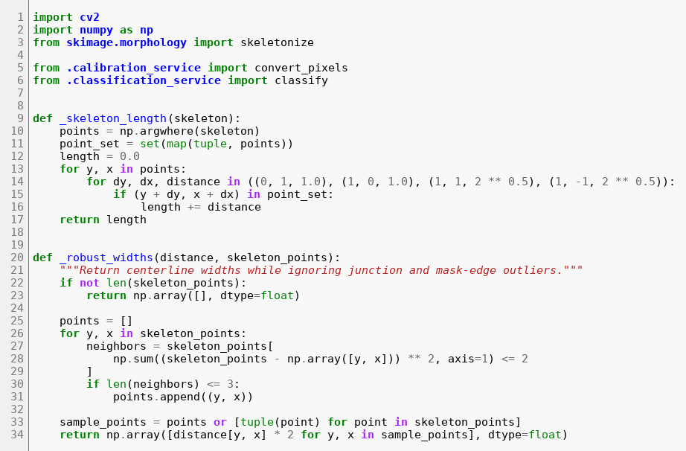
Figure 6.17: services/measurement_service.py, lines 1 to 34
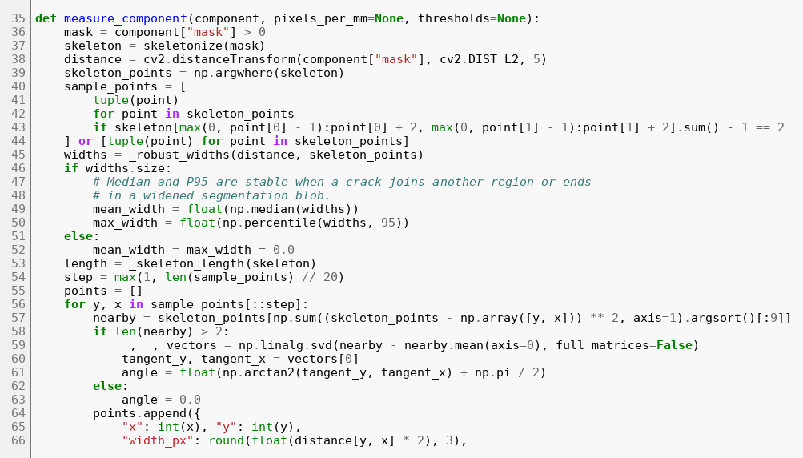
Figure 6.18: services/measurement_service.py, lines 35 to 68
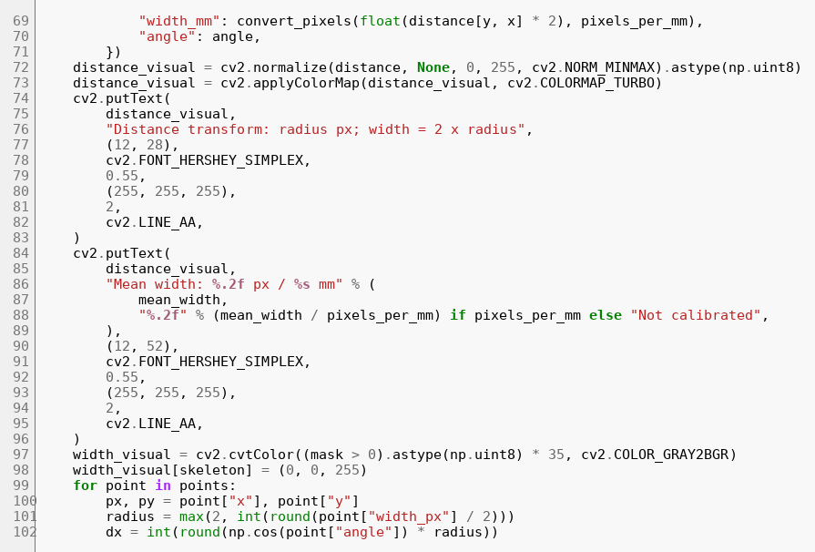
Figure 6.19: services/measurement_service.py, lines 69 to 102
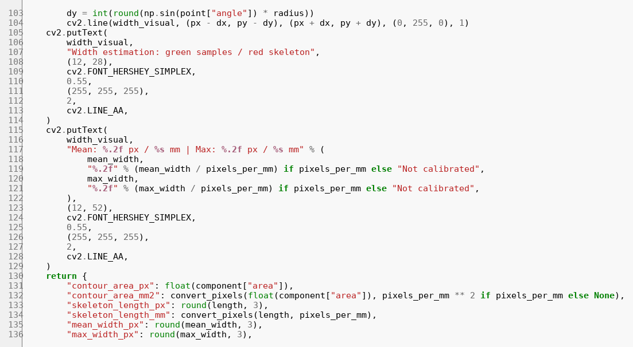
Figure 6.20: services/measurement_service.py, lines 103 to 136
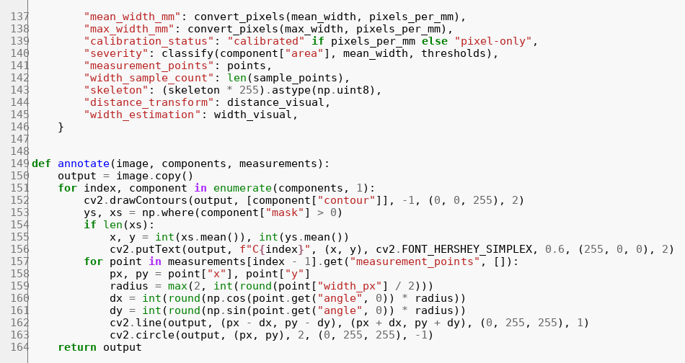
Figure 6.21: services/measurement_service.py, lines 137 to 164

services/classification_service.py — Severity classification (Algorithm 6)
The rule uses mean width and area thresholds. threshold_description returns the same limits as readable text for use in reports.
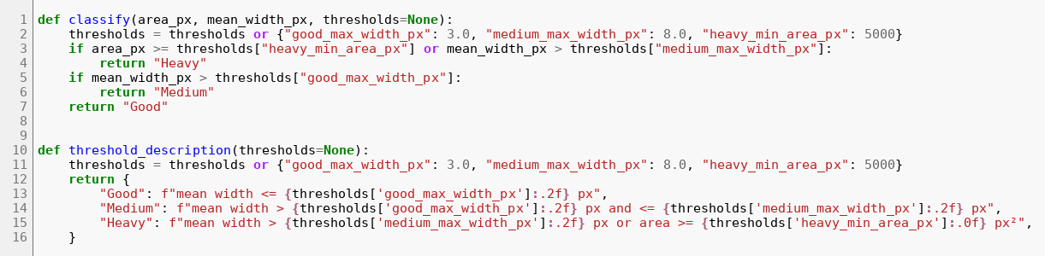
Figure 6.22: services/classification_service.py, lines 1 to 16

services/calibration_service.py — Calibration helpers
validate_pixels_per_mm accepts only a positive number and returns None otherwise; convert_pixels divides a pixel value by the scale, or returns None when no scale is available.
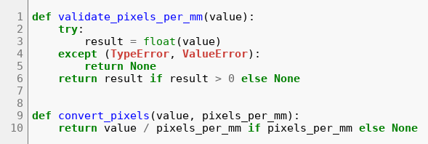
Figure 6.23: services/calibration_service.py, lines 1 to 10

services/storage_service.py — Storage helpers
Every analysis has its own folder storage/analyses/<analysis_id>. These helpers create it on demand and delete it with all its contents when an analysis is removed.
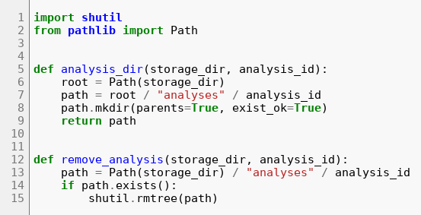
Figure 6.24: services/storage_service.py, lines 1 to 15

services/csv_service.py — CSV report
The function builds an analysis-level summary (counts, total and average length and width, minimum and maximum width, severity counts, overall severity and a remark) and repeats it on every row of a table that has one row per crack. Images without any crack still get a placeholder row. The result is written with pandas using three decimal places.
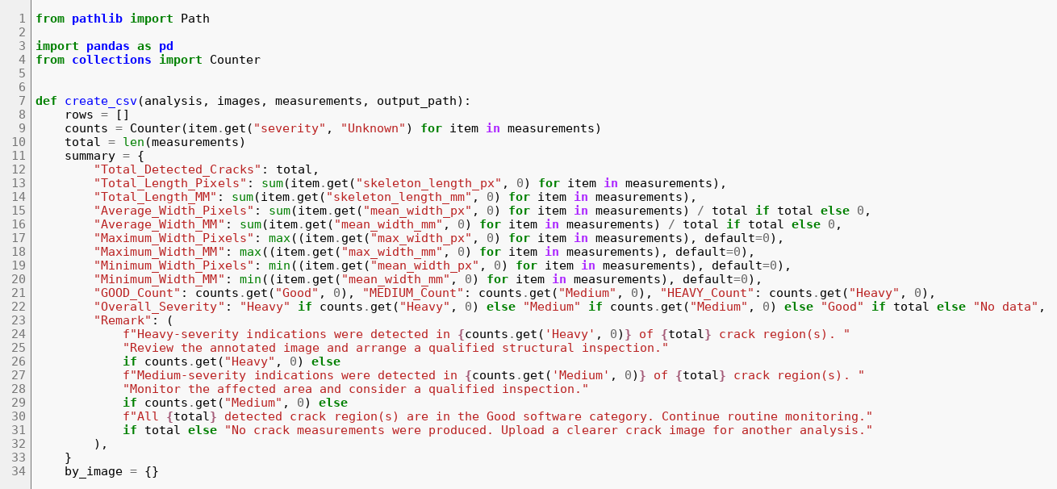
Figure 6.25: services/csv_service.py, lines 1 to 34
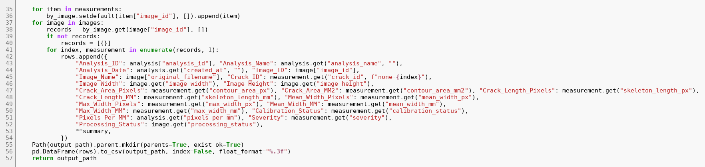
Figure 6.26: services/csv_service.py, lines 35 to 57

services/zip_service.py — ZIP package and manifest
create_manifest writes a short text description of the package. create_zip adds every file under the analysis folder (except the archive itself) under a top-level folder Crack_Analysis_Results, and adds the CSV, PDF and manifest under reports/ without duplicates.
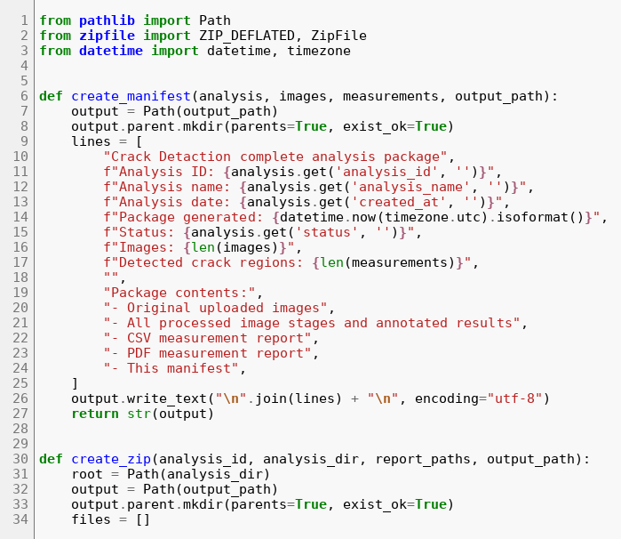
Figure 6.27: services/zip_service.py, lines 1 to 34
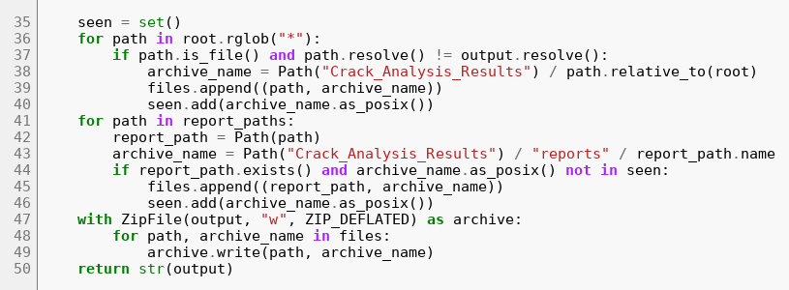
Figure 6.28: services/zip_service.py, lines 35 to 50

models/database.py — Database initialisation and fallback
init_db prepares the in-memory fallback store first, then tries to connect to MongoDB with a short timeout, pings it and creates the indexes. Any failure sets mongo_available to false. get_db and get_fallback_store give the model modules access to the current handle.
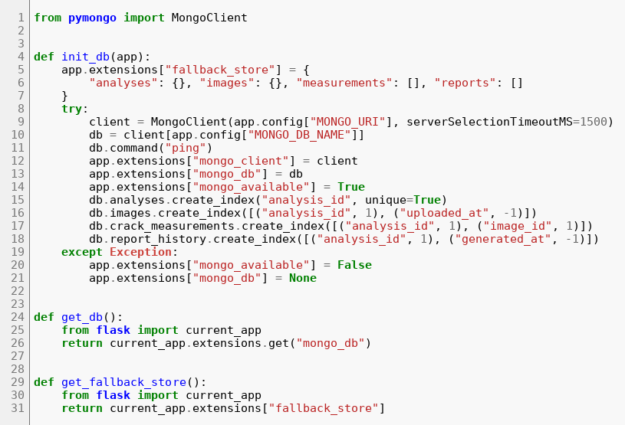
Figure 6.29: models/database.py, lines 1 to 31

models/analysis_model.py — Analysis model
These functions insert, read, update, list and delete analysis documents. Every function has two branches: the MongoDB call, and the equivalent operation on the fallback dictionary. Deleting an analysis also deletes its images, measurements and report-history records.
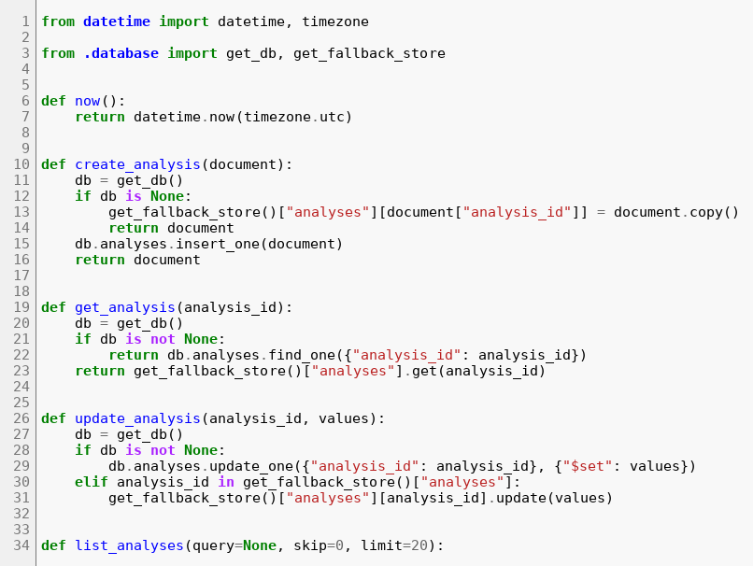
Figure 6.30: models/analysis_model.py, lines 1 to 34
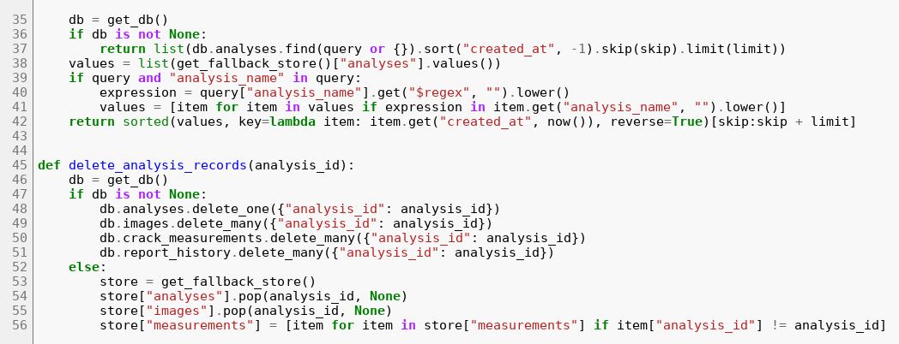
Figure 6.31: models/analysis_model.py, lines 35 to 56

models/image_model.py — Image model
Image documents hold the stored file name and path, status, dimensions, resize scale, the paths of all processed images and the per-stage timings.
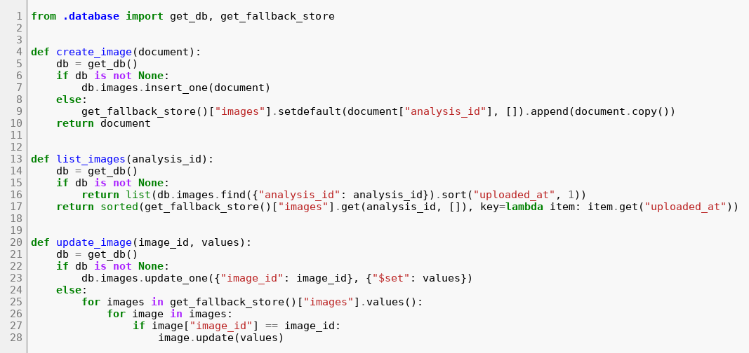
Figure 6.32: models/image_model.py, lines 1 to 28

models/measurement_model.py — Measurement model
Crack measurement documents are inserted in bulk and listed sorted by crack id. update_measurement_calibration can recompute all millimetre values for a new scale, but no route currently exposes it.
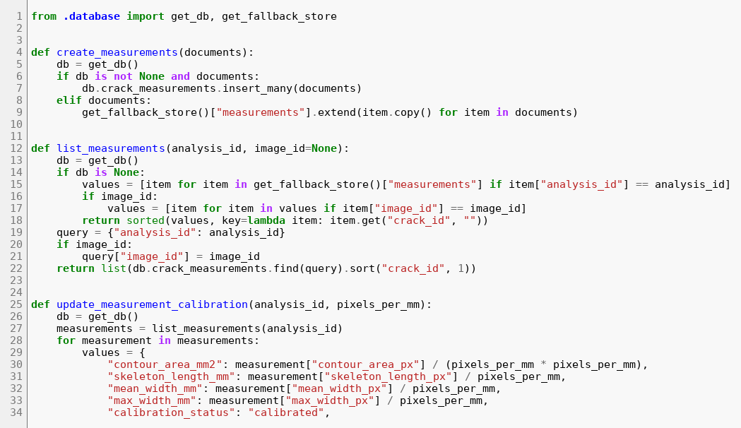
Figure 6.33: models/measurement_model.py, lines 1 to 34
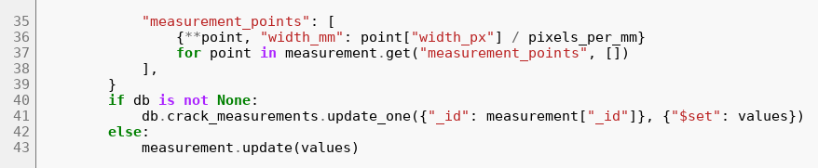
Figure 6.34: models/measurement_model.py, lines 35 to 43

routes/upload_routes.py — Upload and processing route
_validate_files and _create_uploaded_analysis check and store the uploads. _process_analysis is the heart of the application: for each image it loads, pre-processes, detects, filters, validates, measures, annotates and saves everything, recording the time taken by each stage. If any image has no detectable crack or fails, the whole analysis is deleted and an error message is returned. /api/upload and /api/analyze currently perform the same work.
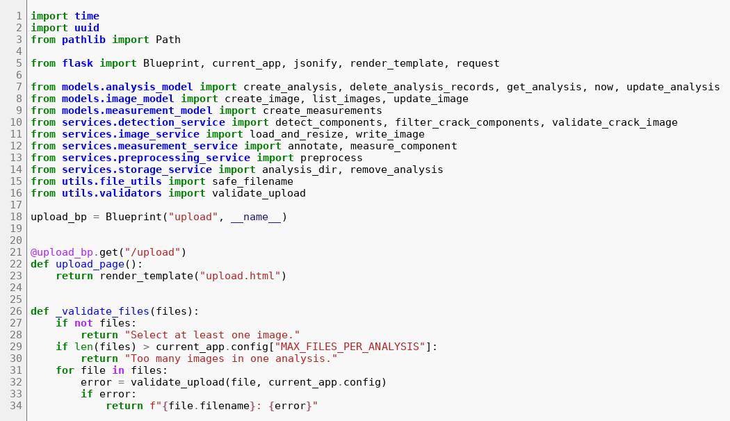
Figure 6.35: routes/upload_routes.py, lines 1 to 34
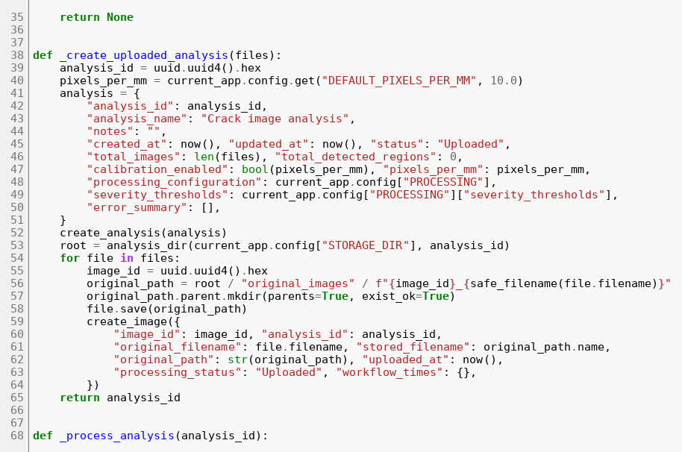
Figure 6.36: routes/upload_routes.py, lines 35 to 68
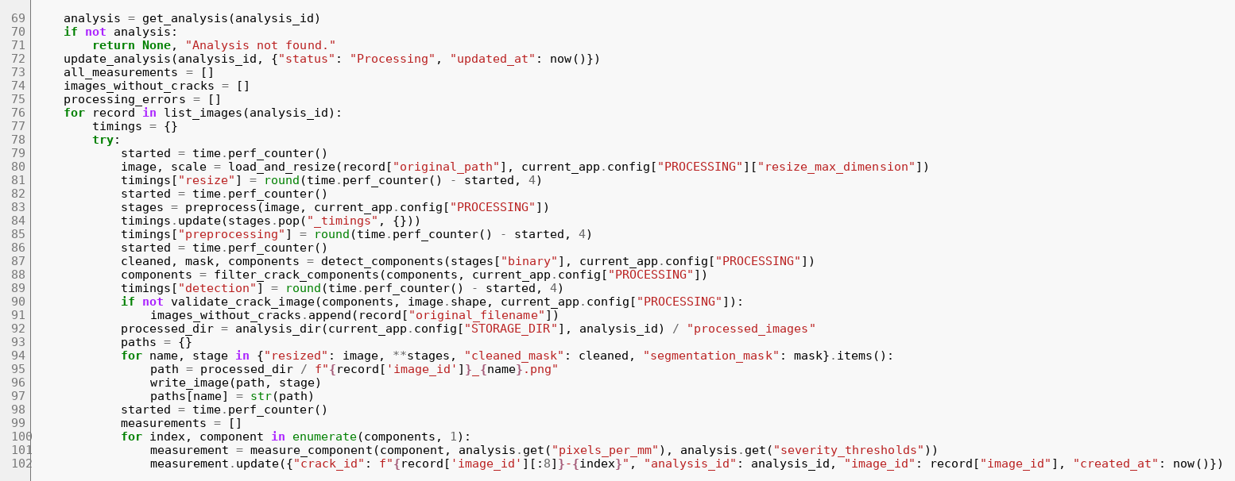
Figure 6.37: routes/upload_routes.py, lines 69 to 102
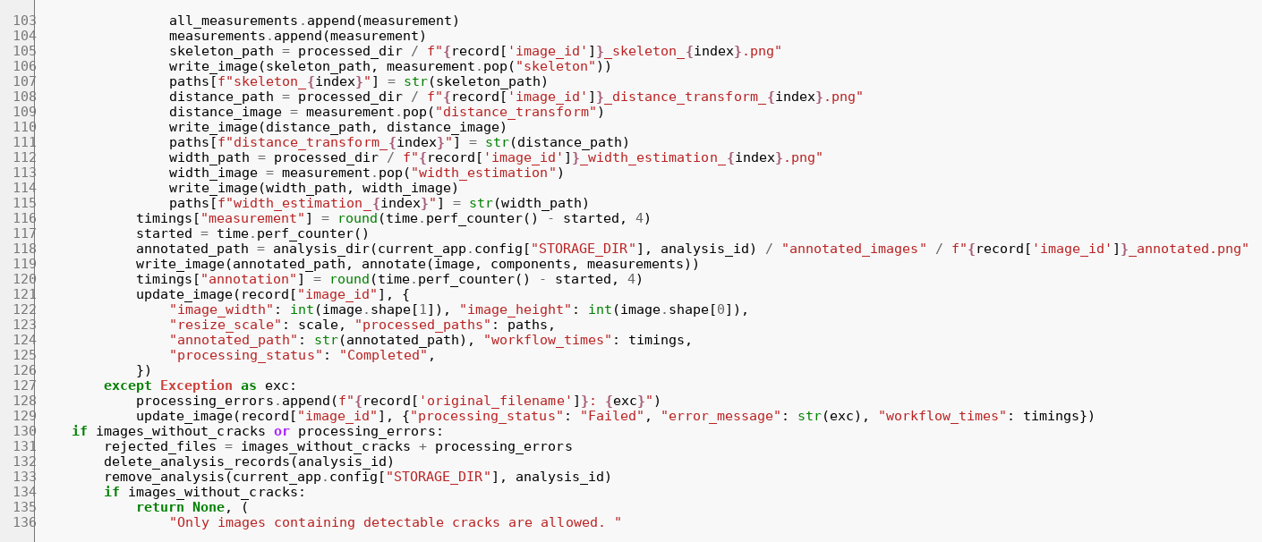
Figure 6.38: routes/upload_routes.py, lines 103 to 136
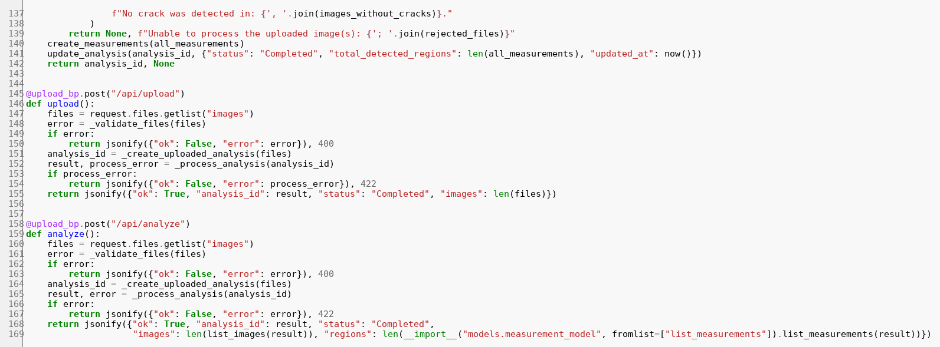
Figure 6.39: routes/upload_routes.py, lines 137 to 169

routes/analysis_routes.py — Results page and file serving
analysis_page computes the summary (totals, averages, severity counts and percentages, overall severity and the remark) and renders the template. analysis_api returns the same data as JSON. The two file routes serve original, annotated and processed images only if the stored path lies inside the analysis folder.
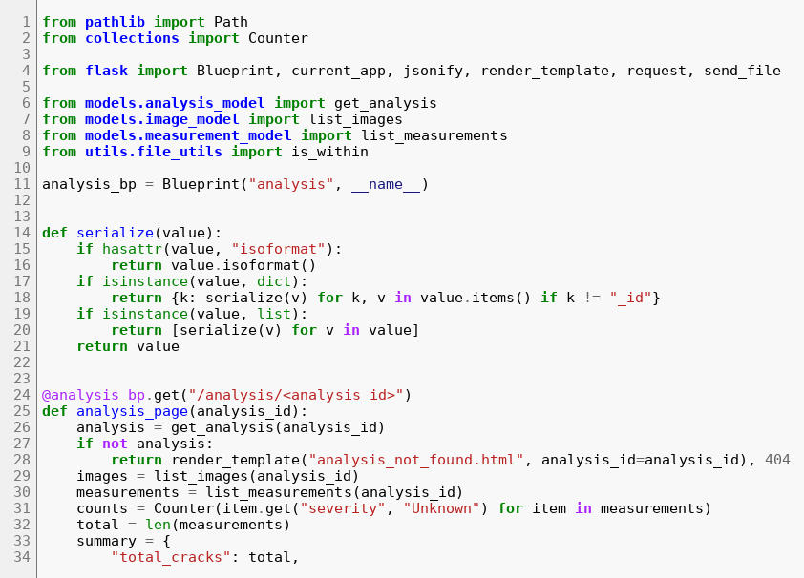
Figure 6.40: routes/analysis_routes.py, lines 1 to 34
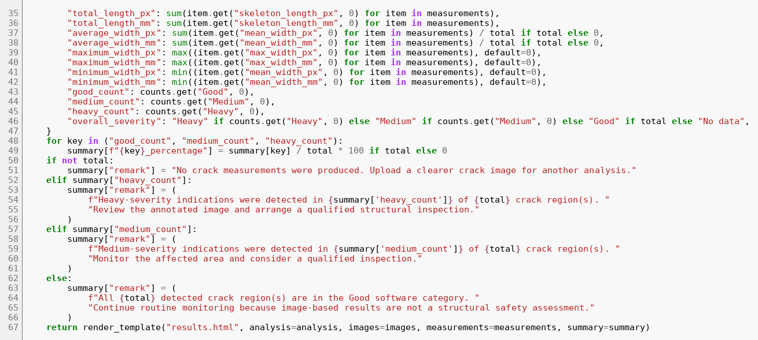
Figure 6.41: routes/analysis_routes.py, lines 35 to 68
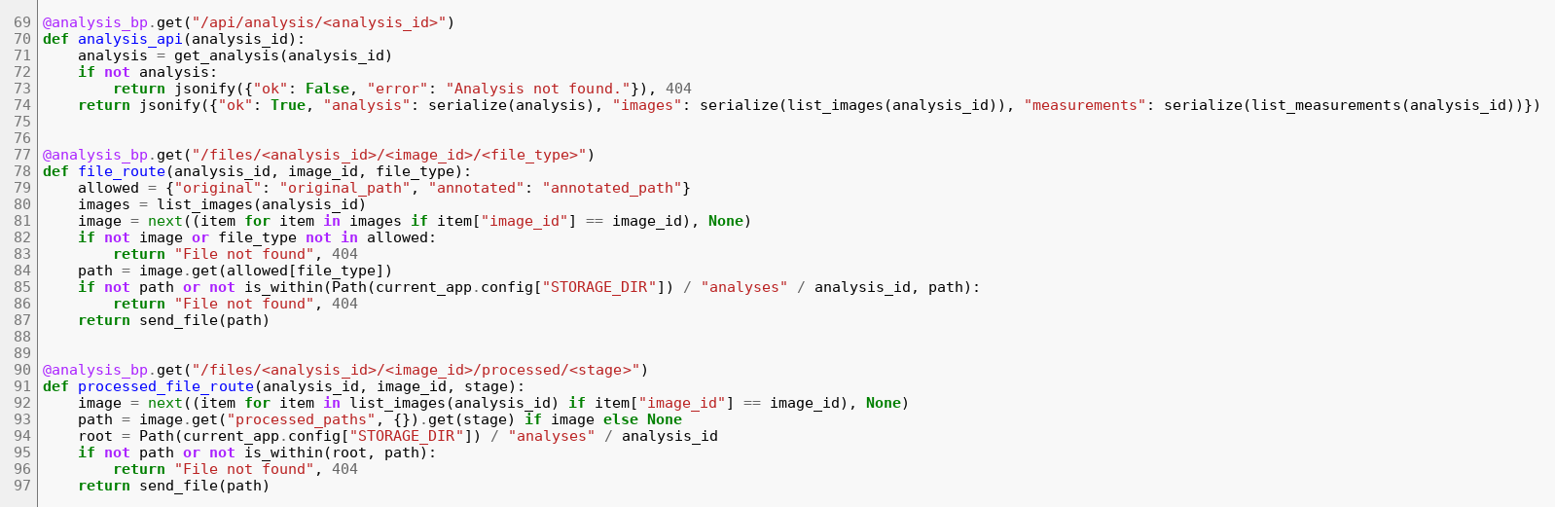
Figure 6.42: routes/analysis_routes.py, lines 69 to 98

routes/history_routes.py — History routes
The history page lists up to 100 analyses; the API supports a case-insensitive name search through a MongoDB regular expression; the DELETE route removes records and files.
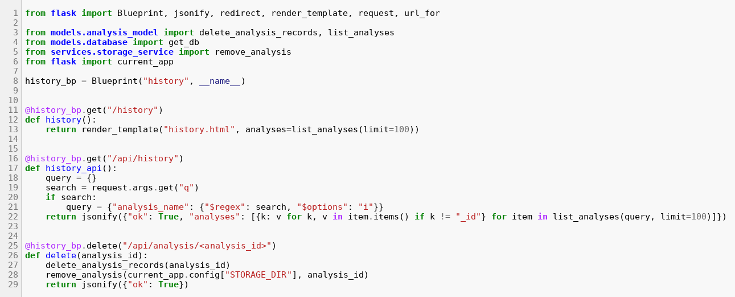
Figure 6.43: routes/history_routes.py, lines 1 to 29

routes/report_routes.py — Report routes
build_report generates CSV or PDF on demand; for ZIP it first builds both, then the manifest, then the archive. download_report rejects unknown report types with HTTP 400 and unknown analyses with 404.
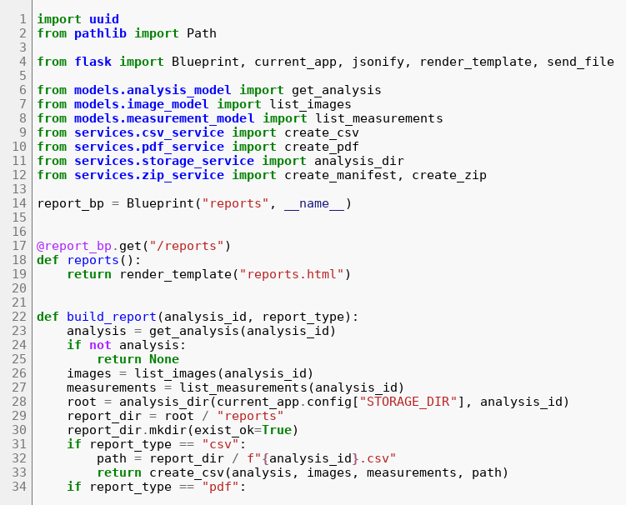
Figure 6.44: routes/report_routes.py, lines 1 to 34
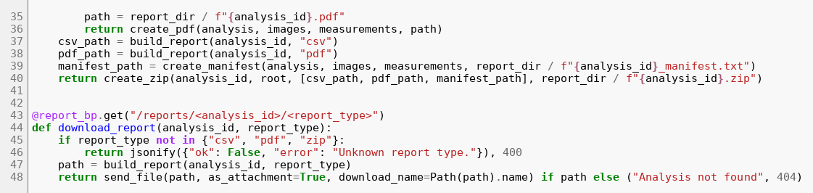
Figure 6.45: routes/report_routes.py, lines 35 to 48

utils/validators.py — Upload validation
The validator checks the extension against the allowed set, rejects empty files, decodes the image to prove that it is valid and enforces the minimum and maximum dimensions.
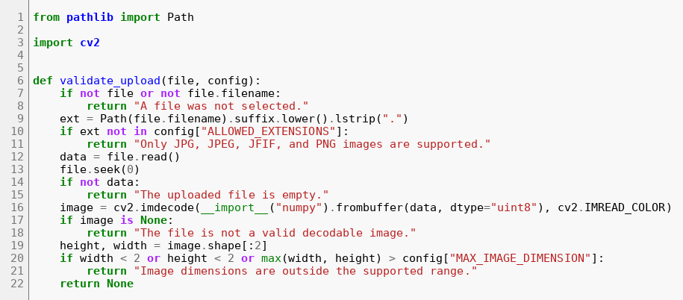
Figure 6.46: utils/validators.py, lines 1 to 22

utils/file_utils.py — File-name and path safety
safe_filename replaces unsafe characters and strips leading and trailing dots and underscores. is_within resolves both paths and checks containment, which blocks path traversal.
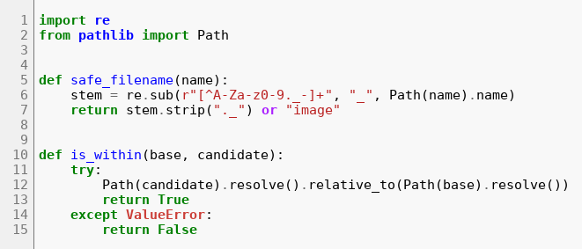
Figure 6.47: utils/file_utils.py, lines 1 to 15

static/app.js — Client-side behaviour
The script previews selected files, lets the user remove one, submits the form asynchronously and shows the result or error message, and implements the image lightbox with zoom controls, wheel zoom and keyboard shortcuts.
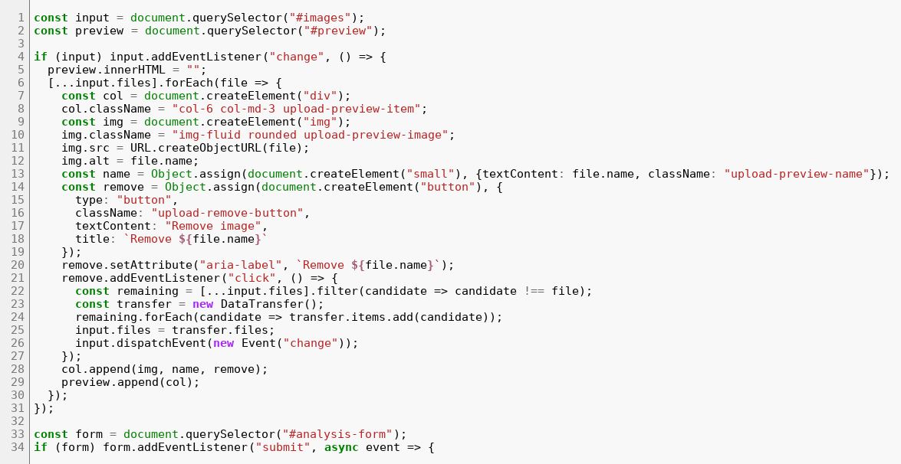
Figure 6.48: static/app.js, lines 1 to 34
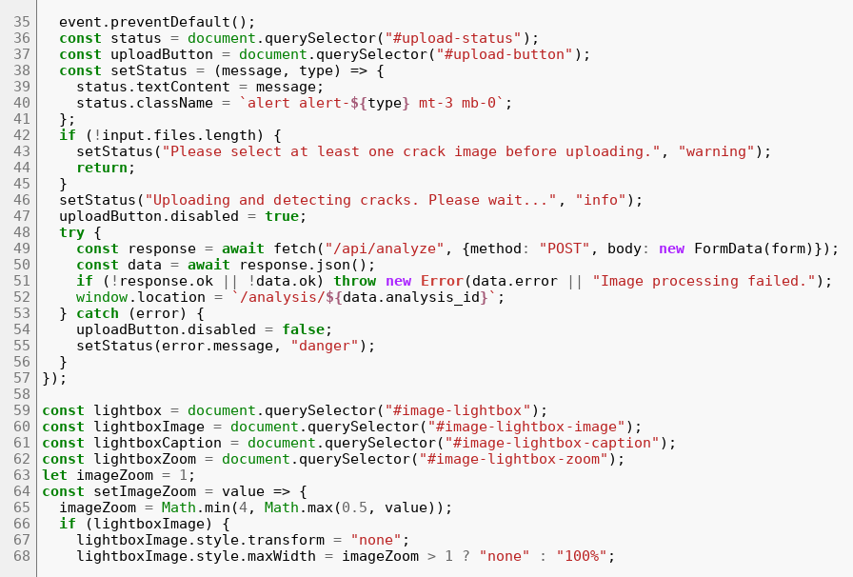
Figure 6.49: static/app.js, lines 35 to 68
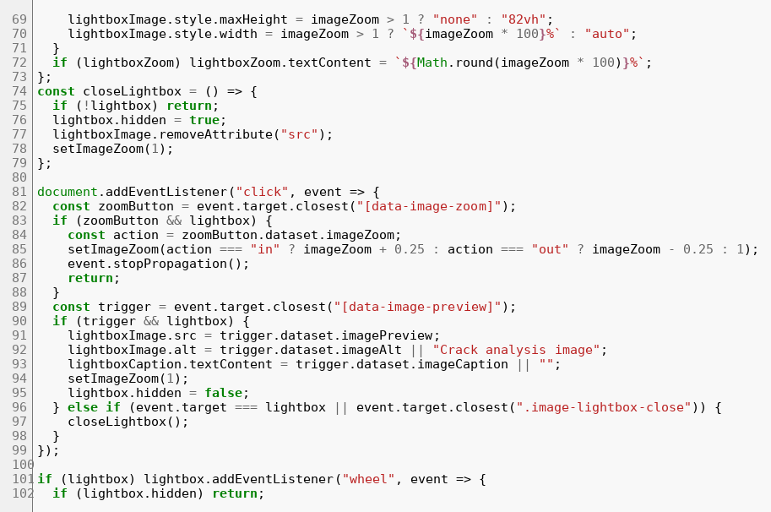
Figure 6.50: static/app.js, lines 69 to 102
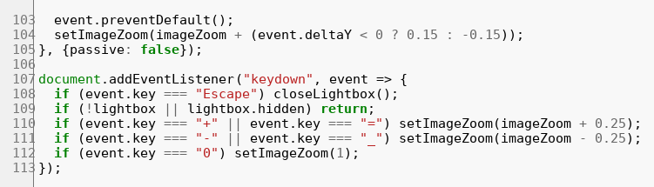
Figure 6.51: static/app.js, lines 103 to 113

requirements.txt — Python dependencies
Version ranges for Flask, python-dotenv, PyMongo, OpenCV (headless), NumPy, scikit-image, pandas, ReportLab, pytest and mongomock.
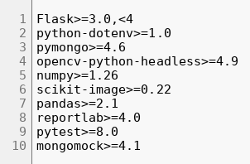
Figure 6.52: requirements.txt, lines 1 to 10

.env.example — Environment template
Sample values for the MongoDB URI and database name, the Flask secret key, the upload limit and the storage folder. The real .env file is excluded by .gitignore.
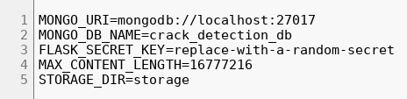
Figure 6.53: .env.example, lines 1 to 5

6.12 Additional user-interface screenshots
The upload page before any file is chosen shows the drop zone, and the history page lists earlier analyses. Further parts of the results page follow.
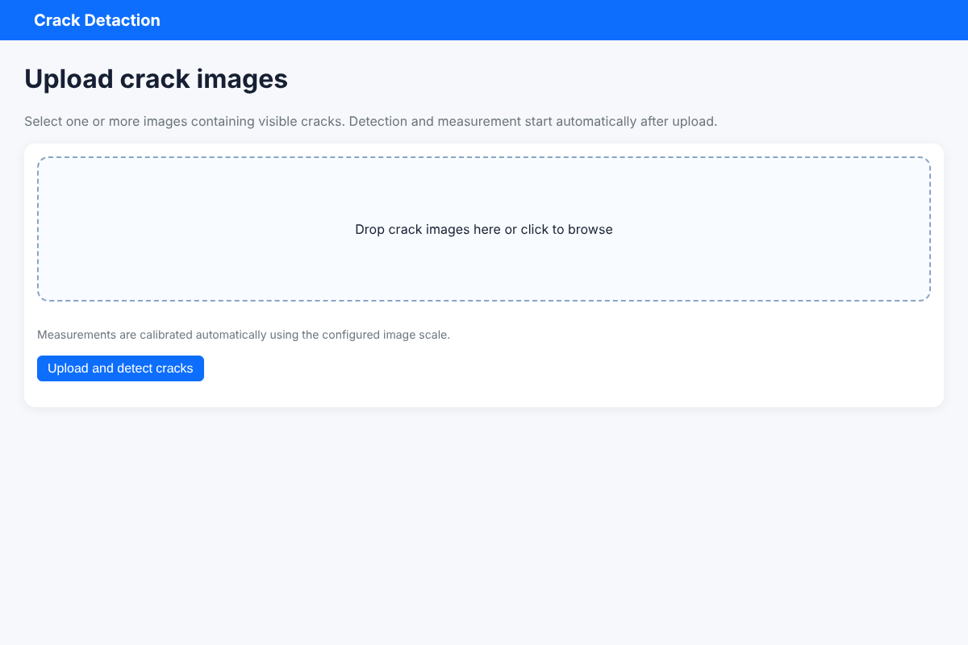
Figure 6.54: Upload page before selecting files
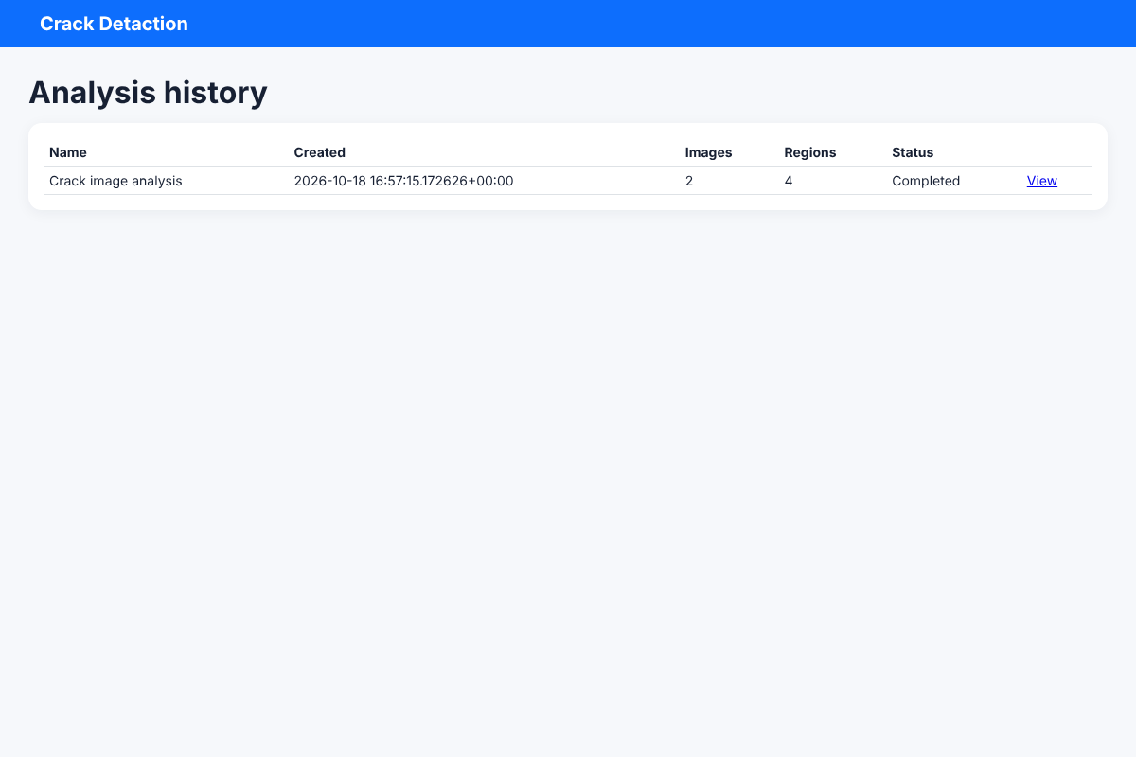
Figure 6.55: History page
Figure 6.56: Download-report card
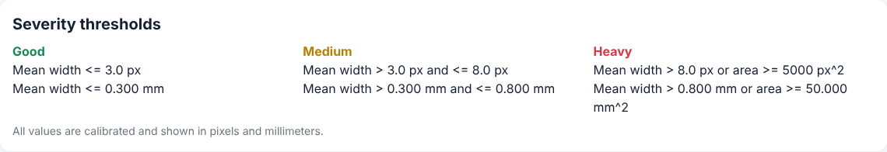
Figure 6.57: Severity thresholds card, shown in pixels and millimetres
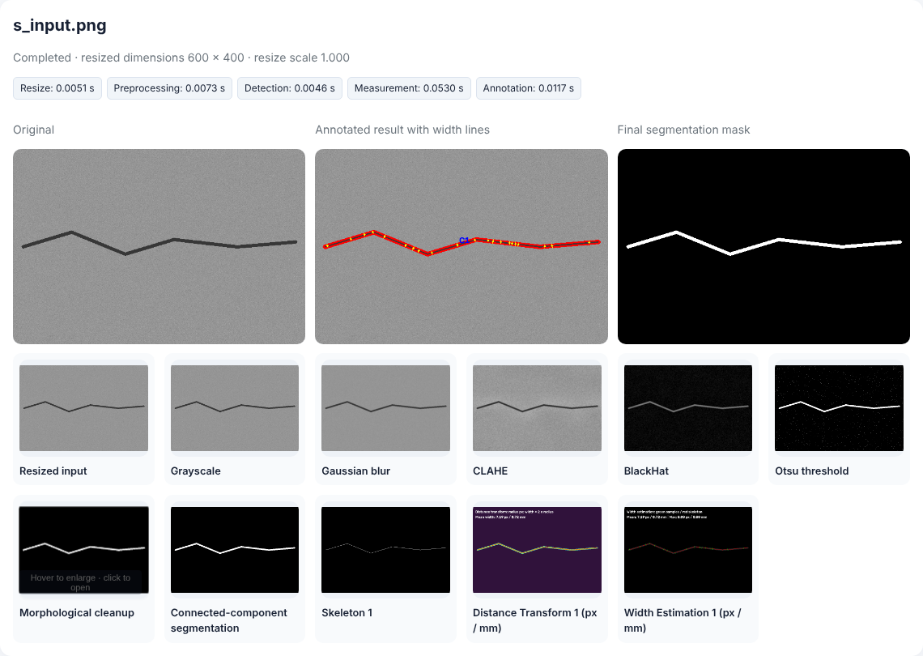
Figure 6.58: Per-image result card for the first synthetic image
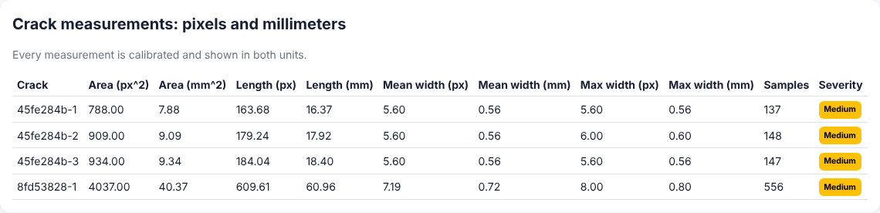
Figure 6.59: Crack measurement table in pixels and millimetres

6.13 Generated output files
The CSV export of the end-to-end run is shown in Figure 6.60 (selected columns; the file has 34 columns). The PDF report has 33 pages for two images because every stage image is included; pages 2 to 4 are shown next. The ZIP archive contained 35 files; its listing follows.
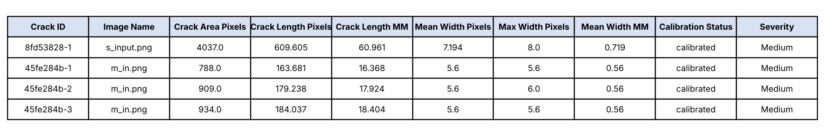
Figure 6.60: CSV report opened as a table (selected columns)
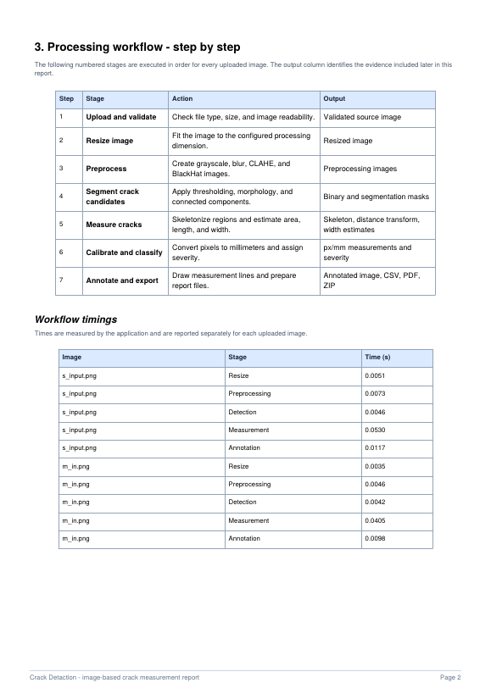
Figure 6.61: PDF report, page 2
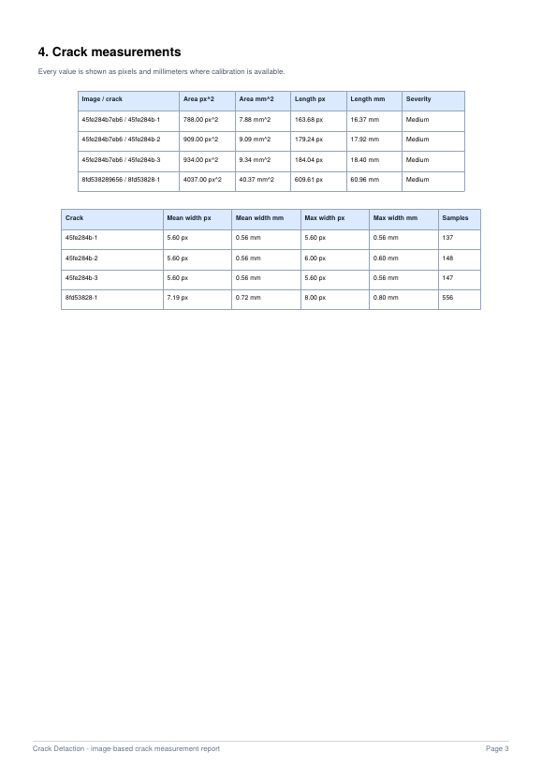
Figure 6.62: PDF report, page 3
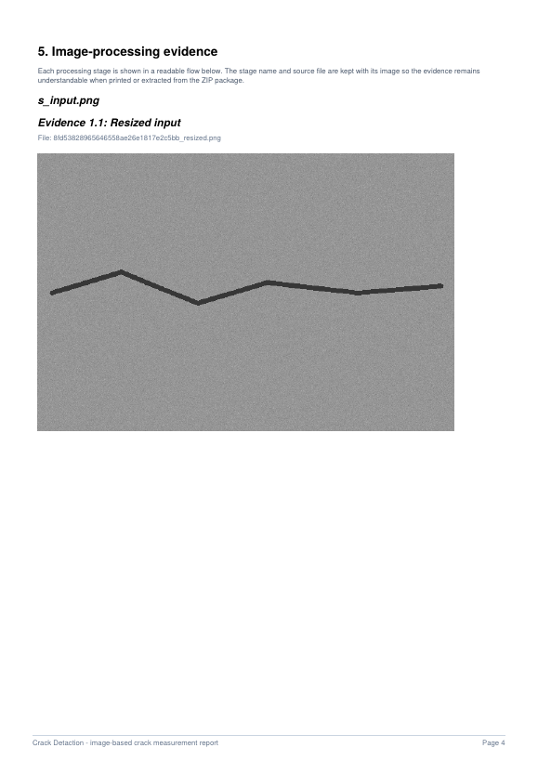
Figure 6.63: PDF report, page 4
Contents of the ZIP archive (size in bytes and path):
329628 CAR/annotated_images/45fe284b7eb642c39bf9a958a00772d1_annotated.png
451958 CAR/annotated_images/8fd53828965646558ae26e1817e2c5bb_annotated.png
19521 CAR/processed_images/45fe284b7eb642c39bf9a958a00772d1_distance_transform_2.png
21448 CAR/processed_images/45fe284b7eb642c39bf9a958a00772d1_width_estimation_2.png
65787 CAR/processed_images/45fe284b7eb642c39bf9a958a00772d1_clahe.png
21502 CAR/processed_images/45fe284b7eb642c39bf9a958a00772d1_width_estimation_3.png
1005 CAR/processed_images/45fe284b7eb642c39bf9a958a00772d1_skeleton_1.png
87755 CAR/processed_images/8fd53828965646558ae26e1817e2c5bb_clahe.png
1403 CAR/processed_images/8fd53828965646558ae26e1817e2c5bb_skeleton_1.png
327929 CAR/processed_images/45fe284b7eb642c39bf9a958a00772d1_resized.png
24129 CAR/processed_images/8fd53828965646558ae26e1817e2c5bb_distance_transform_1.png
1069 CAR/processed_images/45fe284b7eb642c39bf9a958a00772d1_skeleton_3.png
1547 CAR/processed_images/8fd53828965646558ae26e1817e2c5bb_segmentation_mask.png
3688 CAR/processed_images/8fd53828965646558ae26e1817e2c5bb_binary.png
72954 CAR/processed_images/8fd53828965646558ae26e1817e2c5bb_blurred.png
155067 CAR/processed_images/8fd53828965646558ae26e1817e2c5bb_gray.png
112704 CAR/processed_images/45fe284b7eb642c39bf9a958a00772d1_gray.png
68831 CAR/processed_images/45fe284b7eb642c39bf9a958a00772d1_blackhat.png
1547 CAR/processed_images/8fd53828965646558ae26e1817e2c5bb_cleaned_mask.png
19640 CAR/processed_images/45fe284b7eb642c39bf9a958a00772d1_distance_transform_3.png
19169 CAR/processed_images/45fe284b7eb642c39bf9a958a00772d1_distance_transform_1.png
451806 CAR/processed_images/8fd53828965646558ae26e1817e2c5bb_resized.png
22705 CAR/processed_images/8fd53828965646558ae26e1817e2c5bb_width_estimation_1.png
3221 CAR/processed_images/45fe284b7eb642c39bf9a958a00772d1_binary.png
1036 CAR/processed_images/45fe284b7eb642c39bf9a958a00772d1_skeleton_2.png
92628 CAR/processed_images/8fd53828965646558ae26e1817e2c5bb_blackhat.png
55124 CAR/processed_images/45fe284b7eb642c39bf9a958a00772d1_blurred.png
1763 CAR/processed_images/45fe284b7eb642c39bf9a958a00772d1_cleaned_mask.png
21283 CAR/processed_images/45fe284b7eb642c39bf9a958a00772d1_width_estimation_1.png
1763 CAR/processed_images/45fe284b7eb642c39bf9a958a00772d1_segmentation_mask.png
2266 CAR/reports/9530840468384f5f917c3a677f49986b.csv
441 CAR/reports/9530840468384f5f917c3a677f49986b_manifest.txt
2017238 CAR/reports/9530840468384f5f917c3a677f49986b.pdf
451806 CAR/original_images/8fd53828965646558ae26e1817e2c5bb_s_input.png
327929 CAR/original_images/45fe284b7eb642c39bf9a958a00772d1_m_in.png

(CAR/ abbreviates the top-level folder Crack_Analysis_Results/.)

6.14 JSON API response
The JSON returned by GET /api/analysis/<id> for a one-image analysis is shown below, shortened for readability (some lists and the processing configuration are abbreviated with "...").
{
"analysis": {
"analysis_id": "1ae414da1af34a6bb1089de919f3a33b",
"analysis_name": "Crack image analysis",
"calibration_enabled": true,
"created_at": "2026-10-24T04:43:18.402417+00:00",
"error_summary": [],
"notes": "",
"pixels_per_mm": 10.0,
"processing_configuration": {
"...": "..."
},
"severity_thresholds": {
"good_max_width_px": 3.0,
"heavy_min_area_px": 5000,
"medium_max_width_px": 8.0
},
"status": "Completed",
"total_detected_regions": 3,
"total_images": 1,
"updated_at": "2026-10-24T04:43:18.541741+00:00"
},
"images": [
{
"analysis_id": "1ae414da1af34a6bb1089de919f3a33b",
"annotated_path": "/tmp/tmprz6i0e1k/analyses/1ae414da1af34a6bb1089de919f3a33b/annotated_images/eeeaf5f943634f69a4dd104588d55a05_annotated.png",
"image_height": 360,
"image_id": "eeeaf5f943634f69a4dd104588d55a05",
"image_width": 480,
"original_filename": "m_in.png",
"original_path": "/tmp/tmprz6i0e1k/analyses/1ae414da1af34a6bb1089de919f3a33b/original_images/eeeaf5f943634f69a4dd104588d55a05_m_in.png",
"processed_paths": {
"binary": "/tmp/tmprz6i0e1k/analyses/1ae414da1af34a6bb1089de919f3a33b/processed_images/eeeaf5f943634f69a4dd104588d55a05_binary.png",
"blackhat": "/tmp/tmprz6i0e1k/analyses/1ae414da1af34a6bb1089de919f3a33b/processed_images/eeeaf5f943634f69a4dd104588d55a05_blackhat.png",
"blurred": "/tmp/tmprz6i0e1k/analyses/1ae414da1af34a6bb1089de919f3a33b/processed_images/eeeaf5f943634f69a4dd104588d55a05_blurred.png"
},
"processing_status": "Completed",
"resize_scale": 1.0,
"stored_filename": "eeeaf5f943634f69a4dd104588d55a05_m_in.png",
"uploaded_at": "2026-10-24T04:43:18.403694+00:00",
"workflow_times": {
"annotation": 0.0116,
"detection": 0.0096,
"measurement": 0.0823,
"preprocessing": 0.007,
"resize": 0.0039
}
}
],
"measurements": [
{
"analysis_id": "1ae414da1af34a6bb1089de919f3a33b",
"calibration_status": "calibrated",
"contour_area_mm2": 7.88,
"contour_area_px": 788.0,
"crack_id": "eeeaf5f9-1",
"created_at": "2026-10-24T04:43:18.489541+00:00",
"image_id": "eeeaf5f943634f69a4dd104588d55a05",
"max_width_mm": 0.5599999904632569,
"max_width_px": 5.6,
"mean_width_mm": 0.5599999904632569,
"mean_width_px": 5.6,
"measurement_points": [
{
"angle": 4.2055331289795035,
"width_mm": 0.43937997817993163,
"width_px": 4.394,
"x": 159,
"y": 55
},
{
"angle": 4.1685933256376915,
"width_mm": 0.43937997817993163,
"width_px": 4.394,
"x": 152,
"y": 59
},
{
"...": "..."
}
],
"severity": "Medium",
"skeleton_length_mm": 16.368124086713195,
"skeleton_length_px": 163.681,
"width_sample_count": 137
}
],
"ok": true
}

6.15 Step-by-step walkthrough of one analysis
This section follows the synthetic image of Figure 6.1 (600 x 400 px, crack raster width 7 px, Gaussian noise of standard deviation 6) through the pipeline, showing the image produced by each stage and what the next stage does with it.

Input image
The input is a mid-grey noisy surface crossed by a dark six-segment crack. It is smaller than 1600 px, so no resizing is applied (scale factor 1.0).
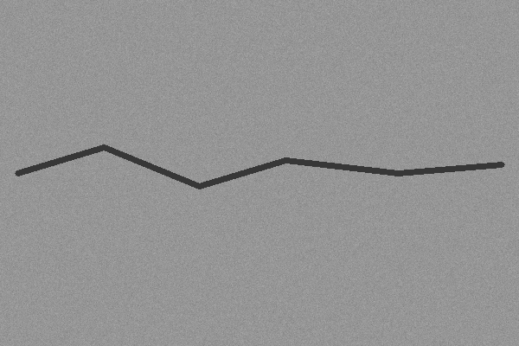
Figure 6.64: Input image

Grayscale
Colour is discarded because a crack is recognised by its darkness, not its hue. All later stages work on this single channel.
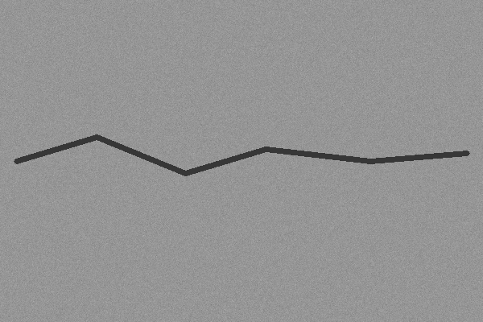
Figure 6.65: Grayscale

Gaussian blur (5 x 5)
The blur averages each pixel with its neighbours and suppresses the grain noise, at the cost of slightly softening the crack edges.
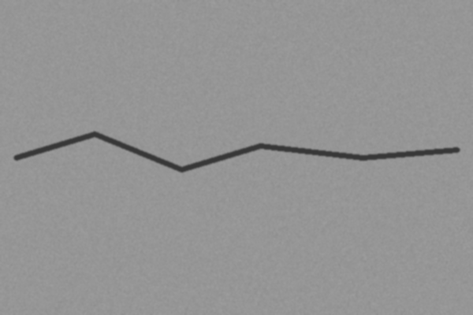
Figure 6.66: Gaussian blur (5 x 5)

CLAHE
Local contrast equalisation in 8 x 8 tiles makes the crack stand out even where lighting varies. It is applied to the blurred image and feeds the BlackHat stage.
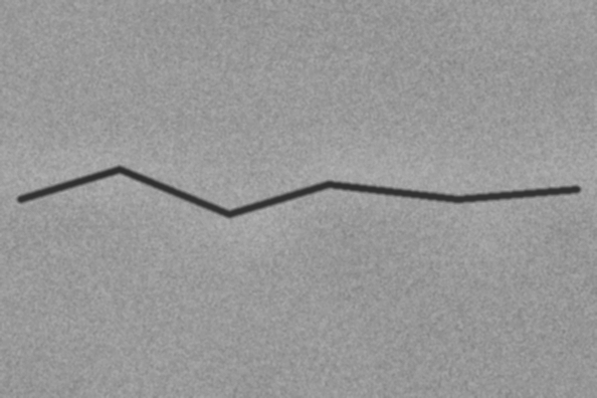
Figure 6.67: CLAHE

BlackHat transform
The difference between the morphological closing and the original image highlights thin dark structures. In this application it is a visual diagnostic; the mask is made from the grayscale image.
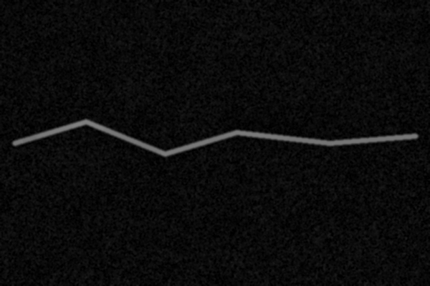
Figure 6.68: BlackHat transform

Adaptive threshold
Each pixel is compared with a Gaussian-weighted local mean (41 x 41 window) minus 16. Pixels darker than that become foreground. The result contains the crack and scattered noise specks.
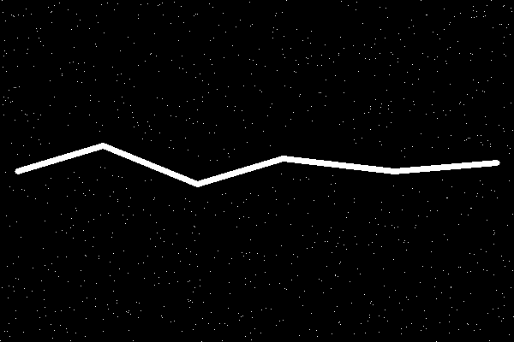
Figure 6.69: Adaptive threshold

Morphological opening and closing
Opening removes isolated specks, closing fills one-pixel gaps in the crack. The crack is now a continuous band.
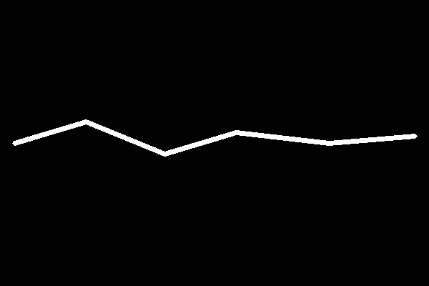
Figure 6.70: Morphological opening and closing

Component mask
Components smaller than 30 px are removed. Here a single elongated component remains, which passes the aspect-ratio test.
Figure 6.71: Component mask

Skeleton
The band is thinned to a one-pixel centre line. The length of this line is the crack length: 609.6 px, or 60.96 mm at 10 px/mm.
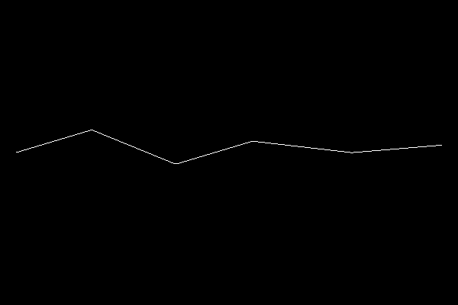
Figure 6.72: Skeleton

Distance transform
Each pixel of the mask stores its distance to the background; the colour map shows larger values (the middle of the band) in lighter colours. The text overlay states mean width 7.19 px / 0.72 mm.
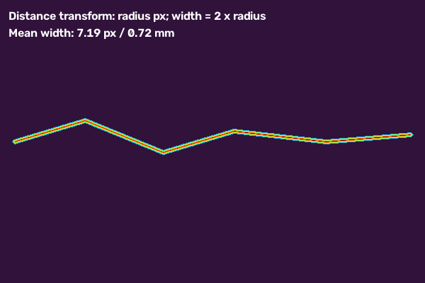
Figure 6.73: Distance transform

Width estimation
Green lines are width samples taken at evenly spaced skeleton points, and the red line is the skeleton. The overlay states mean and maximum widths of 7.19 px and 8.00 px.
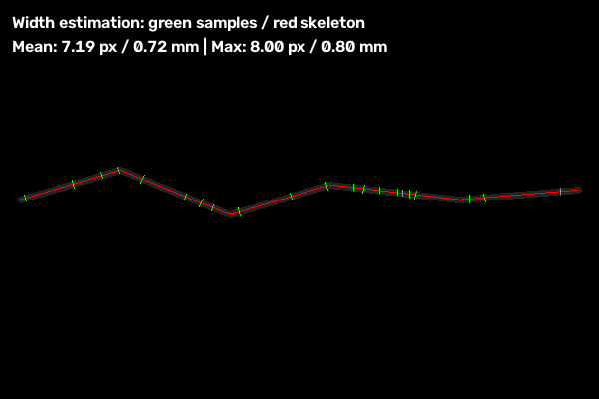
Figure 6.74: Width estimation

Annotated result
The final image draws the crack contour in red, labels it C1 and overlays the width samples. This is the image shown on the results page and stored in annotated_images/.
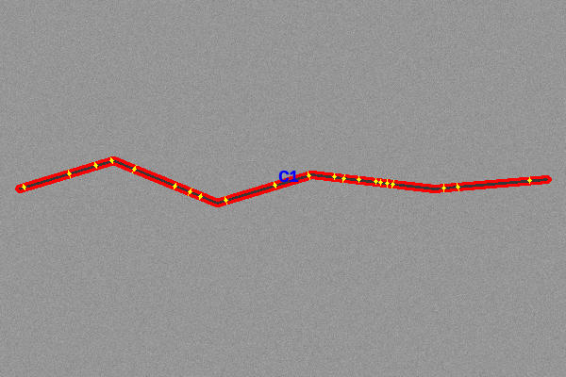
Figure 6.75: Annotated result
Result of the run. One crack was found: length 609.605 px (60.961 mm), mean width 7.194 px (0.719 mm), maximum width 8.000 px (0.800 mm), contour area 4037 px², severity Medium (mean width above 3 px and not above 8 px). Figure 6.76 shows a second run with three separate crack networks.
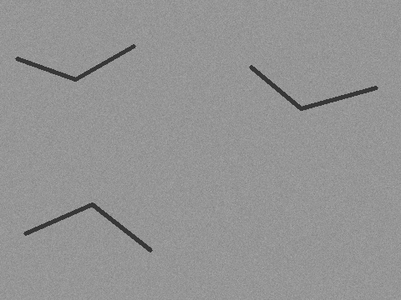
Figure 6.76: Second test image: three separate synthetic cracks
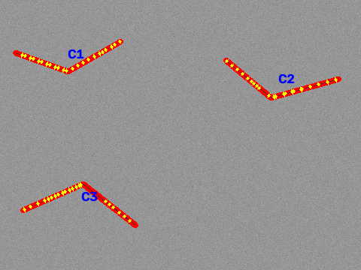
Figure 6.77: Annotated result: cracks C1, C2 and C3 measured independently

6.16 Implementation challenges and how they were handled
Challenge | Observation | Handling in the code
Pavement and wall texture | Global thresholds turn grain into foreground and flood the mask | Adaptive local threshold with offset; minimum component area; elongation filter; coverage limit
Fragmented cracks | A crack split into several short pieces looks like noise | Group components within 18 px; alternative dominant-crack acceptance rule
Several cracks in one image | Keeping only the largest group discards real cracks | Retain every group above an area threshold relative to the largest group
Unstable width values | Branches and blobs distort mean and maximum | Median and 95th percentile of junction-free centre-line samples
Text or objects uploaded by mistake | Letters produce many small elongated components | Component-count, coverage and alignment tests in validate_crack_image
Database not running | Application would fail at start | Short timeout and in-memory fallback store
Large files | Memory and time grow with pixels | Resize to 1600 px and enforce file-size and dimension limits
Table 6.5: Implementation challenges

Chapter 7 — Testing and Validation

7.1 Testing strategy and test environment
Testing combined the repository's automated tests (unit and light integration level, pytest), a scripted end-to-end run of the web application in a headless browser, export checks, and a controlled experiment on synthetic images. All results in this chapter were obtained by running the code during preparation of this report.
Environment and deviations. Linux container, Python 3.13.16, OpenCV 5.0.0.93, scikit-image 0.26.0, Flask 3.1.3. MongoDB was not available, so the application ran on its in-memory fallback store; the pymongo and python-dotenv packages could not be installed in the sandbox and were replaced by minimal stand-in modules (the PyMongo stand-in raises on connection, which triggers the fallback), and pytest could not be installed, so the repository's test functions were executed by a small script that supplies a temporary directory in place of the tmp_path fixture. The test code itself was unchanged. Running pytest -q with the real packages and MongoDB on the student's computer is recommended and should be added to this chapter as screenshot evidence.

7.2 Unit testing
The unit tests exercise the pipeline functions directly with synthetic images: detection of a dark line, rejection of a filled circle and of a text-heavy image, acceptance of fragmented and textured-background cracks, adaptive-threshold behaviour on a noisy road-like image, stable width statistics, independent measurement of three separate crack networks, rejection of dispersed regions, calibration and classification, and ZIP packaging. All 16 tests passed.

7.3 Integration testing
tests/test_app.py builds the Flask application with a test configuration and posts to /api/analyze with no files and with a disallowed file type; both are rejected with HTTP 400. A scripted browser session (Playwright with Chromium) additionally selected two images, submitted the form, was redirected to the results page and checked the page content; the CSV, PDF and ZIP downloads were then requested.

7.4 System testing
The end-to-end run (TC-17) analysed two images (a six-segment crack of drawn width 6 px on a 600 x 400 background, and a 480 x 360 image with three separate crack networks). Four crack regions were detected in total, the summary showed total length 1136.56 px (113.66 mm), average width 6.00 px (0.60 mm), maximum width 8.00 px (0.80 mm) and overall severity Medium, and every stage image was displayed (Figures 6.2 to 6.4).

7.5 Performance and validation tests
Pipeline time (resize excluded, measurement included, single process, CPU) was measured by timing three runs of detection plus measurement on synthetic images; results are in Section 8.3. Negative images (TC-21) and the width-accuracy sweep (TC-22) are reported in Chapter 8. No security penetration test was performed; security measures were reviewed in the code (Section 5.10).

7.6 Test results, defects found and fixes
Test ID | Req. / module | Input / steps | Expected result | Actual result | Status
TC-01 | FR-12 / zip service | create_zip with image, CSV, PDF and an existing ZIP | ZIP omits itself; each report once | As expected | Pass
TC-02 | FR-01 | POST /api/analyze with no files | HTTP 400 | HTTP 400 | Pass
TC-03 | FR-02 | POST a file with a disallowed extension | HTTP 400 | HTTP 400 | Pass
TC-04 | FR-03/04 | Dark 5 px line on light grey; run pipeline, validate, measure | Detected; length > 0; mm length present | As expected | Pass
TC-05 | FR-07 | 4 px horizontal line, measure | 5 ≤ mean width ≤ 7 px; max < 8 px; max ≥ mean | As expected | Pass
TC-06 | FR-08/09 | validate_pixels_per_mm, convert_pixels, classify | "4" → 4; "0" → None; 20 px at 4 px/mm → 5 mm; Good / Medium / Heavy cases | As expected | Pass
TC-07 | FR-05 | Filled circle on light background | No crack-like component | None found | Pass
TC-08 | FR-05 | Image with rows of text | Not accepted | Rejected | Pass
TC-09 | FR-04 | Noisy road-like image, 2 px crack, adaptive threshold | Crack spans > 400 px; total length < 800 px | As expected | Pass
TC-10 | FR-04 | Noisy texture, percentile threshold 90 | Mean binary < 80; crack kept and accepted | As expected | Pass
TC-11 | FR-05 | Three-segment crack plus five texture blobs | 1 to 4 components; accepted | As expected | Pass
TC-12 | FR-05 | Fragmented dominant crack (three segments) | Accepted | Accepted | Pass
TC-13 | FR-05 | Dominant crack with texture fragments | Components found; accepted | As expected | Pass
TC-14 | FR-05 | Wide 8 px dominant crack | Accepted | Accepted | Pass
TC-15 | FR-07 | Three separate crack networks | At least 3 components, each length > 30 px; accepted | As expected | Pass
TC-16 | FR-05 | Six dispersed short marks with strict limits | Rejected | Rejected | Pass
TC-17 | FR-01 to 13 | Browser upload of two synthetic images | Redirect to results; 4 cracks; stages shown | 4 cracks; 1136.56 px; Medium | Pass
TC-18 | FR-12 | GET /reports/<id>/csv | CSV with one row per crack | 4 rows, 34 columns | Pass
TC-19 | FR-12 | GET /reports/<id>/pdf | PDF file | 33-page PDF generated | Pass
TC-20 | FR-12 | GET /reports/<id>/zip | ZIP with images and reports | 35 files in archive | Pass
TC-21 | FR-05/06 | Plain wall, round blob, text image, texture only | No crack accepted | All four rejected | Pass
TC-22 | FR-07 | Cracks of drawn width 2 to 12 px | Report measured widths | See Table 8.2 | Informational
Table 7.1: Test cases and results

Defects and fixes. No test failed in the run reported here. The repository's commit history records earlier defects that were fixed during development (pavement texture producing false cracks, whole-image masks, unstable width values dominated by junctions, and only one crack network being kept); the corresponding regression tests (TC-09 to TC-11, TC-05 and TC-15) are part of the suite. The accuracy experiment (Chapter 8) showed that skeleton length is over-estimated on oblique cracks; this has not been corrected and is listed as a limitation.

7.7 Traceability matrix
Requirement | Test cases
FR-01, FR-02 | TC-02, TC-03, TC-17
FR-03, FR-04 | TC-04, TC-09, TC-10, TC-17
FR-05, FR-06 | TC-07, TC-08, TC-11 to TC-14, TC-16, TC-21
FR-07 | TC-04, TC-05, TC-15, TC-22
FR-08, FR-09 | TC-06
FR-10, FR-11 | TC-17
FR-12 | TC-01, TC-18, TC-19, TC-20
FR-13, FR-14 | TC-17 (fallback store used in all runs); delete and search covered by code review only
NFR-01 | Section 8.3 timings
NFR-02 to NFR-04 | TC-02, TC-03 and code review
Table 7.2: Requirements-to-tests traceability

7.8 Test code and results for each automated test
This section explains each of the 16 automated tests and shows the test files as screenshots, followed by the recorded result of the run. The tests use only synthetic images created in code with NumPy and OpenCV, so they need no external data and run in well under a second each.

TC-01: test_create_zip_excludes_itself_and_duplicate_reports
What it does. Creates a temporary analysis folder containing an image, a CSV, a PDF and an old ZIP, calls create_zip, and opens the archive. It asserts that the archive does not contain itself and that each report appears exactly once.
What it proves. Guards against the archive growing by including itself, and against duplicate report entries.

TC-02: test_upload_rejects_empty_batch
What it does. Builds the application with a test configuration (invalid MongoDB host, so the fallback store is used) and posts to /api/analyze with no files.
What it proves. The server must answer HTTP 400 and not create an analysis.

TC-03: test_upload_rejects_invalid_extension
What it does. Posts a file with a disallowed extension to the same endpoint.
What it proves. The validator must reject the extension with HTTP 400.

TC-04: test_pipeline_detects_synthetic_dark_crack
What it does. Draws a 5 px dark diagonal line on a light grey image, runs pre-processing, detection, filtering and validation, then measures the first component at 10 px/mm.
What it proves. A component must be found and accepted, with positive pixel and millimetre lengths.

TC-05: test_width_measurement_uses_stable_centerline_statistics
What it does. Draws a horizontal 4 px line (5 px raster width) and measures it.
What it proves. Mean width must lie between 5 and 7 px, maximum width must be at least the mean and below 8 px.

TC-06: test_calibration_and_classification
What it does. Calls validate_pixels_per_mm, convert_pixels and classify with fixed inputs.
What it proves. "4" gives 4; "0" gives None; 20 px at 4 px/mm gives 5 mm; (10, 1) is Good; (10, 4) is Medium; (6000, 1) is Heavy.

TC-07: test_validation_rejects_round_non_crack_region
What it does. Draws a filled circle of radius 35 px and runs the filter.
What it proves. The round blob must not pass the elongation test, so no component is returned.

TC-08: test_validation_rejects_text_heavy_image
What it does. Writes ten rows of text on a light image and runs the full detection and validation.
What it proves. The image must not be accepted as a crack image.

TC-09: test_adaptive_threshold_measures_full_normal_road_crack
What it does. Creates a noisy road-like image with a 2 px wide polyline spanning the width and runs the adaptive-threshold pipeline.
What it proves. The components must reach beyond x = 400 and the total skeleton length must stay below 800 px, showing that the whole crack was found without runaway length.

TC-10: test_percentile_threshold_limits_road_texture_noise
What it does. Same style of image with the percentile-threshold option (90th percentile of BlackHat).
What it proves. The mean binary value must be below 80 (limited foreground), the crack must be kept and the image accepted.

TC-11: test_filter_keeps_coherent_crack_and_discards_texture_blobs
What it does. A three-segment crack plus five short texture blobs scattered over the image.
What it proves. Between one and four components must remain and the image must be accepted, showing that isolated blobs are dropped.

TC-12: test_validation_allows_fragmented_dominant_crack
What it does. A crack drawn as three separate segments with very strict component and coverage limits.
What it proves. The dominant-crack rule must still accept the image.

TC-13: test_validation_allows_dominant_crack_with_texture_fragments
What it does. A long 4 px crack on a darker background with four short low-contrast fragments.
What it proves. Components must be found and the image accepted.

TC-14: test_validation_allows_wide_dominant_road_crack
What it does. A short wide (8 px) crack with relaxed dominant-crack parameters.
What it proves. The image must be accepted.

TC-15: test_multiple_separate_crack_networks_are_measured_independently
What it does. Three distant polylines on a noisy background, measured one by one.
What it proves. At least three components with skeleton length above 30 px each must be returned and the image accepted.

TC-16: test_validation_rejects_dispersed_portrait_like_regions
What it does. Six short unrelated marks spread over the image with strict limits.
What it proves. The image must be rejected because the marks are dispersed and not aligned.

Source of tests/test_app.py
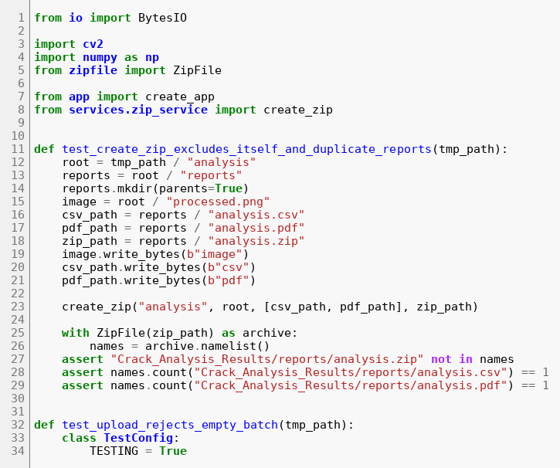
Figure 7.1: tests/test_app.py, lines 1 to 34
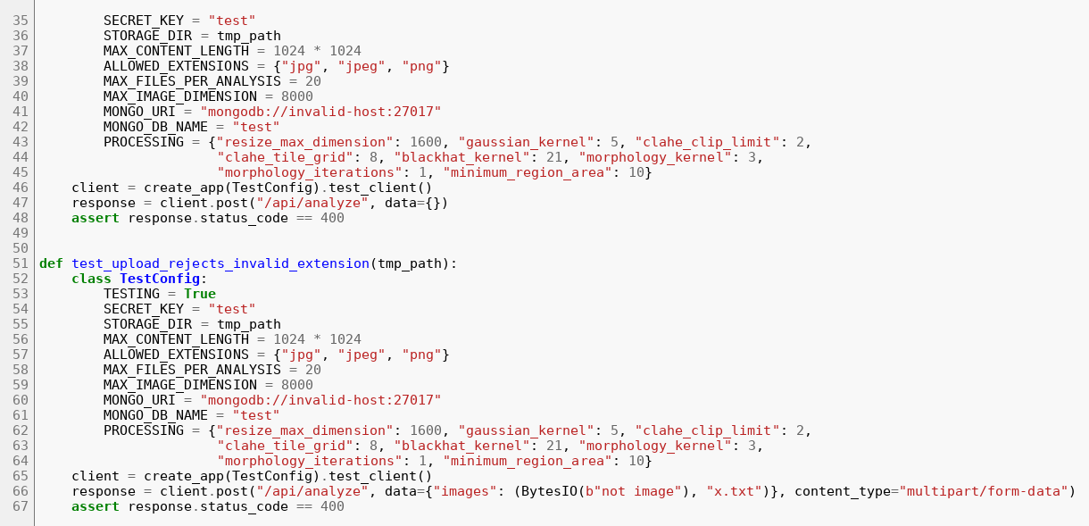
Figure 7.2: tests/test_app.py, lines 35 to 67

Source of tests/test_processing.py
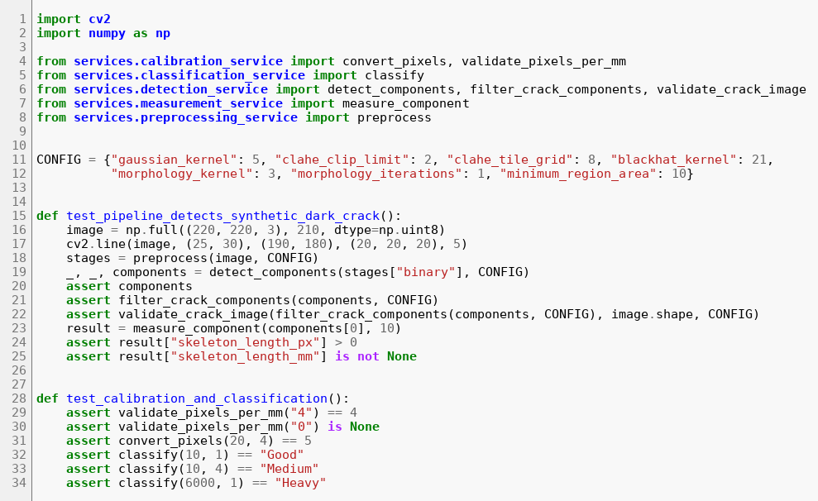
Figure 7.3: tests/test_processing.py, lines 1 to 34
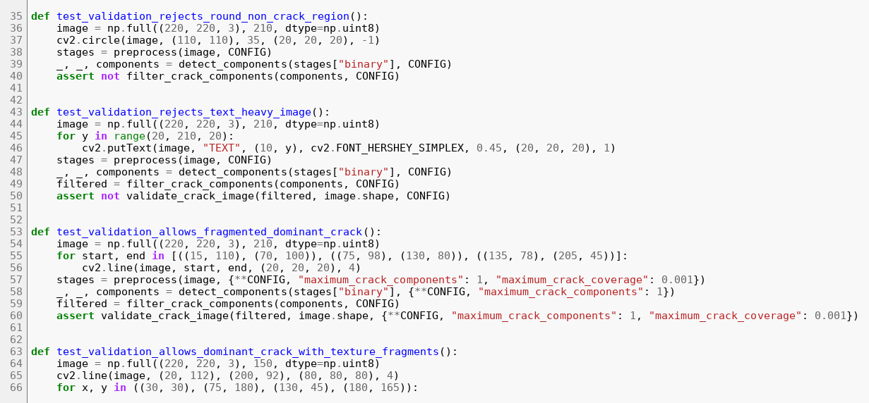
Figure 7.4: tests/test_processing.py, lines 35 to 68
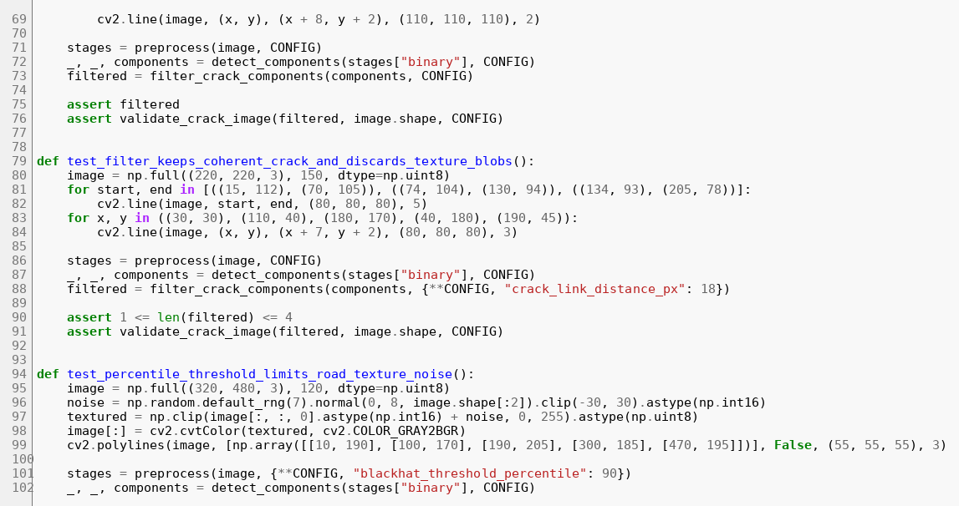
Figure 7.5: tests/test_processing.py, lines 69 to 102
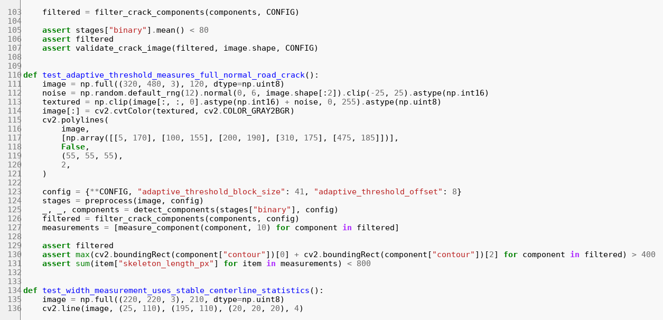
Figure 7.6: tests/test_processing.py, lines 103 to 136
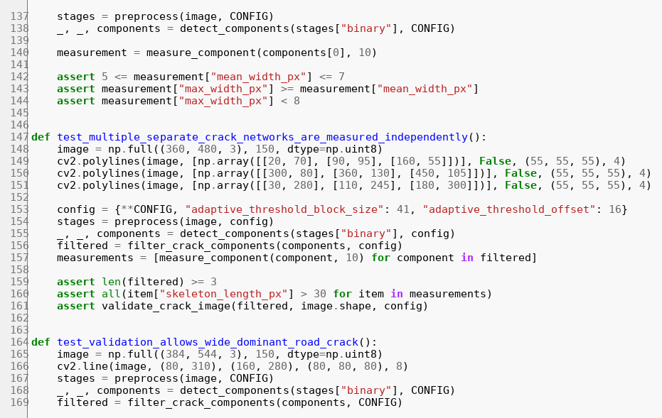
Figure 7.7: tests/test_processing.py, lines 137 to 170
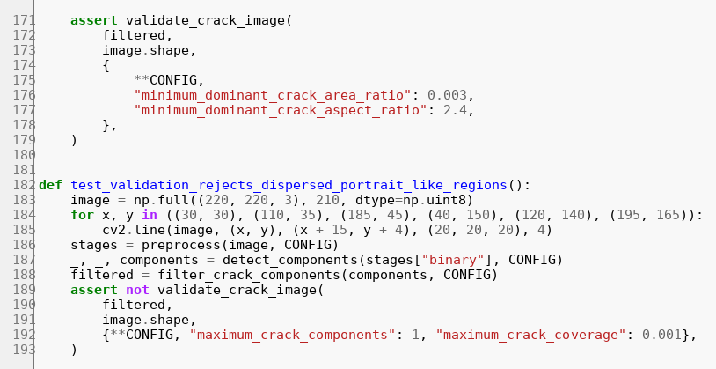
Figure 7.8: tests/test_processing.py, lines 171 to 193

Recorded result of the test run
The output below was produced by the script that executes the repository's test functions (Section 7.1). Each line shows the test file, the test name, the result and the time in seconds.
test_app test_create_zip_excludes_itself_and_duplicate_reports PASS 0.002
test_app test_upload_rejects_empty_batch PASS 0.022
test_app test_upload_rejects_invalid_extension PASS 0.013
test_processing test_adaptive_threshold_measures_full_normal_road_crack PASS 0.077
test_processing test_calibration_and_classification PASS 0.0
test_processing test_filter_keeps_coherent_crack_and_discards_texture_blobs PASS 0.007
test_processing test_multiple_separate_crack_networks_are_measured_independently PASS 0.057
test_processing test_percentile_threshold_limits_road_texture_noise PASS 0.384
test_processing test_pipeline_detects_synthetic_dark_crack PASS 0.012
test_processing test_validation_allows_dominant_crack_with_texture_fragments PASS 0.003
test_processing test_validation_allows_fragmented_dominant_crack PASS 0.003
test_processing test_validation_allows_wide_dominant_road_crack PASS 0.009
test_processing test_validation_rejects_dispersed_portrait_like_regions PASS 0.006
test_processing test_validation_rejects_round_non_crack_region PASS 0.002
test_processing test_validation_rejects_text_heavy_image PASS 0.007
test_processing test_width_measurement_uses_stable_centerline_statistics PASS 0.011
16 / 16

7.9 Test coverage assessment

Area | Covered by | Not covered
Upload validation | Empty batch, bad extension | Corrupt image data, oversized dimensions, more than 20 files, unreadable file
Pre-processing and detection | Synthetic lines, texture, circle, text, dispersed marks | Real photographs, extreme lighting, very large images
Measurement | Width statistics, multiple cracks, calibration | Length accuracy at different angles (added in Section 8.8), sub-pixel accuracy
Classification | Three severity outcomes | Boundary values exactly at the thresholds
Persistence | Fallback store used by all tests | Live MongoDB, indexes, history search and delete
Reports | ZIP assembly (unit test); CSV, PDF, ZIP generation (manual run) | Automated tests of CSV and PDF content
Web pages | Manual browser run | Automated UI tests, accessibility checks
Table 7.3: Test coverage assessment
A coverage tool was not available in the sandbox, so no percentage is given. The table is a manual assessment from reading the tests and the code.

Chapter 8 — Results, Discussion and Limitations

8.1 Implemented features and evidence of completion
All features in FR-01 to FR-14 are implemented in the repository. Evidence is the passing tests (Table 7.1), the end-to-end run (Figures 6.2 to 6.4) and the generated reports (Figure 6.5). Figure 8.1 shows the pipeline outputs for the synthetic image: the annotated result with width-sample lines, the skeleton, and the width-estimation image with the red skeleton and green width samples.
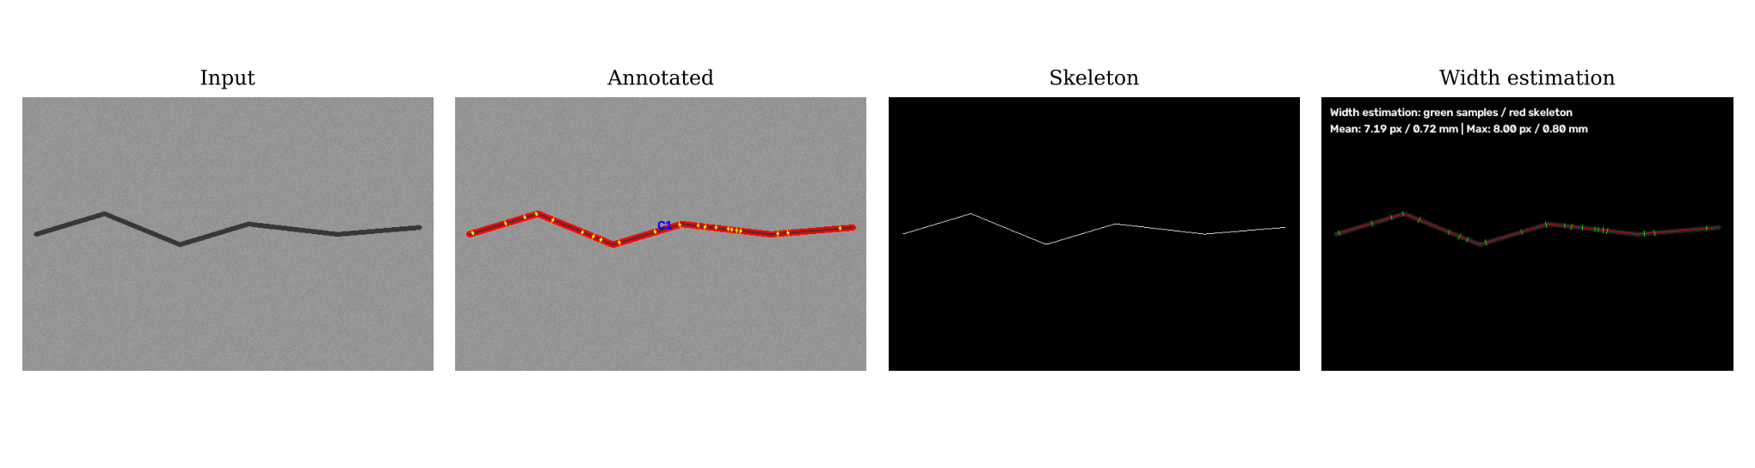
Figure 8.1: Input, annotated result, skeleton and width-estimation image

8.2 Results against each project objective
Objective | Result | Status
O1 Upload and validate | Valid files accepted; empty and invalid-type uploads rejected with 400 | Met
O2 Segment cracks | Synthetic cracks of 2 to 12 px drawn on noisy backgrounds were detected in all 8 sweep images; stages visible | Met on synthetic data
O3 Reject non-crack images | 4 of 4 negative synthetic images rejected; 3 dedicated unit tests pass | Met on synthetic data
O4 Measure length and width | Mean width within -0.2 to +0.6 px of the true raster width; skeleton length 5 to 7 % too long on oblique cracks | Met for width; length bias noted (Section 8.5)
O5 Calibrate and classify | px to mm conversion and 3-level labels work as specified | Met
O6 Present and export | Results page, CSV, PDF, ZIP produced | Met
O7 History | Implemented with MongoDB and fallback; not exercised with a live MongoDB in this report | Implemented; partly verified
Table 8.1: Objective-wise results

8.3 Quantitative metrics and how they were measured
Width accuracy. Eight synthetic 600 x 400 images were created with a Gaussian-noise background (standard deviation 6 grey levels) and a six-point polyline of fixed drawn width (thickness argument 2, 3, 4, 5, 6, 8, 10 and 12, dark grey 55 on a mid-grey background) using OpenCV's polylines. The application's own pipeline and parameters from config.py were applied and the mean-width and maximum-width outputs compared with the width of the line as actually rasterised. This distinction matters: OpenCV draws a line with thickness argument t that is 3, 5, 5, 7, 7, 9, 11 and 13 pixels wide for t = 2, 3, 4, 5, 6, 8, 10 and 12 (counted on a horizontal test line), so the thickness argument is not the true width. An earlier comparison against the thickness argument gave a misleading apparent over-estimate and was discarded; all comparisons here use the counted raster width.
Thickness argument | Raster width (px) | Mean width (px) | Error (px) | Error (%) | Max width P95 (px) | Length (px) | Severity
2 | 3 | 2.8 | -0.20 | -6.7 % | 4.0 | 613.8 | Good
3 | 5 | 5.6 | +0.60 | +12.0 % | 6.0 | 610.2 | Medium
4 | 5 | 5.6 | +0.60 | +12.0 % | 6.0 | 610.2 | Medium
5 | 7 | 7.19 | +0.19 | +2.7 % | 8.0 | 609.6 | Medium
6 | 7 | 7.19 | +0.19 | +2.7 % | 8.0 | 609.6 | Medium
8 | 9 | 8.79 | -0.21 | -2.3 % | 10.0 | 612.2 | Heavy
10 | 11 | 10.79 | -0.21 | -1.9 % | 12.0 | 612.2 | Heavy
12 | 13 | 12.79 | -0.21 | -1.6 % | 14.0 | 608.5 | Heavy

Table 8.2: Measured width against true raster width on synthetic images (geometric polyline length 578.9 px)
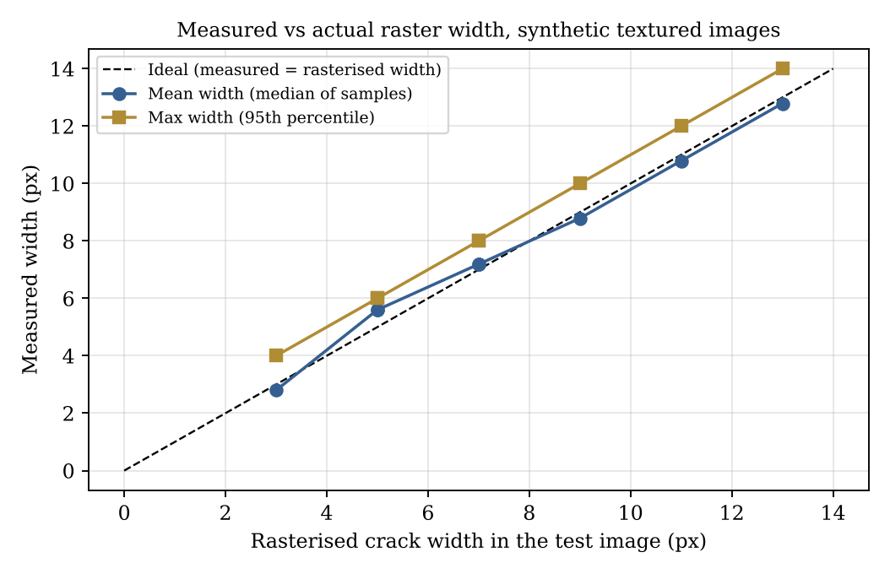
Figure 8.2: Measured versus true raster crack width
Length. The skeleton length of the polyline was 608.5 to 613.8 px against a geometric length of 578.9 px, about 5 to 6 % too long. A separate test with a straight 400 px line at seven angles (Section 8.8) showed errors of about -1 % at 0, 45 and 90 degrees but +6 to +7 % at 15, 30, 60 and 75 degrees.
Speed. Detection plus measurement (median of three runs) took 0.031 s for 640 x 480, 0.079 s for 1024 x 768 and 0.157 s for 1600 x 1200 images with one crack. In the browser run, the per-image timings reported by the application for a 480 x 360 image with three cracks were 0.0035 s (resize), 0.0046 s (pre-processing), 0.0042 s (detection), 0.0405 s (measurement) and 0.0098 s (annotation). Times depend on the machine and on the number and length of cracks (measurement time is dominated by skeleton-point neighbour searches).
Rejection. Plain wall, a filled circle on noisy background, a text-filled image and texture only (standard deviation 10) were all rejected (no crack components retained).
Multiple cracks. Three separate polylines drawn with thickness argument 4 (raster width 5 px) produced three measured cracks of 163.7, 179.2 and 184.0 px skeleton length, each with mean width 5.6 px.

8.4 Comparison with baseline / existing method
No comparison with manual gauge measurements, with a deep-learning model or with another open-source tool was carried out, so no claim of superiority is made. The experiment above measures the system against known synthetic geometry only. A comparison with gauge readings and with an annotated public dataset is listed as future work.

8.5 Interpretation of results and unexpected outcomes
- Against the true raster width, the mean-width estimate was between -0.21 and +0.60 px (-6.7 % to +12 %) for bars 3 to 13 px wide. The largest relative error is for the thinnest cracks, as expected for pixel-based measurement.
- Several widths give identical measurements (thickness arguments 3 and 4 both give 5.6 px; 5 and 6 both give 7.19 px, because they rasterise to the same width), and the other values differ in steps of about 0.4 to 1 px, which shows that width values are quantised by the discrete distance transform and the threshold. Sub-pixel accuracy should not be expected.
- For an ideal rectangular bar the method returns the true width plus one pixel, because the distance transform measures to the nearest background pixel (a 5 px bar gives 2 x 3.0 = 6.0 px; Section 5.12). In the full pipeline the threshold slightly narrows or widens the mask and the net error stayed within the range above; the two effects were not separated.
- Because the severity thresholds are in pixels (3 and 8 px), the same physical crack could receive different labels at different image resolutions; for example, the crack with raster width 5 px was labelled Medium because its measured width was 5.6 px.
- Skeleton length is over-estimated on oblique cracks (Section 8.8), probably because the neighbour-link counting adds both a diagonal and redundant axis-aligned links along a staircase skeleton; this was not isolated by a separate experiment.
- The maximum-width statistic (95th percentile) is about 0 to 1.4 px above the mean width on straight synthetic cracks.

8.6 Known limitations and unresolved issues
- Synthetic evidence only. Accuracy and robustness have been measured on synthetic images; no quantitative evaluation on annotated real concrete or pavement photographs has been done.
- Scale handling. Calibration is a single default (10 px/mm) for all images. Images larger than 1600 px are resized, but the scale is not adjusted for the resize factor (the factor is stored but not applied to the px/mm value), so millimetre values for resized images are only correct if the supplied scale refers to the resized image. A function to recalibrate stored measurements exists in models/measurement_model.py, but no route calls it.
- Length bias on oblique cracks (Section 8.8) and one-pixel quantisation of width (Section 8.5); millimetre values inherit both.
- Appearance assumptions. Cracks are assumed darker than their surroundings; shadows, joints, stains, vegetation and markings can be mistaken for cracks, and very faint cracks can be missed.
- Batch rejection. A single image without a detectable crack causes the whole upload to be discarded.
- Labels. The results page labels the binary stage "Otsu threshold" although the default pipeline uses an adaptive Gaussian threshold; the PROCESSING configuration, not the label, is authoritative.
- No authentication or multi-user control; the delete endpoint is unauthenticated, so the application must not be exposed publicly.
- Persistence. Without MongoDB the history is lost on restart; report_history is indexed but never written.
- Severity categories are software classes, not engineering judgement, and ignore crack depth, location and cause.
- The repository name and application title use the spelling "Crack Detaction" in the user interface and README.

8.7 User feedback or evaluation
No user study was carried out and no user data were collected.

8.8 Additional experiments: robustness and sensitivity
Seven further experiments were run to see how the pipeline behaves when conditions change. In every case the application's own services and the default parameters from config.py were used, on synthetic 600 x 400 images unless stated otherwise (crack: six-point polyline, thickness argument 6, which rasterises to 7 px; background grey 150 plus Gaussian noise). The scripts are the same style as the accuracy experiment and the numbers below are the recorded outputs.

Experiment A — noise level

Noise SD (grey levels) | Runs detected (of 5) | Mean width (px) | Mean components
2 | 5 | 7.19 | 1.0
4 | 5 | 7.19 | 1.0
6 | 5 | 7.19 | 1.0
8 | 5 | 7.19 | 1.0
10 | 5 | 7.19 | 1.0
12 | 5 | 7.19 | 1.0
16 | 5 | 7.19 | 1.0
20 | 5 | 7.19 | 1.0
25 | 5 | 7.19 | 1.0
Table 8.3: Effect of background noise on detection and width
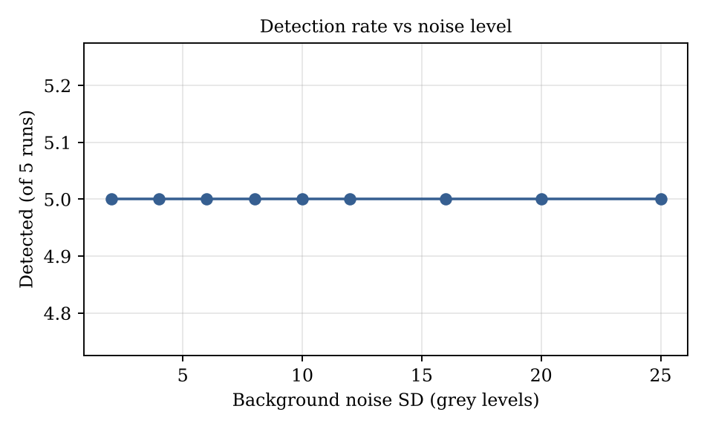
Figure 8.3: Detection rate versus noise level
The crack was detected in all five runs at every noise level from 2 to 25 grey levels, with an identical mean width of 7.19 px and one component. The crack is dark (contrast about 95 grey levels), so noise up to this level does not hide it. This says nothing about weak cracks, which Experiment B addresses.

Experiment B — crack contrast
Crack grey level | Contrast (150 - level) | Components | Accepted | Mean width (px) | Length (px)
20 | 130 | 1 | yes | 7.19 | 609.6
55 | 95 | 1 | yes | 7.19 | 609.6
80 | 70 | 1 | yes | 7.19 | 609.6
100 | 50 | 1 | yes | 7.19 | 609.6
115 | 35 | 1 | yes | 7.19 | 609.6
125 | 25 | 0 | no | - | 0.0
135 | 15 | 0 | no | - | 0.0
Table 8.4: Effect of crack contrast on detection
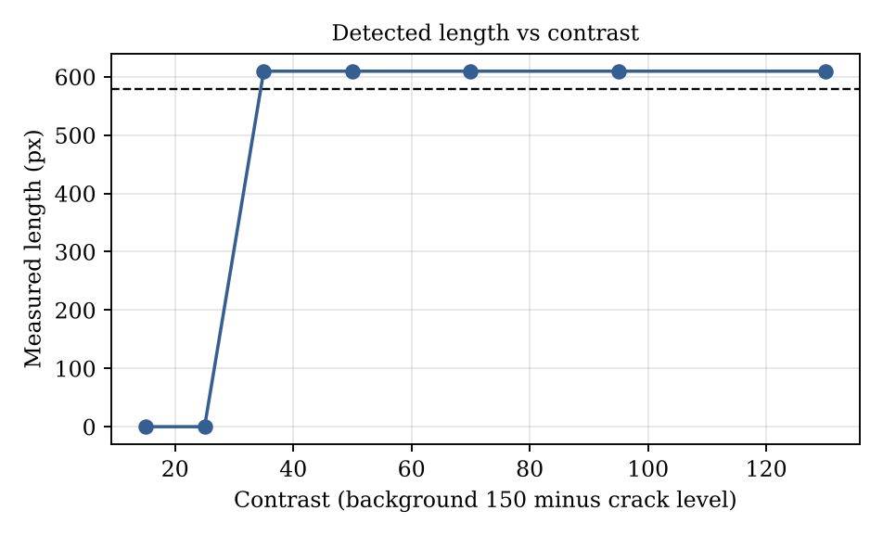
Figure 8.4: Measured length versus contrast (dashed line: geometric length 578.9 px)
Cracks with contrast of 35 grey levels or more were detected with identical measurements. At 25 and 15 grey levels nothing was detected. The practical limit of the default parameters on this background is therefore a contrast of roughly 25 to 35 grey levels; faint cracks on real surfaces may fall below it. Lowering the threshold offset would increase sensitivity but also increase false positives on texture (Experiment D).

Experiment C — crack orientation
Angle (deg) | Geometric length (px) | Measured length (px) | Error (%) | Mean width (px)
0 | 400.0 | 396.0 | -1.0 | 8.0
15 | 400.5 | 427.7 | +6.8 | 7.19
30 | 400.5 | 428.8 | +7.1 | 7.19
45 | 400.2 | 398.8 | -0.4 | 7.19
60 | 401.0 | 426.8 | +6.4 | 7.19
75 | 400.5 | 425.2 | +6.2 | 7.19
90 | 400.0 | 395.0 | -1.2 | 8.0
Table 8.5: Length and width of a straight crack at different angles
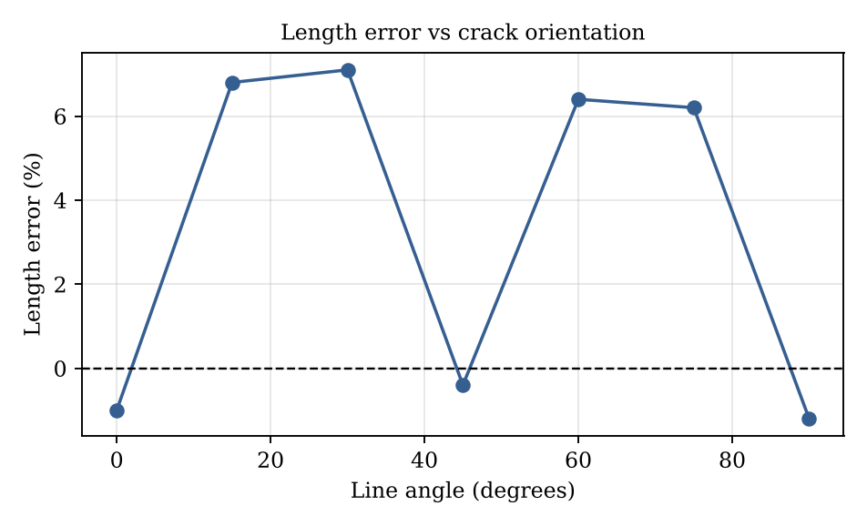
Figure 8.5: Length error versus line angle
The width is stable (7.19 or 8.0 px) at all angles. The length, however, is over-estimated by 6 to 7 % at 15, 30, 60 and 75 degrees and is accurate within about 1 % at 0, 45 and 90 degrees. This pattern points to the way skeleton links are counted: along an oblique staircase-shaped skeleton the loop adds a diagonal link and additional axis-aligned links for the same stretch of crack. The effect is the cause of the 5 to 6 % excess seen on the polyline in Section 8.3. For reporting, lengths of oblique cracks should be read as up to about 7 % high until the counting is corrected.

Experiment D — adaptive-threshold offset C

Offset C | Crack components | Crack accepted | Mean width (px) | Texture-only image accepted | Foreground coverage (%)
4 | 1 | yes | 7.19 | no | 1.68
8 | 1 | yes | 7.19 | no | 1.68
12 | 1 | yes | 7.19 | no | 1.68
16 | 1 | yes | 7.19 | no | 1.68
20 | 1 | yes | 7.19 | no | 1.68
24 | 1 | yes | 7.19 | no | 1.68
Table 8.6: Sensitivity to the threshold offset (texture SD 10)

Within the range 4 to 24, the offset made no difference to the crack (one component, 7.19 px) and the texture-only image (noise SD 10) was always rejected. This is expected for a strong crack on a plain background. The experiment does not show how the offset behaves on weak cracks or on structured texture, where it will matter more, and the default of 16 was inherited from the repository's tuning on its own test images.

Experiment E — adaptive-threshold block size

Block size (px) | Crack components | Crack accepted | Mean width (px) | Texture-only image accepted | Coverage (%)
21 | 1 | yes | 7.19 | no | 1.68
31 | 1 | yes | 7.19 | no | 1.68
41 | 1 | yes | 7.19 | no | 1.68
61 | 1 | yes | 7.19 | no | 1.68
81 | 1 | yes | 7.19 | no | 1.68
Table 8.7: Sensitivity to the threshold neighbourhood size

Block sizes from 21 to 81 px gave the same result. A block that is much narrower than the crack would break it, while one much larger than the crack's surroundings would behave like a global threshold; neither extreme was tested because the default is well inside the stable range.

Experiment F — image scale

Scale | Image size | Thickness argument | Mean width (px) | Measured length (px) | Geometric length (px) | Time (s)
0.5 | 300x200 | 3 | 5.6 | 303.3 | 289.5 | 0.016
0.75 | 450x300 | 4 | 5.6 | 457.8 | 434.2 | 0.025
1.0 | 600x400 | 6 | 7.19 | 609.6 | 578.9 | 0.04
1.5 | 900x600 | 9 | 10.79 | 918.3 | 868.4 | 0.077
2.0 | 1200x800 | 12 | 12.79 | 1222.4 | 1157.9 | 0.122
Table 8.8: Same scene at five image scales

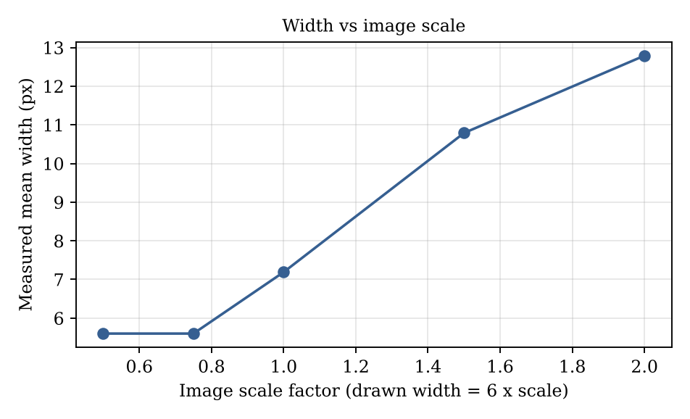
Figure 8.6: Measured width versus image scale
The measured width grows with the image scale, as it should for a quantity measured in pixels, from 5.6 px in the 300 x 200 image to 12.79 px in the 1200 x 800 image. The length scales proportionally and its error stays between 4.8 % and 5.7 %. This confirms that millimetre results are only meaningful when the pixels-per-millimetre value matches the image actually analysed, and it illustrates why the resize step must be accompanied by a scale correction (Section 8.6).

Experiment G — time per processing stage

Stage | Mean time (s) | Standard deviation (s)
Pre-processing | 0.0208 | 0.0012
Detection, filtering and validation | 0.0168 | 0.0015
Measurement (skeleton, width, diagnostic images) | 0.057 | 0.004
Total | 0.0946
Table 8.9: Mean stage time over 20 images of 1024 x 768 px with one crack

Measurement takes the largest share (about 60 %), consistent with the quadratic neighbour search discussed in Section 5.14. The total of about 0.095 s per image means that a batch of 20 images would be analysed in a couple of seconds on this machine, excluding file writing and report generation.

8.9 Discussion
What worked. On synthetic data the pipeline detected strong cracks reliably at all tested noise levels, rejected all four kinds of non-crack image, measured width to within about 0.6 px of the true raster width, handled several crack networks in one image and ran in a fraction of a second. The stage-by-stage output made every result easy to inspect, which was one of the project's design aims.
What did not. Weak cracks (contrast below about 30 grey levels) were not detected; lengths of oblique cracks were about 6 to 7 % too long; width values are quantised to roughly one pixel; and the scale is fixed. These are properties of the current implementation and parameters, not of classical methods in general.
Comparison of the method with its alternatives. A learned segmentation model would probably cope better with real surface texture, but it would need labelled images and a GPU for training, and it would not by itself provide a width in millimetres. The present approach trades robustness on unseen textures for transparency, speed and the absence of training data. A hybrid in which a learned model proposes the crack mask and the present measurement stage computes length and width is a natural next step.

8.10 Threats to validity
- Construct validity: the crack width of a synthetic line is exactly known, but a real crack has irregular, soft edges, so the definition of width differs. Real validation needs gauge readings at marked points.
- Internal validity: an early version of the accuracy comparison used the wrong ground truth (the drawn thickness argument instead of the rasterised width); this was found and corrected, and all values in this report use the counted raster width.
- External validity: the experiments use a single synthetic background type and a single crack colour; results may differ on concrete, brick, asphalt or painted walls.
- Reproducibility: the images are generated with fixed random seeds, and the parameters are those of config.py at the time of writing. The scripts are not part of the repository; adding them as a test or benchmark folder would make the experiments repeatable.

Chapter 9 — Conclusion and Future Scope

9.1 Summary of the problem and solution
The project addressed the need for a repeatable, documented way to detect cracks in images and to measure their length and width. It delivered a Flask web application that applies a classical OpenCV and scikit-image pipeline, estimates length and width from skeletons and distance transforms, converts to millimetres, labels severity, and exports CSV, PDF and ZIP reports, with MongoDB persistence and an in-memory fallback.

9.2 Objective-wise completion status
Objectives O1, O2, O3, O5 and O6 are met as verified on automated tests and synthetic images; O4 is implemented, with width accurate to within about 0.6 px on synthetic data but length over-estimated by about 6 to 7 % on oblique cracks; O7 is implemented but was exercised only through the fallback store. See Table 8.1.

9.3 Main contributions and conclusions
- An end-to-end, explainable crack-measurement tool that runs on a CPU without training data.
- A texture-suppressing detection and validation stage (shape, coherence, coverage and alignment rules) that rejected all negative images in the experiment.
- A robust width statistic (median and 95th percentile of centreline distance-transform widths) and per-crack length, area and severity output.
- A reporting workflow with all intermediate images, suitable for inspection records.

9.4 Limitations
The principal limitations are the absence of real-photograph validation, the one-pixel width quantisation, the length over-estimate on oblique cracks, the fixed and resize-unaware calibration, and the lack of authentication (Section 8.6).

9.5 Future enhancements
- Evaluate on public annotated crack datasets and on gauge measurements; report precision, recall, IoU and width error.
- Correct the skeleton-length counting for oblique cracks (for example, by counting each skeleton step once along an ordered path) and add regression tests with known lengths and widths.
- Per-image calibration (reference object or user-entered scale) and automatic adjustment of the scale for resized images.
- Define severity thresholds in millimetres, with standards-based categories agreed with a structural engineer.
- Optional learned segmentation model combined with the existing measurement stage.
- Perspective correction, video or drone input, crack-growth tracking across visits, user accounts and deployment hardening.

9.6 Learning outcomes and skills demonstrated
The project demonstrates applied image processing (contrast enhancement, thresholding, morphology, skeletonisation, distance transforms), Python web development with Flask, NoSQL data modelling with MongoDB, automated testing with synthetic data, report generation, version control with Git and GitHub, and the practice of reporting measured results and limitations honestly.

References
- Borgefors, G. (1986). Distance transformations in digital images. Computer Vision, Graphics, and Image Processing, 34(3), 344–371. https://doi.org/10.1016/S0734-189X(86)80047-0
- Bradski, G. (2000). The OpenCV Library. Dr. Dobb's Journal of Software Tools.
- Cha, Y.-J., Choi, W., & Büyüköztürk, O. (2017). Deep learning-based crack damage detection using convolutional neural networks. Computer-Aided Civil and Infrastructure Engineering, 32(5), 361–378. https://doi.org/10.1111/mice.12263
- Dorafshan, S., Thomas, R. J., & Maguire, M. (2018). Comparison of deep convolutional neural networks and edge detectors for image-based crack detection in concrete. Construction and Building Materials, 186, 1031–1045. https://doi.org/10.1016/j.conbuildmat.2018.08.011
- Harris, C. R., Millman, K. J., van der Walt, S. J., et al. (2020). Array programming with NumPy. Nature, 585, 357–362. https://doi.org/10.1038/s41586-020-2649-2
- Koch, C., Georgieva, K., Kasireddy, V., Akinci, B., & Fieguth, P. (2015). A review on computer vision based defect detection and condition assessment of concrete and asphalt civil infrastructure. Advanced Engineering Informatics, 29(2), 196–210. https://doi.org/10.1016/j.aei.2015.01.008
- McKinney, W. (2010). Data structures for statistical computing in Python. Proceedings of the 9th Python in Science Conference, 56–61.
- Mohan, A., & Poobal, S. (2018). Crack detection using image processing: A critical review and analysis. Alexandria Engineering Journal, 57(2), 787–798. https://doi.org/10.1016/j.aej.2017.01.020
- MongoDB, Inc. (n.d.). MongoDB documentation. https://www.mongodb.com/docs/
- OpenCV team. (n.d.). OpenCV documentation. https://docs.opencv.org/
- Otsu, N. (1979). A threshold selection method from gray-level histograms. IEEE Transactions on Systems, Man, and Cybernetics, 9(1), 62–66. https://doi.org/10.1109/TSMC.1979.4310076
- Özgenel, Ç. F. (2019). Concrete crack images for classification (Version 2) [Data set]. Mendeley Data. https://doi.org/10.17632/5y9wdsg2zt.2
- Özgenel, Ç. F., & Gönenç Sorguç, A. (2018). Performance comparison of pretrained convolutional neural networks on crack detection in buildings. Proceedings of the 35th International Symposium on Automation and Robotics in Construction (ISARC).
- Pallets. (n.d.). Flask documentation. https://flask.palletsprojects.com/
- ReportLab. (n.d.). ReportLab documentation. https://docs.reportlab.com/
- van der Walt, S., Schönberger, J. L., Nunez-Iglesias, J., et al. (2014). scikit-image: Image processing in Python. PeerJ, 2, e453. https://doi.org/10.7717/peerj.453
- Yamaguchi, T., & Hashimoto, S. (2010). Fast crack detection method for large-size concrete surface images using percolation-based image processing. Machine Vision and Applications, 21(5), 797–809. https://doi.org/10.1007/s00138-009-0189-8
- Zhang, L., Yang, F., Zhang, Y. D., & Zhu, Y. J. (2016). Road crack detection using deep convolutional neural network. 2016 IEEE International Conference on Image Processing (ICIP), 3708–3712. https://doi.org/10.1109/ICIP.2016.7533052
- Zhang, T. Y., & Suen, C. Y. (1984). A fast parallel algorithm for thinning digital patterns. Communications of the ACM, 27(3), 236–239. https://doi.org/10.1145/357994.358023
- Zuiderveld, K. (1994). Contrast limited adaptive histogram equalization. In P. S. Heckbert (Ed.), Graphics Gems IV (pp. 474–485). Academic Press.
- Patel, M. (2026). OpenCV-Based System for Crack Identification and Width Estimation [Source code]. GitHub. https://github.com/ManPatel448/OpenCV-Based-System-for-Crack-Identification-and-Width-Estimation

Appendices / Annexures
Appendices A to J follow the list in the institutional format. Items that depend on university records are marked for the student to attach.

Appendix A — Approved synopsis / proposal and approval record
[Attach the approved synopsis and approval record, if required by the institution.]

Appendix B — Detailed Software Requirements Specification
Purpose and product perspective. A self-contained web application used locally to analyse crack photographs. User classes: inspector or student (single class). Operating environment: Python 3.10+, any OS, optional MongoDB. Design constraints: OpenCV-based processing; images stored on disk; calibration by a single positive number.

Interface | Specification
User interface | Web pages /upload, /analysis/<id>, /history, /reports; files .jpg, .jpeg, .jfif, .png
Software interface | OpenCV (image operations), scikit-image (skeletonize), NumPy, pandas (CSV), ReportLab (PDF), PyMongo (database)
Communication | HTTP on 127.0.0.1:5000; JSON for APIs; multipart form data for upload
Data limits | At most 20 files per analysis; request size limit 16 MB; longest side 8000 px; resize to 1600 px
Environment variables | FLASK_SECRET_KEY, MONGO_URI, MONGO_DB_NAME, MAX_CONTENT_LENGTH, STORAGE_DIR, FLASK_AUTO_RELOAD
Table 9.1: External interface specification

Appendix C — Database dictionary and sample report

Collection | Fields
analyses | analysis_id (string, unique), analysis_name, notes, created_at, updated_at, status (Uploaded / Processing / Completed), total_images, total_detected_regions, calibration_enabled, pixels_per_mm, processing_configuration, severity_thresholds, error_summary
images | image_id, analysis_id, original_filename, stored_filename, original_path, uploaded_at, processing_status (Uploaded / Completed / Failed), workflow_times, image_width, image_height, resize_scale, processed_paths, annotated_path, error_message
crack_measurements | crack_id, analysis_id, image_id, created_at, contour_area_px, contour_area_mm2, skeleton_length_px, skeleton_length_mm, mean_width_px, max_width_px, mean_width_mm, max_width_mm, calibration_status (calibrated / pixel-only), severity, measurement_points (x, y, width_px, width_mm, angle), width_sample_count
report_history | Indexed (analysis_id, generated_at) but not written by the current code
Table 9.2: Logical database dictionary
Sample CSV rows (from the end-to-end run, selected columns; the file has 34 columns):

Crack_ID | Length (px) | Length (mm) | Mean width (px) | Max width (px) | Mean width (mm) | Severity
8fd53828-1 | 609.605 | 60.961 | 7.194 | 8.000 | 0.719 | Medium
45fe284b-1 | 163.681 | 16.368 | 5.600 | 5.600 | 0.560 | Medium
45fe284b-2 | 179.238 | 17.924 | 5.600 | 5.600 | 0.560 | Medium
45fe284b-3 | 184.037 | 18.404 | 5.600 | 5.600 | 0.560 | Medium
Table 9.3: Sample CSV measurement rows

Appendix D — Detailed test cases and test evidence
The test cases are listed in Table 7.1. The procedures for the experiments are as follows.
- Unit tests (TC-01 to TC-16): functions in tests/test_app.py and tests/test_processing.py, executed with Python 3.13.16 using a small runner; 16 of 16 passed, each in under 0.25 s.
- TC-17 to TC-20: Flask server started with python app.py (auto-reload off); Playwright/Chromium opened /upload, attached two images, clicked "Upload and detect cracks", waited for the results URL, captured screenshots; reports requested with HTTP GET.
- TC-21 negatives: 400 x 300 images: constant grey wall (170); noisy background with a filled circle of radius 40; light background with rows of text; noisy background (SD 10) only.
- TC-22 sweep: 600 x 400 images; background 150 plus Gaussian noise (SD 6, clipped at ±25); polyline points (20,200), (120,170), (230,215), (330,185), (460,200), (580,190); colour (55,55,55); widths 2, 3, 4, 5, 6, 8, 10, 12 px; pixels per millimetre 10.

Appendix E — User manual / installation and execution guide
- Follow the steps in Section 6.9 to install and start the application.
- Open http://127.0.0.1:5000 (redirects to /upload). Click the drop area or drag images onto it. Use "Remove image" to deselect a file.
- Click "Upload and detect cracks". If an image contains no detectable crack, an error message is shown and nothing is stored; choose clearer images and retry.
- On the results page read the summary, remark and thresholds; click any image to enlarge it; scroll to the measurement table for per-crack values.
- Use Download CSV, Download PDF or Download ZIP. Use /history to find or delete earlier analyses.
- Interpret severity as a screening label only; consult a qualified engineer for structural decisions.

Appendix F — Repository details and selected source
Repository:https://github.com/ManPatel448/OpenCV-Based-System-for-Crack-Identification-and-Width-Estimation.git Commit history (from git log):

Date | Commit message
2026-10-05 | Initial commit: crack identification application
2026-10-05 | Delete PROJECT_DOCUMENTATION.md; Delete run_crackscope.bat; Update README to remove Windows launch instructions
2026-10-12 | Improve crack validation for textured images; Merge remote repository updates; Improve road crack validation and auto reload; Restore Windows application launcher
2026-10-12 | Keep only coherent crack paths in annotations; Reduce pavement texture in crack segmentation; Improve normal crack measurement geometry; Stabilize crack width measurements; Detect multiple crack networks per image
2026-10-18 | Update project files (three commits); Remove batch file from repository
Table 9.4: Commit history summary

File | Lines | File | Lines
services/pdf_service.py | 291 | services/measurement_service.py | 164
tests/test_processing.py | 193 | routes/upload_routes.py | 169
services/detection_service.py | 130 | static/app.js | 113
routes/analysis_routes.py | 98 | tests/test_app.py | 67
services/csv_service.py | 57 | models/analysis_model.py | 56
app.py | 54 | services/zip_service.py | 50
Table 9.5: Larger source files (line counts); the repository has about 1,990 lines in total

F.1 Full source listings
The files below are reproduced from the repository so that the report is self-contained. Core algorithm files are shown as screenshots in Section 6.11; the test files, report generator, templates, style sheet and configuration files are listed here as text. Long single-line template files are wrapped.

F.1 — services/pdf_service.py
1 from collections import Counter
2 from datetime import datetime, timezone
3 from pathlib import Path
4 from xml.sax.saxutils import escape
5
6 from reportlab.lib import colors
7 from reportlab.lib.enums import TA_CENTER
8 from reportlab.lib.pagesizes import A4
9 from reportlab.lib.styles import ParagraphStyle, getSampleStyleSheet
10 from reportlab.lib.units import inch
11 from reportlab.platypus import (
12 Image,
13 PageBreak,
14 Paragraph,
15 SimpleDocTemplate,
16 Spacer,
17 Table,
18 TableStyle,
19 KeepTogether,
20 )
21 from reportlab.lib.utils import ImageReader
22
23
24 WORKFLOW_STEPS = [
25 ("1", "Upload and validate", "Check file type, size, and image readability.", "Validated source
26 image"),
27 ("2", "Resize image", "Fit the image to the configured processing dimension.", "Resized image"),
28 ("3", "Preprocess", "Create grayscale, blur, CLAHE, and BlackHat images.", "Preprocessing images"),
29 ("4", "Segment crack candidates", "Apply thresholding, morphology, and connected components.",
30 "Binary and segmentation masks"),
31 ("5", "Measure cracks", "Skeletonize regions and estimate area, length, and width.", "Skeleton,
32 distance transform, width estimates"),
33 ("6", "Calibrate and classify", "Convert pixels to millimeters and assign severity.", "px/mm
34 measurements and severity"),
35 ("7", "Annotate and export", "Draw measurement lines and prepare report files.", "Annotated image,
36 CSV, PDF, ZIP"),
37 ]
38
39
40 def _text(value):
41 return escape(str(value if value is not None else ""))
42
43
44 def _number(value, unit=""):
45 if value is None:
46 return "Not calibrated" if unit == "mm" else "-"
47 return f"{float(value):.2f} {unit}".strip()
48
49
50 def _date_time(value):
51 if hasattr(value, "astimezone"):
52 local_value = value.astimezone()
53 return local_value.strftime("%Y-%m-%d %H:%M:%S %z")
54 if value:
55 return str(value)
56 return "Not available"
57
58
59 def _image(path, max_width=6.4 * inch, max_height=3.8 * inch):
60 """Create an aspect-preserving ReportLab image."""
61 reader = ImageReader(str(path))
62 width, height = reader.getSize()
63 scale = min(max_width / width, max_height / height)
64 image = Image(str(path), width=width * scale, height=height * scale)
65 image.hAlign = "LEFT"
66 return image
67
68
69 def _table(rows, widths, header=True, font_size=8):
70 style = [
71 ("GRID", (0, 0), (-1, -1), 0.35, colors.HexColor("#94a3b8")),
72 ("VALIGN", (0, 0), (-1, -1), "MIDDLE"),
73 ("FONTSIZE", (0, 0), (-1, -1), font_size),
74 ("LEFTPADDING", (0, 0), (-1, -1), 5),
75 ("RIGHTPADDING", (0, 0), (-1, -1), 5),
76 ("TOPPADDING", (0, 0), (-1, -1), 5),
77 ("BOTTOMPADDING", (0, 0), (-1, -1), 5),
78 ]
79 if header:
80 style.extend([
81 ("BACKGROUND", (0, 0), (-1, 0), colors.HexColor("#dbeafe")),
82 ("TEXTCOLOR", (0, 0), (-1, 0), colors.HexColor("#172033")),
83 ("FONTNAME", (0, 0), (-1, 0), "Helvetica-Bold"),
84 ])
85 return Table(rows, colWidths=widths, repeatRows=1 if header else 0, style=TableStyle(style))
86
87
88 def _footer(canvas, document):
89 canvas.saveState()
90 canvas.setStrokeColor(colors.HexColor("#cbd5e1"))
91 canvas.line(36, 28, A4[0] - 36, 28)
92 canvas.setFont("Helvetica", 8)
93 canvas.setFillColor(colors.HexColor("#64748b"))
94 canvas.drawString(36, 16, "Crack Detaction - image-based crack measurement report")
95 canvas.drawRightString(A4[0] - 36, 16, f"Page {document.page}")
96 canvas.restoreState()
97
98
99 def create_pdf(analysis, images, measurements, output_path):
100 Path(output_path).parent.mkdir(parents=True, exist_ok=True)
101 doc = SimpleDocTemplate(
102 str(output_path),
103 pagesize=A4,
104 rightMargin=36,
105 leftMargin=36,
106 topMargin=42,
107 bottomMargin=42,
108 title=f"Crack Detaction report - {analysis.get('analysis_name', '')}",
109 )
110 styles = getSampleStyleSheet()
111 styles.add(ParagraphStyle(name="ReportTitle", parent=styles["Title"], alignment=TA_CENTER,
112 fontSize=20, leading=24, spaceAfter=10, textColor=colors.HexColor("#123b66")))
113 styles.add(ParagraphStyle(name="Small", parent=styles["BodyText"], fontSize=8, leading=10,
114 spaceAfter=6, textColor=colors.HexColor("#475569")))
115 styles.add(ParagraphStyle(name="Step", parent=styles["BodyText"], fontSize=9, leading=12,
116 spaceAfter=3))
117 styles["Heading2"].spaceBefore = 12
118 styles["Heading2"].spaceAfter = 8
119 styles["Heading3"].spaceBefore = 10
120 styles["Heading3"].spaceAfter = 6
121 generated_at = datetime.now(timezone.utc)
122 story = [
123 Paragraph("Crack Detaction Measurement Report", styles["ReportTitle"]),
124 Spacer(1, 6),
125 Paragraph(f"<b>Analysis:</b> {_text(analysis.get('analysis_name', 'Untitled analysis'))}",
126 styles["Heading2"]),
127 Paragraph(f"<b>Analysis ID:</b> {_text(analysis.get('analysis_id', ''))} &nbsp;&nbsp;
128 <b>Status:</b> {_text(analysis.get('status', ''))}", styles["Small"]),
129 Paragraph(f"<b>Analysis date and time:</b> {_text(_date_time(analysis.get('created_at')))}",
130 styles["Small"]),
131 Paragraph(f"<b>Report generated date and time:</b> {_text(_date_time(generated_at))}",
132 styles["Small"]),
133 Paragraph("This report contains automated image-processing results. It is not a certified
134 structural safety assessment.", styles["Small"]),
135 Spacer(1, 14),
136 ]
137
138 counts = Counter(item.get("severity", "Unknown") for item in measurements)
139 total = len(measurements)
140 calibrated = bool(analysis.get("calibration_enabled") and analysis.get("pixels_per_mm"))
141 pixels_per_mm = analysis.get("pixels_per_mm")
142 total_length_px = sum(item.get("skeleton_length_px", 0) for item in measurements)
143 total_length_mm = sum(item.get("skeleton_length_mm") or 0 for item in measurements) if calibrated
144 else None
145 average_width_px = sum(item.get("mean_width_px", 0) for item in measurements) / total if total else 0
146 average_width_mm = sum(item.get("mean_width_mm") or 0 for item in measurements) / total if total and
147 calibrated else None
148 maximum_width_px = max((item.get("max_width_px", 0) for item in measurements), default=0)
149 maximum_width_mm = max((item.get("max_width_mm") or 0 for item in measurements), default=0) if
150 calibrated else None
151 overall = "Heavy" if counts["Heavy"] else "Medium" if counts["Medium"] else "Good" if total else "No
152 data"
153
154 summary_rows = [
155 ["Report item", "Result"],
156 ["Images processed", str(len(images))],
157 ["Detected crack regions", str(total)],
158 ["Total crack length", f"{_number(total_length_px, 'px')} / {_number(total_length_mm, 'mm')}"],
159 ["Average crack width", f"{_number(average_width_px, 'px')} / {_number(average_width_mm,
160 'mm')}"],
161 ["Maximum crack width", f"{_number(maximum_width_px, 'px')} / {_number(maximum_width_mm,
162 'mm')}"],
163 ["Overall severity", f"{overall} (Good {counts['Good']}, Medium {counts['Medium']}, Heavy
164 {counts['Heavy']})"],
165 ["Calibration", f"{_number(pixels_per_mm, 'pixels/mm')}" if calibrated else "Pixel-only;
166 millimeters not calibrated"],
167 ]
168 story.extend([
169 KeepTogether([
170 Paragraph("1. Crack analysis summary", styles["Heading2"]),
171 Paragraph("This section provides the key results before the detailed workflow and evidence.",
172 styles["Small"]),
173 Spacer(1, 10),
174 _table(summary_rows, [2.3 * inch, 4.0 * inch]),
175 ]),
176 Spacer(1, 14),
177 ])
178
179 thresholds = analysis.get("severity_thresholds", {"good_max_width_px": 3, "medium_max_width_px": 8,
180 "heavy_min_area_px": 5000})
181 threshold_rows = [["Category", "Pixel rule", "Millimeter rule"]]
182 if calibrated:
183 threshold_rows.extend([
184 ["Good", f"Mean width <= {thresholds['good_max_width_px']} px", f"Mean width <=
185 {thresholds['good_max_width_px'] / pixels_per_mm:.3f} mm"],
186 ["Medium", f"> {thresholds['good_max_width_px']} and <= {thresholds['medium_max_width_px']}
187 px", f"> {thresholds['good_max_width_px'] / pixels_per_mm:.3f} and <=
188 {thresholds['medium_max_width_px'] / pixels_per_mm:.3f} mm"],
189 ["Heavy", f"> {thresholds['medium_max_width_px']} px or area >=
190 {thresholds['heavy_min_area_px']} px^2", f"> {thresholds['medium_max_width_px'] / pixels_per_mm:.3f}
191 mm or area >= {thresholds['heavy_min_area_px'] / pixels_per_mm**2:.3f} mm^2"],
192 ])
193 else:
194 threshold_rows.extend([
195 ["Good", f"Mean width <= {thresholds['good_max_width_px']} px", "Not calibrated"],
196 ["Medium", f"> {thresholds['good_max_width_px']} and <= {thresholds['medium_max_width_px']}
197 px", "Not calibrated"],
198 ["Heavy", f"> {thresholds['medium_max_width_px']} px or area >=
199 {thresholds['heavy_min_area_px']} px^2", "Not calibrated"],
200 ])
201 story.extend([
202 KeepTogether([
203 Paragraph("2. Calibration and severity thresholds", styles["Heading2"]),
204 Spacer(1, 10),
205 _table(threshold_rows, [1.0 * inch, 2.8 * inch, 2.5 * inch]),
206 ]),
207 Spacer(1, 14),
208 PageBreak(),
209 ])
210
211 workflow_rows = [["Step", "Stage", "Action", "Output"]]
212 workflow_rows.extend([
213 [number, Paragraph(f"<b>{_text(title)}</b>", styles["Step"]), Paragraph(_text(description),
214 styles["Step"]), Paragraph(_text(output), styles["Step"])]
215 for number, title, description, output in WORKFLOW_STEPS
216 ])
217 story.extend([
218 KeepTogether([
219 Paragraph("3. Processing workflow - step by step", styles["Heading2"]),
220 Paragraph("The following numbered stages are executed in order for every uploaded image. The
221 output column identifies the evidence included later in this report.", styles["Small"]),
222 Spacer(1, 10),
223 ]),
224 _table(workflow_rows, [.45 * inch, 1.45 * inch, 2.55 * inch, 1.95 * inch], font_size=8),
225 Spacer(1, 12),
226 ])
227 timing_rows = [["Image", "Stage", "Time (s)"]]
228 for image in images:
229 for stage, seconds in image.get("workflow_times", {}).items():
230 timing_rows.append([_text(image.get("original_filename", "")), stage.replace("_", "
231 ").title(), f"{float(seconds):.4f}"])
232 story.append(Paragraph("Workflow timings", styles["Heading3"]))
233 story.append(Paragraph("Times are measured by the application and are reported separately for each
234 uploaded image.", styles["Small"]))
235 if len(timing_rows) > 1:
236 story.extend([Spacer(1, 8), _table(timing_rows, [2.8 * inch, 2.3 * inch, 1.2 * inch])])
237 story.append(PageBreak())
238 story.append(KeepTogether([
239 Paragraph("4. Crack measurements", styles["Heading2"]),
240 Paragraph("Every value is shown as pixels and millimeters where calibration is available.",
241 styles["Small"]),
242 Spacer(1, 10),
243 ]))
244 measurement_rows = [["Image / crack", "Area px^2", "Area mm^2", "Length px", "Length mm",
245 "Severity"]]
246 for item in measurements:
247 measurement_rows.append([
248 f"{_text(item.get('image_id', ''))[:12]} / {_text(item.get('crack_id', ''))}",
249 _number(item.get("contour_area_px"), "px^2"),
250 _number(item.get("contour_area_mm2"), "mm^2"),
251 _number(item.get("skeleton_length_px"), "px"),
252 _number(item.get("skeleton_length_mm"), "mm"),
253 _text(item.get("severity", "")),
254 ])
255 if len(measurement_rows) == 1:
256 measurement_rows.append(["No candidate crack regions", "-", "-", "-", "-", "-"])
257 story.append(_table(measurement_rows, [1.55 * inch, .85 * inch, .85 * inch, .85 * inch, .85 * inch,
258 .95 * inch], font_size=7))
259 story.append(Spacer(1, 10))
260 width_rows = [["Crack", "Mean width px", "Mean width mm", "Max width px", "Max width mm", "Samples"]]
261 for item in measurements:
262 width_rows.append([
263 _text(item.get("crack_id", "")),
264 _number(item.get("mean_width_px"), "px"),
265 _number(item.get("mean_width_mm"), "mm"),
266 _number(item.get("max_width_px"), "px"),
267 _number(item.get("max_width_mm"), "mm"),
268 str(item.get("width_sample_count", 0)),
269 ])
270 if len(width_rows) == 1:
271 width_rows.append(["No measurements", "-", "-", "-", "-", "-"])
272 story.extend([Spacer(1, 10), _table(width_rows, [1.55 * inch, 1.05 * inch, 1.05 * inch, 1.05 * inch,
273 1.05 * inch, .65 * inch], font_size=7)])
274 story.append(PageBreak())
275 story.append(KeepTogether([
276 Paragraph("5. Image-processing evidence", styles["Heading2"]),
277 Paragraph("Each processing stage is shown in a readable flow below. The stage name and source
278 file are kept with its image so the evidence remains understandable when printed or extracted from
279 the ZIP package.", styles["Small"]),
280 ]))
281 for image_index, image in enumerate(images, 1):
282 story.append(Paragraph(_text(image.get("original_filename", "Image")), styles["Heading3"]))
283 stage_order = [
284 ("resized", "Resized input"),
285 ("gray", "Grayscale"),
286 ("blurred", "Gaussian blur"),
287 ("clahe", "CLAHE"),
288 ("blackhat", "BlackHat"),
289 ("binary", "Otsu threshold"),
290 ("cleaned_mask", "Morphological cleanup"),
291 ("segmentation_mask", "Segmentation mask"),
292 ]
293 stage_order.extend(
294 (stage, stage.replace("_", " ").title())
295 for stage in image.get("processed_paths", {})
296 if stage.startswith(("distance_transform_", "width_estimation_", "skeleton_"))
297 )
298 evidence_rows = []
299 for stage_index, (stage, title) in enumerate(stage_order, 1):
300 path = image.get("processed_paths", {}).get(stage)
301 if path and Path(path).exists():
302 if stage_index > 1 or image_index > 1:
303 story.append(PageBreak())
304 story.extend([
305 Paragraph(f"Evidence {image_index}.{stage_index}: {_text(title)}",
306 styles["Heading3"]),
307 Paragraph(f"<font color='#64748b'>File: {_text(Path(path).name)}</font>",
308 styles["Small"]),
309 Spacer(1, 6),
310 _image(path, 6.4 * inch, 5.0 * inch),
311 Spacer(1, 14),
312 ])
313 annotated = image.get("annotated_path")
314 if annotated and Path(annotated).exists():
315 story.extend([Spacer(1, 10), Paragraph("Annotated result with measurement lines",
316 styles["Heading3"]), _image(annotated)])
317 story.append(PageBreak())
318
319 story.append(Paragraph("6. Assessment notes", styles["Heading2"]))
320 if counts["Heavy"]:
321 remark = f"Heavy-severity indications were detected in {counts['Heavy']} of {total} crack
322 region(s). Review the annotated evidence and arrange a qualified structural inspection."
323 elif counts["Medium"]:
324 remark = f"Medium-severity indications were detected in {counts['Medium']} of {total} crack
325 region(s). Monitor the affected area and consider a qualified inspection."
326 elif total:
327 remark = f"All {total} detected crack region(s) are in the Good software category. Continue
328 routine monitoring."
329 else:
330 remark = "No crack measurements were produced. Upload a clearer crack image for another
331 analysis."
332 story.extend([
333 Paragraph(remark, styles["BodyText"]),
334 Spacer(1, 8),
335 Paragraph("The results depend on lighting, image resolution, texture, resizing, segmentation
336 thresholds, and calibration accuracy. Use this report as an inspection aid, not as a standalone
337 engineering conclusion.", styles["BodyText"]),
338 ])
339 doc.build(story, onFirstPage=_footer, onLaterPages=_footer)
340 return output_path

F.1 — routes/history_routes.py
1 from flask import Blueprint, jsonify, redirect, render_template, request, url_for
2
3 from models.analysis_model import delete_analysis_records, list_analyses
4 from models.database import get_db
5 from services.storage_service import remove_analysis
6 from flask import current_app
7
8 history_bp = Blueprint("history", __name__)
9
10
11 @history_bp.get("/history")
12 def history():
13 return render_template("history.html", analyses=list_analyses(limit=100))
14
15
16 @history_bp.get("/api/history")
17 def history_api():
18 query = {}
19 search = request.args.get("q")
20 if search:
21 query = {"analysis_name": {"$regex": search, "$options": "i"}}
22 return jsonify({"ok": True, "analyses": [{k: v for k, v in item.items() if k != "_id"} for item in
23 list_analyses(query, limit=100)]})
24
25
26 @history_bp.delete("/api/analysis/<analysis_id>")
27 def delete(analysis_id):
28 delete_analysis_records(analysis_id)
29 remove_analysis(current_app.config["STORAGE_DIR"], analysis_id)
30 return jsonify({"ok": True})

F.1 — routes/report_routes.py
1 import uuid
2 from pathlib import Path
3
4 from flask import Blueprint, current_app, jsonify, render_template, send_file
5
6 from models.analysis_model import get_analysis
7 from models.image_model import list_images
8 from models.measurement_model import list_measurements
9 from services.csv_service import create_csv
10 from services.pdf_service import create_pdf
11 from services.storage_service import analysis_dir
12 from services.zip_service import create_manifest, create_zip
13
14 report_bp = Blueprint("reports", __name__)
15
16
17 @report_bp.get("/reports")
18 def reports():
19 return render_template("reports.html")
20
21
22 def build_report(analysis_id, report_type):
23 analysis = get_analysis(analysis_id)
24 if not analysis:
25 return None
26 images = list_images(analysis_id)
27 measurements = list_measurements(analysis_id)
28 root = analysis_dir(current_app.config["STORAGE_DIR"], analysis_id)
29 report_dir = root / "reports"
30 report_dir.mkdir(exist_ok=True)
31 if report_type == "csv":
32 path = report_dir / f"{analysis_id}.csv"
33 return create_csv(analysis, images, measurements, path)
34 if report_type == "pdf":
35 path = report_dir / f"{analysis_id}.pdf"
36 return create_pdf(analysis, images, measurements, path)
37 csv_path = build_report(analysis_id, "csv")
38 pdf_path = build_report(analysis_id, "pdf")
39 manifest_path = create_manifest(analysis, images, measurements, report_dir /
40 f"{analysis_id}_manifest.txt")
41 return create_zip(analysis_id, root, [csv_path, pdf_path, manifest_path], report_dir /
42 f"{analysis_id}.zip")
43
44
45 @report_bp.get("/reports/<analysis_id>/<report_type>")
46 def download_report(analysis_id, report_type):
47 if report_type not in {"csv", "pdf", "zip"}:
48 return jsonify({"ok": False, "error": "Unknown report type."}), 400
49 path = build_report(analysis_id, report_type)
50 return send_file(path, as_attachment=True, download_name=Path(path).name) if path else ("Analysis not
51 found", 404)

F.1 — services/storage_service.py
1 import shutil
2 from pathlib import Path
3
4
5 def analysis_dir(storage_dir, analysis_id):
6 root = Path(storage_dir)
7 path = root / "analyses" / analysis_id
8 path.mkdir(parents=True, exist_ok=True)
9 return path
10
11
12 def remove_analysis(storage_dir, analysis_id):
13 path = Path(storage_dir) / "analyses" / analysis_id
14 if path.exists():
15 shutil.rmtree(path)

F.1 — tests/test_app.py
1 from io import BytesIO
2
3 import cv2
4 import numpy as np
5 from zipfile import ZipFile
6
7 from app import create_app
8 from services.zip_service import create_zip
9
10
11 def test_create_zip_excludes_itself_and_duplicate_reports(tmp_path):
12 root = tmp_path / "analysis"
13 reports = root / "reports"
14 reports.mkdir(parents=True)
15 image = root / "processed.png"
16 csv_path = reports / "analysis.csv"
17 pdf_path = reports / "analysis.pdf"
18 zip_path = reports / "analysis.zip"
19 image.write_bytes(b"image")
20 csv_path.write_bytes(b"csv")
21 pdf_path.write_bytes(b"pdf")
22
23 create_zip("analysis", root, [csv_path, pdf_path], zip_path)
24
25 with ZipFile(zip_path) as archive:
26 names = archive.namelist()
27 assert "Crack_Analysis_Results/reports/analysis.zip" not in names
28 assert names.count("Crack_Analysis_Results/reports/analysis.csv") == 1
29 assert names.count("Crack_Analysis_Results/reports/analysis.pdf") == 1
30
31
32 def test_upload_rejects_empty_batch(tmp_path):
33 class TestConfig:
34 TESTING = True
35 SECRET_KEY = "test"
36 STORAGE_DIR = tmp_path
37 MAX_CONTENT_LENGTH = 1024 * 1024
38 ALLOWED_EXTENSIONS = {"jpg", "jpeg", "png"}
39 MAX_FILES_PER_ANALYSIS = 20
40 MAX_IMAGE_DIMENSION = 8000
41 MONGO_URI = "mongodb://invalid-host:27017"
42 MONGO_DB_NAME = "test"
43 PROCESSING = {"resize_max_dimension": 1600, "gaussian_kernel": 5, "clahe_clip_limit": 2,
44 "clahe_tile_grid": 8, "blackhat_kernel": 21, "morphology_kernel": 3,
45 "morphology_iterations": 1, "minimum_region_area": 10}
46 client = create_app(TestConfig).test_client()
47 response = client.post("/api/analyze", data={})
48 assert response.status_code == 400
49
50
51 def test_upload_rejects_invalid_extension(tmp_path):
52 class TestConfig:
53 TESTING = True
54 SECRET_KEY = "test"
55 STORAGE_DIR = tmp_path
56 MAX_CONTENT_LENGTH = 1024 * 1024
57 ALLOWED_EXTENSIONS = {"jpg", "jpeg", "png"}
58 MAX_FILES_PER_ANALYSIS = 20
59 MAX_IMAGE_DIMENSION = 8000
60 MONGO_URI = "mongodb://invalid-host:27017"
61 MONGO_DB_NAME = "test"
62 PROCESSING = {"resize_max_dimension": 1600, "gaussian_kernel": 5, "clahe_clip_limit": 2,
63 "clahe_tile_grid": 8, "blackhat_kernel": 21, "morphology_kernel": 3,
64 "morphology_iterations": 1, "minimum_region_area": 10}
65 client = create_app(TestConfig).test_client()
66 response = client.post("/api/analyze", data={"images": (BytesIO(b"not image"), "x.txt")},
67 content_type="multipart/form-data")
68 assert response.status_code == 400

F.1 — tests/test_processing.py
1 import cv2
2 import numpy as np
3
4 from services.calibration_service import convert_pixels, validate_pixels_per_mm
5 from services.classification_service import classify
6 from services.detection_service import detect_components, filter_crack_components, validate_crack_image
7 from services.measurement_service import measure_component
8 from services.preprocessing_service import preprocess
9
10
11 CONFIG = {"gaussian_kernel": 5, "clahe_clip_limit": 2, "clahe_tile_grid": 8, "blackhat_kernel": 21,
12 "morphology_kernel": 3, "morphology_iterations": 1, "minimum_region_area": 10}
13
14
15 def test_pipeline_detects_synthetic_dark_crack():
16 image = np.full((220, 220, 3), 210, dtype=np.uint8)
17 cv2.line(image, (25, 30), (190, 180), (20, 20, 20), 5)
18 stages = preprocess(image, CONFIG)
19 _, _, components = detect_components(stages["binary"], CONFIG)
20 assert components
21 assert filter_crack_components(components, CONFIG)
22 assert validate_crack_image(filter_crack_components(components, CONFIG), image.shape, CONFIG)
23 result = measure_component(components[0], 10)
24 assert result["skeleton_length_px"] > 0
25 assert result["skeleton_length_mm"] is not None
26
27
28 def test_calibration_and_classification():
29 assert validate_pixels_per_mm("4") == 4
30 assert validate_pixels_per_mm("0") is None
31 assert convert_pixels(20, 4) == 5
32 assert classify(10, 1) == "Good"
33 assert classify(10, 4) == "Medium"
34 assert classify(6000, 1) == "Heavy"
35
36
37 def test_validation_rejects_round_non_crack_region():
38 image = np.full((220, 220, 3), 210, dtype=np.uint8)
39 cv2.circle(image, (110, 110), 35, (20, 20, 20), -1)
40 stages = preprocess(image, CONFIG)
41 _, _, components = detect_components(stages["binary"], CONFIG)
42 assert not filter_crack_components(components, CONFIG)
43
44
45 def test_validation_rejects_text_heavy_image():
46 image = np.full((220, 220, 3), 210, dtype=np.uint8)
47 for y in range(20, 210, 20):
48 cv2.putText(image, "TEXT", (10, y), cv2.FONT_HERSHEY_SIMPLEX, 0.45, (20, 20, 20), 1)
49 stages = preprocess(image, CONFIG)
50 _, _, components = detect_components(stages["binary"], CONFIG)
51 filtered = filter_crack_components(components, CONFIG)
52 assert not validate_crack_image(filtered, image.shape, CONFIG)
53
54
55 def test_validation_allows_fragmented_dominant_crack():
56 image = np.full((220, 220, 3), 210, dtype=np.uint8)
57 for start, end in [((15, 110), (70, 100)), ((75, 98), (130, 80)), ((135, 78), (205, 45))]:
58 cv2.line(image, start, end, (20, 20, 20), 4)
59 stages = preprocess(image, {**CONFIG, "maximum_crack_components": 1, "maximum_crack_coverage":
60 0.001})
61 _, _, components = detect_components(stages["binary"], {**CONFIG, "maximum_crack_components": 1})
62 filtered = filter_crack_components(components, CONFIG)
63 assert validate_crack_image(filtered, image.shape, {**CONFIG, "maximum_crack_components": 1,
64 "maximum_crack_coverage": 0.001})
65
66
67 def test_validation_allows_dominant_crack_with_texture_fragments():
68 image = np.full((220, 220, 3), 150, dtype=np.uint8)
69 cv2.line(image, (20, 112), (200, 92), (80, 80, 80), 4)
70 for x, y in ((30, 30), (75, 180), (130, 45), (180, 165)):
71 cv2.line(image, (x, y), (x + 8, y + 2), (110, 110, 110), 2)
72
73 stages = preprocess(image, CONFIG)
74 _, _, components = detect_components(stages["binary"], CONFIG)
75 filtered = filter_crack_components(components, CONFIG)
76
77 assert filtered
78 assert validate_crack_image(filtered, image.shape, CONFIG)
79
80
81 def test_filter_keeps_coherent_crack_and_discards_texture_blobs():
82 image = np.full((220, 220, 3), 150, dtype=np.uint8)
83 for start, end in [((15, 112), (70, 105)), ((74, 104), (130, 94)), ((134, 93), (205, 78))]:
84 cv2.line(image, start, end, (80, 80, 80), 5)
85 for x, y in ((30, 30), (110, 40), (180, 170), (40, 180), (190, 45)):
86 cv2.line(image, (x, y), (x + 7, y + 2), (80, 80, 80), 3)
87
88 stages = preprocess(image, CONFIG)
89 _, _, components = detect_components(stages["binary"], CONFIG)
90 filtered = filter_crack_components(components, {**CONFIG, "crack_link_distance_px": 18})
91
92 assert 1 <= len(filtered) <= 4
93 assert validate_crack_image(filtered, image.shape, CONFIG)
94
95
96 def test_percentile_threshold_limits_road_texture_noise():
97 image = np.full((320, 480, 3), 120, dtype=np.uint8)
98 noise = np.random.default_rng(7).normal(0, 8, image.shape[:2]).clip(-30, 30).astype(np.int16)
99 textured = np.clip(image[:, :, 0].astype(np.int16) + noise, 0, 255).astype(np.uint8)
100 image[:] = cv2.cvtColor(textured, cv2.COLOR_GRAY2BGR)
101 cv2.polylines(image, [np.array([[10, 190], [100, 170], [190, 205], [300, 185], [470, 195]])], False,
102 (55, 55, 55), 3)
103
104 stages = preprocess(image, {**CONFIG, "blackhat_threshold_percentile": 90})
105 _, _, components = detect_components(stages["binary"], CONFIG)
106 filtered = filter_crack_components(components, CONFIG)
107
108 assert stages["binary"].mean() < 80
109 assert filtered
110 assert validate_crack_image(filtered, image.shape, CONFIG)
111
112
113 def test_adaptive_threshold_measures_full_normal_road_crack():
114 image = np.full((320, 480, 3), 120, dtype=np.uint8)
115 noise = np.random.default_rng(12).normal(0, 6, image.shape[:2]).clip(-25, 25).astype(np.int16)
116 textured = np.clip(image[:, :, 0].astype(np.int16) + noise, 0, 255).astype(np.uint8)
117 image[:] = cv2.cvtColor(textured, cv2.COLOR_GRAY2BGR)
118 cv2.polylines(
119 image,
120 [np.array([[5, 170], [100, 155], [200, 190], [310, 175], [475, 185]])],
121 False,
122 (55, 55, 55),
123 2,
124 )
125
126 config = {**CONFIG, "adaptive_threshold_block_size": 41, "adaptive_threshold_offset": 8}
127 stages = preprocess(image, config)
128 _, _, components = detect_components(stages["binary"], config)
129 filtered = filter_crack_components(components, config)
130 measurements = [measure_component(component, 10) for component in filtered]
131
132 assert filtered
133 assert max(cv2.boundingRect(component["contour"])[0] + cv2.boundingRect(component["contour"])[2] for
134 component in filtered) > 400
135 assert sum(item["skeleton_length_px"] for item in measurements) < 800
136
137
138 def test_width_measurement_uses_stable_centerline_statistics():
139 image = np.full((220, 220, 3), 210, dtype=np.uint8)
140 cv2.line(image, (25, 110), (195, 110), (20, 20, 20), 4)
141 stages = preprocess(image, CONFIG)
142 _, _, components = detect_components(stages["binary"], CONFIG)
143
144 measurement = measure_component(components[0], 10)
145
146 assert 5 <= measurement["mean_width_px"] <= 7
147 assert measurement["max_width_px"] >= measurement["mean_width_px"]
148 assert measurement["max_width_px"] < 8
149
150
151 def test_multiple_separate_crack_networks_are_measured_independently():
152 image = np.full((360, 480, 3), 150, dtype=np.uint8)
153 cv2.polylines(image, [np.array([[20, 70], [90, 95], [160, 55]])], False, (55, 55, 55), 4)
154 cv2.polylines(image, [np.array([[300, 80], [360, 130], [450, 105]])], False, (55, 55, 55), 4)
155 cv2.polylines(image, [np.array([[30, 280], [110, 245], [180, 300]])], False, (55, 55, 55), 4)
156
157 config = {**CONFIG, "adaptive_threshold_block_size": 41, "adaptive_threshold_offset": 16}
158 stages = preprocess(image, config)
159 _, _, components = detect_components(stages["binary"], config)
160 filtered = filter_crack_components(components, config)
161 measurements = [measure_component(component, 10) for component in filtered]
162
163 assert len(filtered) >= 3
164 assert all(item["skeleton_length_px"] > 30 for item in measurements)
165 assert validate_crack_image(filtered, image.shape, config)
166
167
168 def test_validation_allows_wide_dominant_road_crack():
169 image = np.full((384, 544, 3), 150, dtype=np.uint8)
170 cv2.line(image, (80, 310), (160, 280), (80, 80, 80), 8)
171 stages = preprocess(image, CONFIG)
172 _, _, components = detect_components(stages["binary"], CONFIG)
173 filtered = filter_crack_components(components, CONFIG)
174
175 assert validate_crack_image(
176 filtered,
177 image.shape,
178 {
179 **CONFIG,
180 "minimum_dominant_crack_area_ratio": 0.003,
181 "minimum_dominant_crack_aspect_ratio": 2.4,
182 },
183 )
184
185
186 def test_validation_rejects_dispersed_portrait_like_regions():
187 image = np.full((220, 220, 3), 210, dtype=np.uint8)
188 for x, y in ((30, 30), (110, 35), (185, 45), (40, 150), (120, 140), (195, 165)):
189 cv2.line(image, (x, y), (x + 15, y + 4), (20, 20, 20), 4)
190 stages = preprocess(image, CONFIG)
191 _, _, components = detect_components(stages["binary"], CONFIG)
192 filtered = filter_crack_components(components, CONFIG)
193 assert not validate_crack_image(
194 filtered,
195 image.shape,
196 {**CONFIG, "maximum_crack_components": 1, "maximum_crack_coverage": 0.001},
197 )

F.1 — templates/base.html
1 <!doctype html>
2 <html lang="en">
3 <head>
4 <meta charset="utf-8"><meta name="viewport" content="width=device-width, initial-scale=1">
5 <title>{% block title %}Crack Detaction{% endblock %}</title>
6 <link href="https://cdn.jsdelivr.net/npm/bootstrap@5.3.3/dist/css/bootstrap.min.css" rel="stylesheet">
7 <link rel="stylesheet" href="{{ url_for('static', filename='app.css') }}">
8 </head>
9 <body>
10 <nav class="navbar navbar-dark bg-primary"><div class="container"><a class="navbar-brand fw-bold"
11 href="/upload">Crack Detaction</a></div></nav>
12 <main class="container py-4">{% block content %}{% endblock %}</main>
13 <div class="image-lightbox" id="image-lightbox" hidden role="dialog" aria-modal="true" aria-label="Image
14 preview">
15 <button class="image-lightbox-close" type="button" aria-label="Close image preview">&times;</button>
16 <figure class="image-lightbox-content">
17 <div class="image-lightbox-toolbar" role="toolbar" aria-label="Image zoom controls">
18 <button type="button" data-image-zoom="out" aria-label="Zoom out">−</button>
19 <button type="button" data-image-zoom="reset">Reset</button>
20 <button type="button" data-image-zoom="in" aria-label="Zoom in">+</button>
21 <span id="image-lightbox-zoom">100%</span>
22 </div>
23 <img id="image-lightbox-image" alt="">
24 <figcaption id="image-lightbox-caption"></figcaption>
25 </figure>
26 </div>
27 <script src="{{ url_for('static', filename='app.js') }}"></script>
28 </body></html>

F.1 — templates/upload.html
1 {% extends "base.html" %}{% block title %}Upload - Crack Detaction{% endblock %}{% block content %}
2 <h1>Upload crack images</h1>
3 <p class="text-muted">Select one or more images containing visible cracks. Detection and measurement
4 start automatically after upload.</p>
5 <form id="analysis-form" class="card card-body" enctype="multipart/form-data">
6 <label class="dropzone mb-3" for="images">
7 <input id="images" name="images" type="file" accept=".jpg,.jpeg,.jfif,.png" multiple>
8 <span>Drop crack images here or click to browse</span>
9 </label>
10 <div id="preview" class="row g-2 mb-3"></div>
11 <p class="small text-muted mb-3">Measurements are calibrated automatically using the configured image
12 scale.</p>
13 <button id="upload-button" class="btn btn-primary" type="submit">Upload and detect cracks</button>
14 <div id="upload-status" class="mt-3" role="alert" aria-live="polite"></div>
15 </form>
16 {% endblock %}

F.1 — templates/history.html
1 {% extends "base.html" %}{% block title %}History - Crack Detaction{% endblock %}{% block content
2 %}<h1>Analysis history</h1><div class="card card-body"><div class="table-responsive"><table class="ta
3 ble"><tr><th>Name</th><th>Created</th><th>Images</th><th>Regions</th><th>Status</th><th></th></tr>{%
4 for item in analyses %}<tr><td>{{ item.analysis_name }}</td><td>{{ item.created_at }}</td><td>{{
5 item.total_images }}</td><td>{{ item.total_detected_regions }}</td><td>{{ item.status }}</td><td><a
6 href="/analysis/{{ item.analysis_id }}">View</a></td></tr>{% else %}<tr><td colspan="6">No saved
7 analyses.</td></tr>{% endfor %}</table></div></div>{% endblock %}

F.1 — templates/reports.html
1 {% extends "base.html" %}{% block title %}Reports - Crack Detaction{% endblock %}{% block content
2 %}<h1>Reports</h1><p class="text-muted">Open an analysis from history to generate CSV, PDF, or ZIP
3 outputs.</p><a href="/history" class="btn btn-primary">Choose analysis</a>{% endblock %}

F.1 — templates/analysis_not_found.html
1 {% extends "base.html" %}{% block title %}Analysis unavailable - Crack Detaction{% endblock %}{% block
2 content %}
3 <div class="card card-body text-center py-5">
4 <h1 class="h3">Analysis output is unavailable</h1>
5 <p class="text-muted">This analysis record is no longer available in the current application session.
6 Upload the images again, or configure MongoDB so results persist after restarting Flask.</p>
7 <div><a class="btn btn-primary" href="/upload">Upload images again</a> <a class="btn btn-outline-
8 secondary" href="/history">Open history</a></div>
9 </div>
10 {% endblock %}

F.1 — templates/results.html
1 {% extends "base.html" %}{% block title %}Results - Crack Detaction{% endblock %}{% block content %}
2 <div class="d-flex justify-content-between align-items-start mb-4"><div><h1>{{ analysis.analysis_name
3 }}</h1><p class="text-muted mb-1">ID: {{ analysis.analysis_id }} · {{ analysis.status }}</p><p
4 class="small">Automatic calibration: {{ "%.4f"|format(analysis.pixels_per_mm) }}
5 pixels/mm</p></div><a class="btn btn-primary" href="/upload">Retry image upload</a></div>
6 <div class="card card-body mb-4"><h2 class="h5">Crack analysis summary</h2><div class="row g-3"><div
7 class="col-md-3"><small class="text-muted">Total cracks</small><div class="h4 mb-0">{{
8 summary.total_cracks }}</div></div><div class="col-md-3"><small class="text-muted">Total crack
9 length</small><div class="h4 mb-0">{{ "%.2f"|format(summary.total_length_px) }} px</div><div>{{
10 "%.2f"|format(summary.total_length_mm) }} mm</div></div><div class="col-md-3"><small class="text-
11 muted">Average width</small><div class="h4 mb-0">{{ "%.2f"|format(summary.average_width_px) }}
12 px</div><div>{{ "%.2f"|format(summary.average_width_mm) }} mm</div></div><div class="col-md-3"><small
13 class="text-muted">Maximum width</small><div class="h4 mb-0">{{
14 "%.2f"|format(summary.maximum_width_px) }} px</div><div>{{ "%.2f"|format(summary.maximum_width_mm) }}
15 mm</div></div></div><div class="row g-3 mt-1"><div class="col-md-4"><small class="text-muted">Minimum
16 width</small><div>{{ "%.2f"|format(summary.minimum_width_px) }} px / {{
17 "%.2f"|format(summary.minimum_width_mm) }} mm</div></div><div class="col-md-4"><small class="text-
18 muted">Overall severity</small><div class="h5 mb-0">{{ summary.overall_severity
19 }}</div></div></div><hr><div class="row g-3"><div class="col-md-4"><span class="badge text-bg-
20 success">GOOD</span> {{ summary.good_count }} ({{ "%.1f"|format(summary.good_count_percentage)
21 }}%)</div><div class="col-md-4"><span class="badge text-bg-warning">MEDIUM</span> {{
22 summary.medium_count }} ({{ "%.1f"|format(summary.medium_count_percentage) }}%)</div><div class="col-
23 md-4"><span class="badge text-bg-danger">HEAVY</span> {{ summary.heavy_count }} ({{
24 "%.1f"|format(summary.heavy_count_percentage) }}%)</div></div><p class="small text-muted mt-3
25 mb-0">Severity is an automated software classification based on measured crack width and configured
26 thresholds; it is not a structural safety assessment.</p></div>
27 <div class="card card-body mb-4 border-start border-4 border-primary"><h2 class="h5">Remark</h2><p
28 class="mb-0">{{ summary.remark }}</p></div>
29 <div class="card card-body mb-4"><div class="d-flex flex-wrap justify-content-between align-items-center
30 gap-2"><div><h2 class="h5 mb-1">Download reports</h2><p class="small text-muted mb-0">Export this
31 analysis and its processed images.</p></div><div class="d-flex flex-wrap gap-2"><a class="btn btn-
32 outline-primary" href="/reports/{{ analysis.analysis_id }}/csv" download>Download CSV</a><a
33 class="btn btn-outline-primary" href="/reports/{{ analysis.analysis_id }}/pdf" download>Download
34 PDF</a><a class="btn btn-primary" href="/reports/{{ analysis.analysis_id }}/zip" download>Download
35 ZIP</a></div></div></div>
36 <div class="card card-body mb-4"><h2 class="h5">Severity thresholds</h2><div class="row"><div class="col-
37 md-4"><b class="text-success">Good</b><br>Mean width &lt;= {{
38 analysis.severity_thresholds.good_max_width_px }} px<br>Mean width &lt;= {{
39 "%.3f"|format(analysis.severity_thresholds.good_max_width_px / analysis.pixels_per_mm) }}
40 mm</div><div class="col-md-4"><b class="text-warning">Medium</b><br>Mean width &gt; {{
41 analysis.severity_thresholds.good_max_width_px }} px and &lt;= {{
42 analysis.severity_thresholds.medium_max_width_px }} px<br>Mean width &gt; {{
43 "%.3f"|format(analysis.severity_thresholds.good_max_width_px / analysis.pixels_per_mm) }} mm and
44 &lt;= {{ "%.3f"|format(analysis.severity_thresholds.medium_max_width_px / analysis.pixels_per_mm) }}
45 mm</div><div class="col-md-4"><b class="text-danger">Heavy</b><br>Mean width &gt; {{
46 analysis.severity_thresholds.medium_max_width_px }} px or area &gt;= {{
47 analysis.severity_thresholds.heavy_min_area_px }} px^2<br>Mean width &gt; {{
48 "%.3f"|format(analysis.severity_thresholds.medium_max_width_px / analysis.pixels_per_mm) }} mm or
49 area &gt;= {{ "%.3f"|format(analysis.severity_thresholds.heavy_min_area_px / (analysis.pixels_per_mm
50 * analysis.pixels_per_mm)) }} mm^2</div></div><p class="small text-muted mt-2 mb-0">All values are
51 calibrated and shown in pixels and millimeters.</p></div>
52 {% for image in images %}<div class="card mb-4"><div class="card-body"><h2 class="h5">{{
53 image.original_filename }}</h2><p class="small text-muted">{{ image.processing_status }} · resized
54 dimensions {{ image.image_width }} × {{ image.image_height }} · resize scale {{
55 "%.3f"|format(image.resize_scale or 1) }}</p><div class="workflow-times">{% for key, value in
56 image.workflow_times.items() %}<span>{{ key|replace("_", " ")|title }}: {{ "%.4f"|format(value) }}
57 s</span>{% endfor %}</div><div class="row g-3"><div class="col-md-4"><p class="small text-
58 muted">Original</p><button class="image-preview border-0 p-0 w-100" type="button" data-image-
59 preview="/files/{{ analysis.analysis_id }}/{{ image.image_id }}/original" data-image-alt="{{
60 image.original_filename }}" data-image-caption="Original: {{ image.original_filename }}"><img
61 class="result-image" src="/files/{{ analysis.analysis_id }}/{{ image.image_id }}/original"
62 alt="Original {{ image.original_filename }}"></button></div><div class="col-md-4"><p class="small
63 text-muted">Annotated result with width lines</p><button class="image-preview border-0 p-0 w-100"
64 type="button" data-image-preview="/files/{{ analysis.analysis_id }}/{{ image.image_id }}/annotated"
65 data-image-alt="Annotated crack result" data-image-caption="Annotated result with width sample
66 lines"><img class="result-image" src="/files/{{ analysis.analysis_id }}/{{ image.image_id
67 }}/annotated" alt="Annotated crack result"></button></div><div class="col-md-4"><p class="small text-
68 muted">Final segmentation mask</p><button class="image-preview border-0 p-0 w-100" type="button"
69 data-image-preview="/files/{{ analysis.analysis_id }}/{{ image.image_id
70 }}/processed/segmentation_mask" data-image-alt="Final segmentation mask" data-image-caption="Final
71 segmentation mask"><img class="result-image" src="/files/{{ analysis.analysis_id }}/{{ image.image_id
72 }}/processed/segmentation_mask" alt="Final segmentation mask"></button></div></div><div class="stage-
73 grid">{% for stage, title in [("resized","Resized input"),("gray","Grayscale"),("blurred","Gaussian
74 blur"),("clahe","CLAHE"),("blackhat","BlackHat"),("binary","Otsu
75 threshold"),("cleaned_mask","Morphological cleanup"),("segmentation_mask","Connected-component
76 segmentation")] %}{% if image.processed_paths.get(stage) %}<figure><button class="image-preview
77 border-0 p-0 w-100" type="button" data-image-preview="/files/{{ analysis.analysis_id }}/{{
78 image.image_id }}/processed/{{ stage }}" data-image-alt="{{ title }}" data-image-caption="{{ title
79 }}"><img class="result-image" src="/files/{{ analysis.analysis_id }}/{{ image.image_id
80 }}/processed/{{ stage }}" alt="{{ title }}"></button><figcaption>{{ title }}</figcaption></figure>{%
81 endif %}{% endfor %}{% for key, path in image.processed_paths.items() if key.startswith("skeleton_")
82 %}<figure><button class="image-preview border-0 p-0 w-100" type="button" data-image-
83 preview="/files/{{ analysis.analysis_id }}/{{ image.image_id }}/processed/{{ key }}" data-image-
84 alt="{{ key|replace("_", " ")|title }}" data-image-caption="{{ key|replace("_", " ")|title }}"><img
85 class="result-image" src="/files/{{ analysis.analysis_id }}/{{ image.image_id }}/processed/{{ key }}"
86 alt="{{ key|replace("_", " ")|title }}"></button><figcaption>{{ key|replace("_", " ")|title
87 }}</figcaption></figure>{% endfor %}{% for key, path in image.processed_paths.items() if
88 key.startswith("distance_transform_") or key.startswith("width_estimation_") %}<figure><button
89 class="image-preview border-0 p-0 w-100" type="button" data-image-preview="/files/{{
90 analysis.analysis_id }}/{{ image.image_id }}/processed/{{ key }}" data-image-alt="{{ key|replace("_",
91 " ")|title }}" data-image-caption="{{ key|replace("_", " ")|title }} (px and mm labels
92 included)"><img class="result-image" src="/files/{{ analysis.analysis_id }}/{{ image.image_id
93 }}/processed/{{ key }}" alt="{{ key|replace("_", " ")|title }}"></button><figcaption>{{
94 key|replace("_", " ")|title }} (px / mm)</figcaption></figure>{% endfor %}</div></div></div>{% endfor
95 %}
96 <div class="card card-body mb-4"><h2 class="h5">Assessment notes</h2><ul class="mb-0"><li>Measurements
97 are based on the uploaded image and automatic {{ "%.2f"|format(analysis.pixels_per_mm) }} pixels/mm
98 calibration.</li><li>{{ summary.total_cracks }} crack(s) detected with a combined length of {{
99 "%.2f"|format(summary.total_length_mm) }} mm.</li><li>Severity distribution: Good {{
100 "%.1f"|format(summary.good_count_percentage) }}%, Medium {{
101 "%.1f"|format(summary.medium_count_percentage) }}%, Heavy {{
102 "%.1f"|format(summary.heavy_count_percentage) }}%.</li><li>Review the original and annotated images
103 together; lighting, texture, image resolution and resizing can affect measurements.</li></ul></div>
104 <div class="card card-body"><h2 class="h5">Crack measurements: pixels and millimeters</h2><p class="small
105 text-muted">Every measurement is calibrated and shown in both units.</p><div class="table-
106 responsive"><table class="table table-sm align-middle"><tr><th>Crack</th><th>Area (px^2)</th><th>Area
107 (mm^2)</th><th>Length (px)</th><th>Length (mm)</th><th>Mean width (px)</th><th>Mean width
108 (mm)</th><th>Max width (px)</th><th>Max width (mm)</th><th>Samples</th><th>Severity</th></tr>{% for
109 item in measurements %}<tr><td>{{ item.crack_id }}</td><td>{{ "%.2f"|format(item.contour_area_px)
110 }}</td><td>{{ "%.2f"|format(item.contour_area_mm2) }}</td><td>{{
111 "%.2f"|format(item.skeleton_length_px) }}</td><td>{{ "%.2f"|format(item.skeleton_length_mm)
112 }}</td><td>{{ "%.2f"|format(item.mean_width_px) }}</td><td>{{ "%.2f"|format(item.mean_width_mm)
113 }}</td><td>{{ "%.2f"|format(item.max_width_px) }}</td><td>{{ "%.2f"|format(item.max_width_mm)
114 }}</td><td>{{ item.width_sample_count }}</td><td><span class="badge text-bg-warning">{{ item.severity
115 }}</span></td></tr>{% else %}<tr><td colspan="11">No candidate regions detected. Try a better-lit
116 image or adjust processing thresholds.</td></tr>{% endfor %}</table></div></div>
117 {% endblock %}

F.1 — static/app.css
1 body { background: #f6f8fb; color: #172033; }
2 .metric, .card { border: 0; border-radius: 14px; box-shadow: 0 3px 15px rgba(23,32,51,.06); }
3 .dropzone { display:flex; align-items:center; justify-content:center; min-height:180px; border:2px dashed
4 #8aa4c4; border-radius:14px; background:#f8fbff; cursor:pointer; }
5 .dropzone input { display:none; }
6 .upload-preview-item { position:relative; padding:8px; border:1px solid #dbe3ee; border-radius:10px;
7 background:#f8fafc; }
8 .upload-preview-image { display:block; width:100%; height:150px; object-fit:cover; }
9 .upload-preview-name { display:block; overflow:hidden; margin-top:6px; padding-right:4px; text-
10 overflow:ellipsis; white-space:nowrap; }
11 .upload-remove-button { position:absolute; top:12px; right:12px; padding:4px 8px; border:1px solid
12 #dc3545; border-radius:6px; background:#fff; color:#dc3545; font-size:.75rem; font-weight:600; line-
13 height:1.2; cursor:pointer; box-shadow:0 1px 3px rgba(23,32,51,.2); }
14 .upload-remove-button:hover, .upload-remove-button:focus { background:#dc3545; color:#fff; }
15 .result-image { width:100%; max-height:420px; object-fit:contain; background:#eef2f7; border-radius:10px;
16 }
17 .stage-grid { display:grid; grid-template-columns:repeat(auto-fit,minmax(150px,1fr)); gap:12px; }
18 .stage-grid figure { margin:0; padding:8px; background:#f8fafc; border-radius:10px; }
19 .stage-grid .result-image { height:120px; }
20 .stage-grid figcaption { font-size:.8rem; margin-top:5px; font-weight:600; }
21 .image-preview { position:relative; display:block; cursor:zoom-in; }
22 .image-preview::after { content:"Hover to enlarge · click to open"; position:absolute; right:8px;
23 bottom:8px; padding:3px 6px; color:#fff; background:rgba(23,32,51,.72); border-radius:4px; font-
24 size:.68rem; opacity:0; transition:opacity .15s ease; }
25 .image-preview:hover::after, .image-preview:focus-within::after { opacity:1; }
26 .image-preview img { transition:transform .15s ease, box-shadow .15s ease; }
27 .image-preview:hover img, .image-preview:focus-within img { transform:scale(1.025); box-shadow:0 8px 22px
28 rgba(23,32,51,.18); }
29 .image-lightbox[hidden] { display:none; }
30 .image-lightbox { position:fixed; inset:0; z-index:1050; display:flex; align-items:center; justify-
31 content:center; padding:32px; background:rgba(7,15,30,.86); }
32 .image-lightbox-content { width:min(1200px, 94vw); max-height:92vh; margin:0; overflow:auto; text-
33 align:center; }
34 .image-lightbox-toolbar { display:flex; align-items:center; justify-content:center; gap:8px; margin-
35 bottom:10px; }
36 .image-lightbox-toolbar button { min-width:38px; padding:5px 10px; border:1px solid
37 rgba(255,255,255,.65); border-radius:5px; background:#fff; color:#172033; cursor:pointer; }
38 .image-lightbox-toolbar span { min-width:55px; color:#fff; font-size:.85rem; }
39 .image-lightbox-content img { display:block; max-width:100%; max-height:82vh; margin:auto; object-
40 fit:contain; border-radius:10px; background:#fff; transform-origin:center center;
41 transition:transform .12s ease; }
42 .image-lightbox-content figcaption { margin-top:8px; color:#fff; font-size:.9rem; }
43 .image-lightbox-close { position:absolute; top:14px; right:24px; border:0; background:transparent;
44 color:#fff; font-size:2.2rem; line-height:1; cursor:pointer; }
45 .workflow { display:flex; flex-direction:column; gap:6px; max-width:760px; }
46 .workflow span { padding:9px 12px; border-left:4px solid #0d6efd; background:#eef5ff; border-radius:6px;
47 font-size:.86rem; }
48 .workflow-times { display:flex; flex-wrap:wrap; gap:6px; margin-bottom:12px; }
49 .workflow-times span { background:#f1f5f9; border:1px solid #dbe3ee; border-radius:5px; padding:4px 8px;
50 font-size:.75rem; }

F.1 — pytest.ini
1 [pytest]
2 pythonpath = .
3 testpaths = tests

F.1 — .gitignore
1 .env
2 .venv/
3 __pycache__/
4 *.py[cod]
5 .pytest_cache/
6 *.bat
7
8 # Runtime-generated uploads, reports, and analysis artifacts.
9 storage/*
10 !storage/.gitkeep
11
12 # Local editor and operating-system files.
13 .idea/
14 .vscode/
15 .DS_Store
16 Thumbs.db
17 run_crackscope.bat.bat
18 *.bat

F.1 — README.md
1 # Crack Detaction
2
3 Crack Detaction is a Flask/OpenCV research application for identifying candidate crack-like regions in
4 concrete, road, wall, and pavement images. It reports measurements in pixels and optionally converts
5 them to millimeters when a valid pixels-per-millimeter calibration is provided. Its severity labels
6 are configurable software categories, not professional structural safety judgments.
7
8 ## Prerequisites
9
10 - Python 3.10+
11 - MongoDB Community Server, or a MongoDB Atlas connection string
12
13 ## Setup
14
15 ```powershell
16 python -m venv .venv
17 .venv\Scripts\Activate.ps1
18 pip install -r requirements.txt
19 Copy-Item .env.example .env
20 ```
21
22 Edit `.env` with your MongoDB URI and a secret key. The default database is `crack_detection_db`. The app
23 stores image stages and reports under `storage/`; those files are intentionally not stored in
24 MongoDB.
25
26 ## Run
27
28 ### Automatic Windows launch
29
30 Double-click [`run_crackscope.bat`](./run_crackscope.bat). It will:
31
32 1. Create `.venv` if it does not exist.
33 2. Create `.env` from `.env.example` if needed.
34 3. Install or update the Python dependencies.
35 4. Start Flask on `http://127.0.0.1:5000`.
36 5. Wait until Flask responds and open the upload page in your default browser.
37
38 The launcher enables automatic source reload, so Python changes restart the server without manually
39 closing and starting it again. Keep the **Crack Detaction Flask Server** console open while using the
40 application. Close that console to stop Flask.
41
42 ### Manual launch
43
44 ```powershell
45 python app.py
46 ```
47
48 Open `http://127.0.0.1:5000`. Use **Upload** to select one or more JPG, JPEG, JFIF, or PNG files. Pixel-
49 to-millimeter calibration is applied automatically using the configured default of 10 pixels/mm.
50 Detection starts automatically; uploads that contain no detected crack are rejected with an error.
51 Results include original, preprocessing stages, segmentation, skeletons, and annotated images. The
52 analysis page provides CSV, PDF, and ZIP downloads.
53
54 ## Processing workflow
55
56 The pipeline resizes while preserving aspect ratio, converts to grayscale, applies Gaussian blur and
57 CLAHE, computes a BlackHat transform, uses adaptive local thresholding to preserve normal crack lines
58 without turning pavement texture into foreground, cleans morphology, filters connected components,
59 preserves multiple sufficiently strong crack networks, skeletonizes each candidate, estimates
60 skeleton length and distance-transform width, and draws annotated results. Width is reported from
61 stable centerline samples: the median is used for mean width and the 95th percentile is used for
62 maximum width, preventing a branch or segmentation blob from dominating the result. Synthetic tests
63 exercise this pipeline; real photographs still require domain validation and suitable calibration.
64
65 ## Tests
66
67 ```powershell
68 pytest -q
69 ```
70
71 If MongoDB is unavailable, the Flask process still starts and keeps newly created results available for
72 the current running session. Configure MongoDB for permanent history. When running `python app.py`,
73 source changes automatically restart Flask; set `FLASK_AUTO_RELOAD=0` to disable this behavior.
74
75 ## Troubleshooting
76
77 - Check that MongoDB is running and `MONGO_URI` is correct.
78 - Ensure the account can create indexes and collections.
79 - Increase `MAX_CONTENT_LENGTH` for larger images.
80 - Candidate detection is sensitive to lighting, texture, and the configured BlackHat and minimum-area
81 parameters.

Appendix G — Progress reports / mentor review records
The weekly progress-report schedule is shown below.
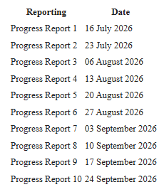
Figure 9.1: Progress report schedule

Appendix H — Questionnaire, consent form or data-collection instrument
Not applicable: no human participants or personal data were involved.

Appendix I — Team-member contribution statement
Not applicable: this is an individual project carried out by PATEL MAN VISHNUBHAI.

